IAM

1. Way to authenticate and authorize to access services on AWS
2. A principal is a person or application that can make a request for an action or operation on an AWS resource
3. Policies can be Identity-based policy or Resource based policy
4. Identity based policies can be applied to users, groups and roles.
5. Resource based policies apply to resources such as S3, DynamoDB
6. In IAM you can create upto 5,000 individual user accounts.
7. Users have no permissions by default – they can only login to the AWS console
8. Each user has friendly name and ARN (Amazon Resource Name)
9. Groups are collection of users. Users can be members of up to 10 groups
10. Roles are assumed by users, applications and services. Once assumed, the identity becomes role and gain the roles permissions
11. All permissions are implicitly denied by default.
12. When a user is created, two types of access can be granted: Programmatic Access or AWS Management Console Access.
13. IAM is eventually consistent. It means if you make a change and then you immediately try to read from IAM, you might not see that change.
14. Authentication methods
    1. Console password – use to login to AWS Management Console
    2. Access keys – used for programmatic access
    3. Server certificates – uses SSL/TLS certificates
15. IAM Users can be created to represent applications and these are known as “service accounts”
16. A group is not an identity and cannot be identified as a principal in an IAM policy
17. Groups cannot be nested

Types of policies

1. Identity-based policies
2. Resource-based policies
3. IAM permissions boundaries
4. AWS Organizations Service Control Policies (SCP)
5. Session Policies

Identity-based IAM Policies

1. JSON permission policy documents that control what actions an identity can perform, on which resources and under what conditions
2. Inline Policies
   1. Inline policies have 1-1 relationship with the user, group or role
   2. Inline policy is created for specific user, group and role
   3. We can’t share them among users or roles or groups
   4. If the user to which inline policy is attached is deleted, that policy will get deleted alongside
3. Managed Policies
   1. They can be either AWS managed or customer managed
   2. AWS managed are created and managed by AWS
   3. Customer managed are created and managed by you
   4. Managed policies are standalone policies that can be attached to multiple entities (multiple users, groups or roles)
4. There is no principal in identity based policy

Resource based Policies

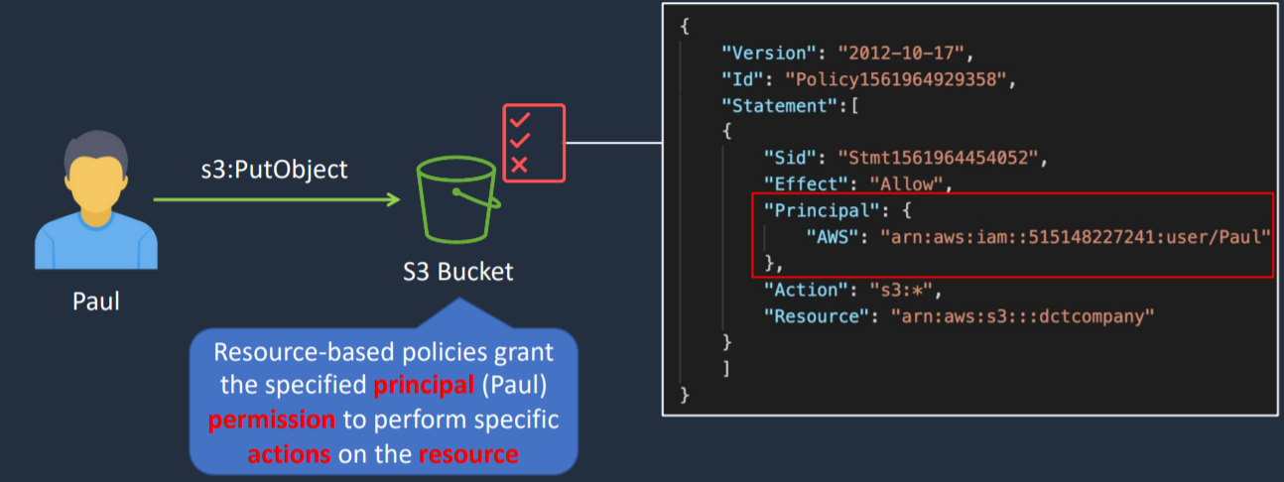

1. Resource-based policies are JSON policy documents that you attach to a resource such as Amazon S3 bucket, DynamoDB table, etc.
2. Resource based policies can also be attached to IAM Role
3. With IAM Role, we have Trust Policy and Permissions Policy.
4. Trust Policy is an example of resource-based policy whereas a permissions policy is an identity-based policy.
5. Resource based policy contains principal in it

MFA

1. Virtual MFA
   1. Google Authenticator on your smart phone
2. Physical MFA
   1. Physical tokens can be purchased from third parties

AWS Security Token Service (STS)

1. Provides short term temporary credentials
2. Temporary credentials include:
   1. AccessKeyId
   2. Expiration
   3. SecretAccessKey
   4. SessionToken
3. Temporary credentials are used with identity federation, delegation, cross-account access and IAM roles

IAM Policy Evaluation Logic

Evaluating Policies within an AWS account

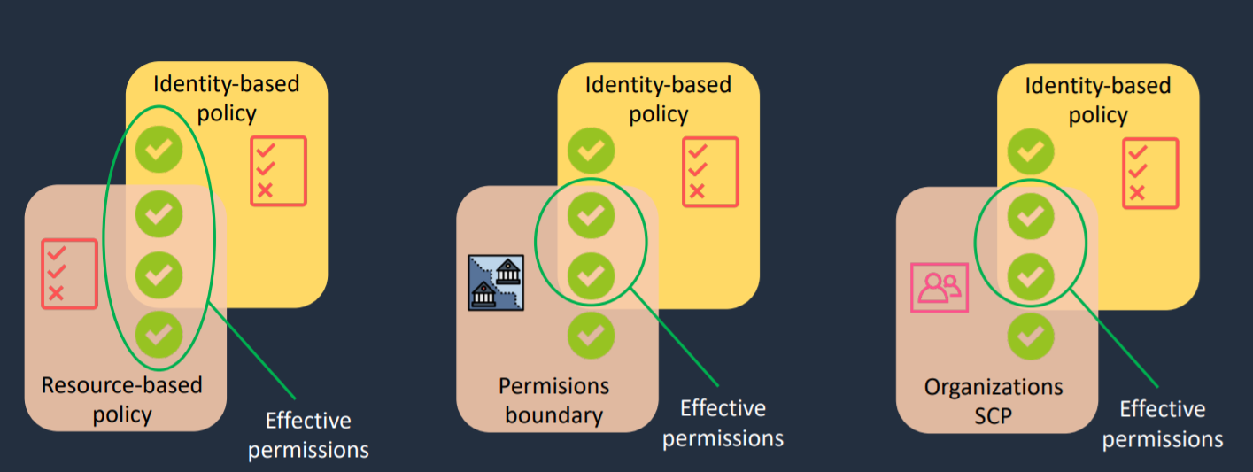

Determination Rules

1. By default, all requests are implicitly denied (though root user has full access)
2. An explicit allow in an identity-based or resource-based policy overrides this default
3. If a permissions boundary, organizations SCP, or session policy is present, it might override the allow with an implicit deny
4. An explicit deny in any policy overrides any allows

Evaluation logic

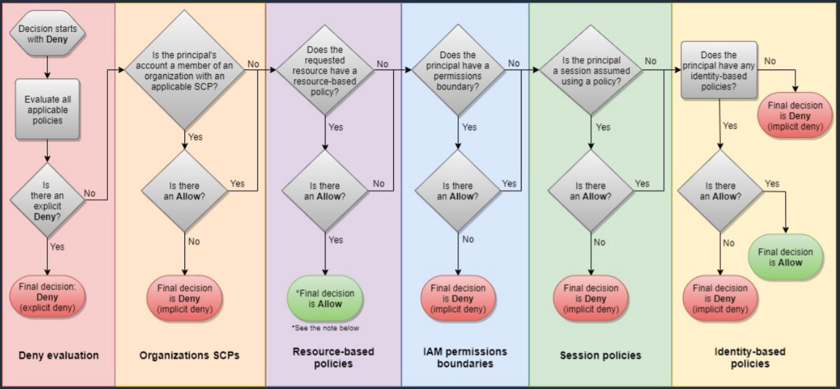

IAM Policy Simulator

1. Enables you to actually simulate policies being applied to users and actually view what permissions they should granted or restricted

IAM Best Practices

1. Lock away your AWS account root user access keys
2. Create individual IAM users
3. Use groups to assign permissions to IAM users
4. Grant least privilege
5. Get started using permissions with AWS managed policies
6. Use customer managed policies instead of inline policies
7. Regularly audit the permissions that are assigned to all of your users and other principles in your account
8. Configure a strong password policy for your users
9. Enable MFA
10. Use roles for applications that run on Amazon EC2 instances
11. Use roles to delegate permissions
12. Do not share access keys
13. Rotate credentials regularly
14. Remove unnecessary credentials
15. Use policy conditions for extra security
16. Monitor activity in your AWS account

Architecture Patterns – AWS IAM

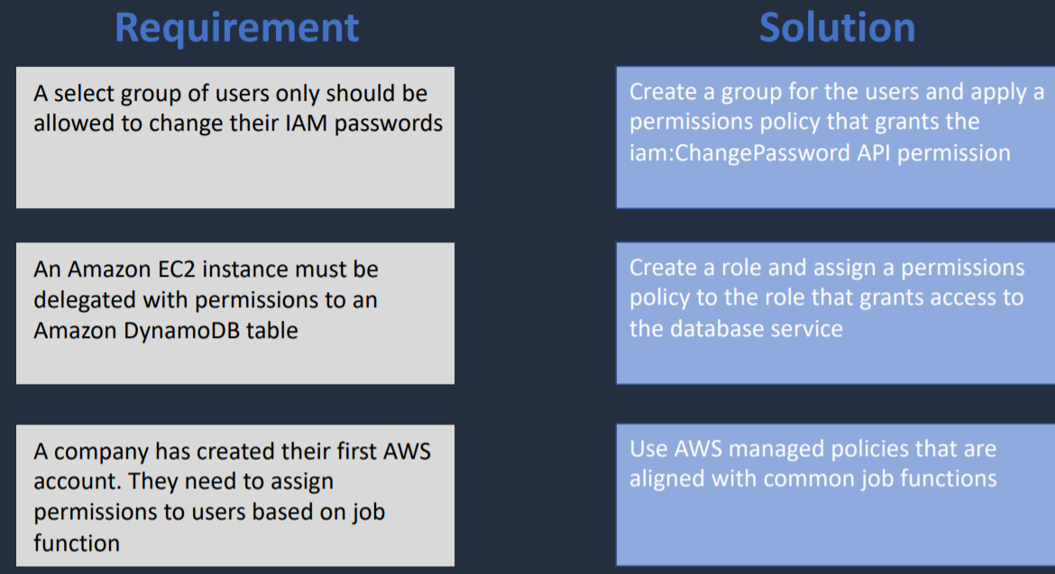

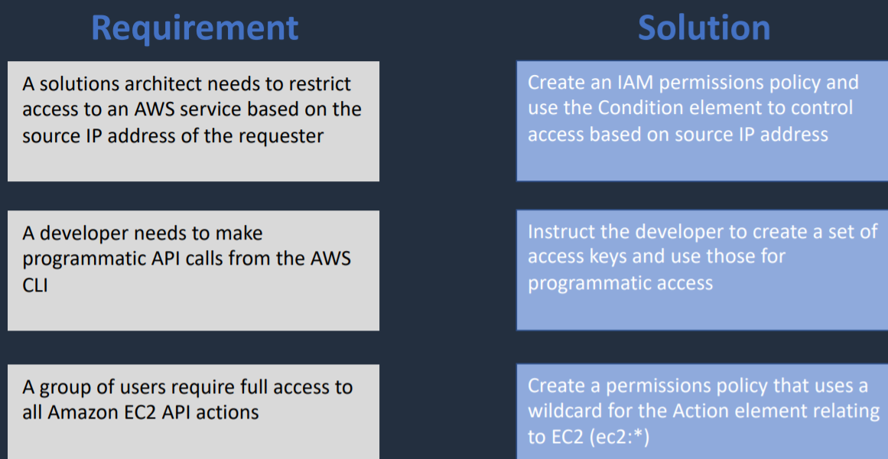

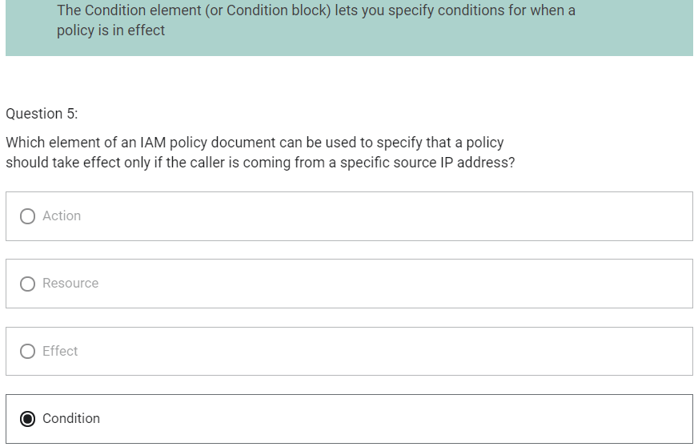

EC2

AMI (Amazon Machine Image)

1. AMI provides the information required to launch an instance
2. An AMI includes the following:
   1. A template for the root volume for the instance
   2. Launch permissions
   3. A block device mapping specifying the volumes to attach
3. AMIs are regional. You can only launch an AMI from the region in which it is stored.
4. You can copy AMI’s to other region using console, command line or the API.

EC2 Placement Groups

1. Cluster Placement Group
   1. Packs instances close together inside an AZ
   2. Enables to achieve the low-latency network performance necessary for tightly-coupled node-to-node communication that is typical of HPC applications
2. Partition Placement Group
   1. Spreads your instances across logical partitions such that groups of instances in one partition do not share the underlying hardware with group of instances in different partitions.
   2. This strategy is typically used by large distributed and replicated workloads such as Hadoop, Cassandra, and Kafka.
   3. Partitions can be within an AZ or across AZ
   4. Partitions can be in multiple AZs (up to 7 per AZ)
3. Spread Placement Group
   1. Strictly places a small group of instances across distinct underlying hardware to reduce correlated failures
   2. Instances can be within an AZ or across AZ

Network Interfaces (ENI, ENA, EFA)

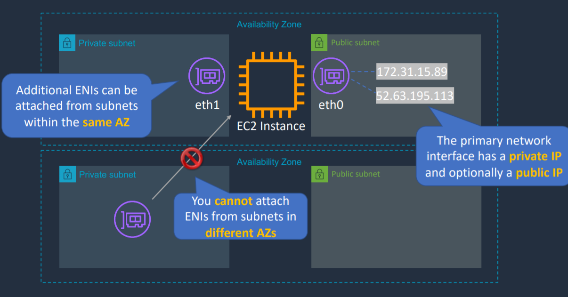

1. The primary network interface has a private IP and optionally a public IP
2. Additional ENIs can be attached from subnets within the same AZ
3. You cannot attach ENIs from subnets in different AZs

ENI (Elastic Network Interface)

1. Basic adapter type for when you don’t have any high performance requirements
2. Can use with all instance types

ENA (Elastic Network Adapter)

1. Enhanced networking performance
2. Higher bandwidth and lower inter-instance latency
3. Must choose supported instance type

EFA (Elastic Fabric Adapter)

1. Use with High Performance Computing and MPI and ML use cases
2. Tightly coupled applications
3. Can use with all instance types

Public, Private and Elastic IP address

1. Public IP address
   1. It is a dynamic address
   2. When in instance is stopped and started again, new IPv4 address will be picked up.
   3. On rebooting (restarting) the instance, same IP address is retained
   4. No charge
   5. Used in public subnet
   6. Associated with private IP address on the instance
   7. Cannot be moved between instances
2. Private IP address
   1. Retained when the instance is stopped
   2. Used in public and private subnets
3. Elastic IP address
   1. It is also a public IP but it is static IP address
   2. You are charged if not used
   3. Associated with a private IP address on the instance
   4. Can be moved between instances and Elastic Network Adapters

Note

Both ENIs and EIPs can be remapped to a different instance in same AZ.

EIPs can be remapped across AZs. But, ENIs cannot be remapped across AZs.

NAT for Public Address

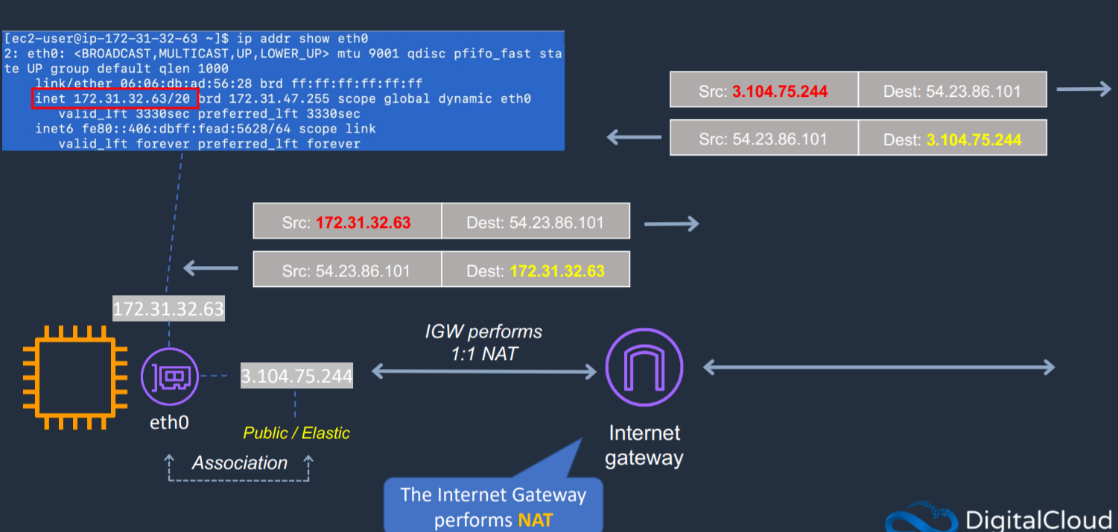

1. Internet Gateway performs NAT

NAT Gateway and NAT Instances

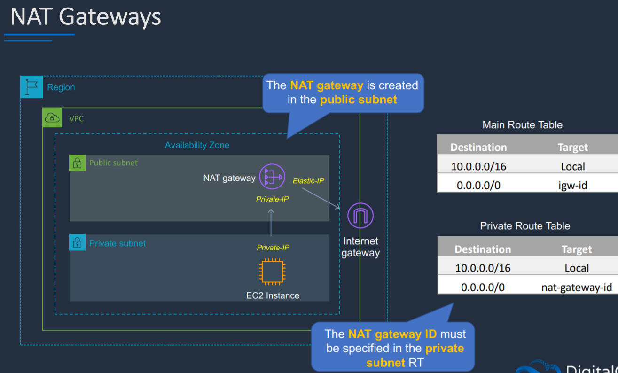

1. They are used to enable the instances we deployed in private subnet to connect to Internet
2. It is outbound only
3. NAT Gateway
   1. It is created in the public subnet.
   2. Nat Gateway ID must be specified in the private subnet route table
4. NAT Instance
   1. Uses a special AMI with the string “amzn-ami-vpc-nat” in the name
   2. Must disable source/destination checks
   3. NAT Instance ID must be specified in the private subnet route table

Difference between NAT Instance and NAT Gateway

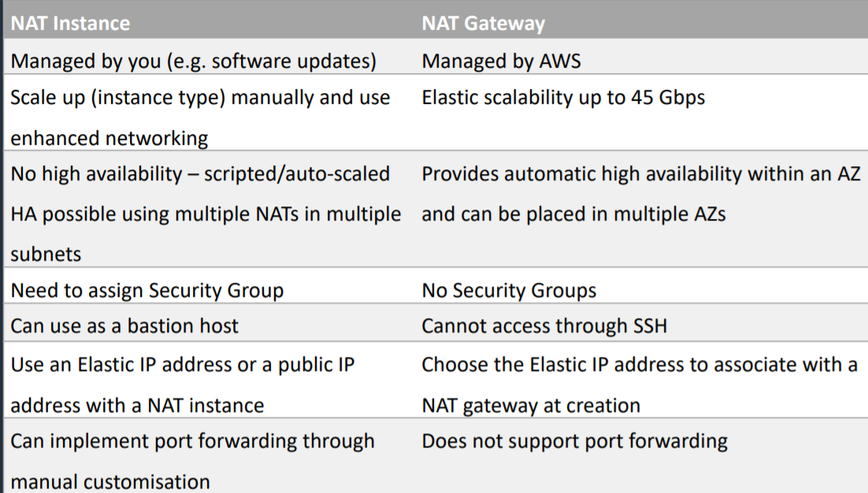

EC2 Lifecycle

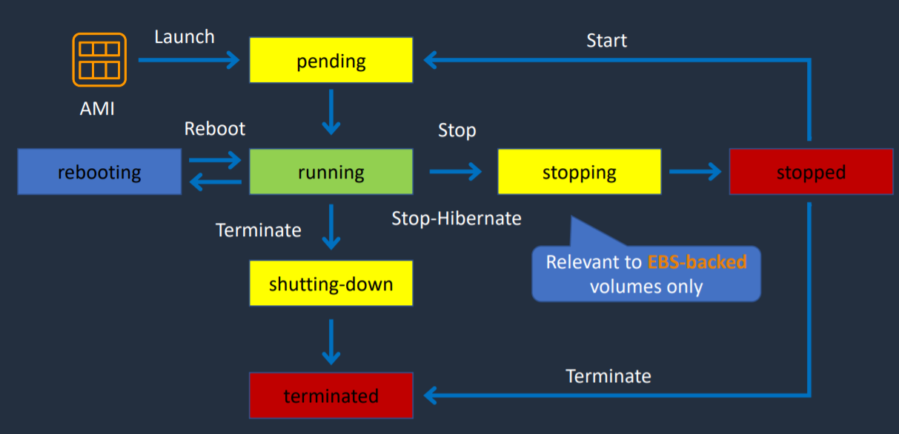

1. If your instance uses Instance Store volume, then you cannot hibernate the instance
2. Stopping EC2 instances
   1. Only applicable for EBS backed instances
   2. No charge for stopped instances
   3. EBS volumes remain attached and they are chargeable
   4. Data in RAM is lost
   5. Instance is migrated to different host
   6. Private IPv4 addresses and IPv6 addresses are retained
   7. Public IPv4 addresses are released
   8. Any Associated Elastic IPs are retained
3. Hibernating EC2 Instances
   1. Applies to on-demand or reserved Linux instances
   2. Contents of RAM are saved to EBS volume
   3. Must be enabled for hibernation when launched
   4. Specific prerequisites apply
   5. When started
      1. The EBS root volume is restored to its previous state
      2. The RAM contents are reloaded
      3. The processes that were previously running on the instance are resumed
      4. Previously attached data volumes are reattached and the instance retains its instance ID
4. Rebooting EC2 instance
   1. Equivalent to an OS reboot
   2. DNS name and all IPv6 and IPv4 addresses are retained
   3. Does not affect billing
5. Retiring EC2 Instances
   1. Instances may be retired if AWS detects irreparable failure of the underlying hardware that hosts the instance
   2. When an instance reaches its scheduled retirement date, it is stopped or terminated by AWS
6. Terminating EC2 Instances
   1. Deleting the EC2 instance
   2. Cannot recover a terminated instance
   3. By default root EBS volumes are deleted
7. Recovering EC2 Instances
   1. CloudWatch can be used to monitor system status checks and recover instance if needed
   2. Applies if the instance becomes impaired due to underlying hardware/platform issues
   3. Recovered instance is identical to original instance

AWS Nitro System

1. Nitro is the underlying platform for the next generation of EC2 Instances
2. Support for many virtualized and bare metal instance types
3. Breaks functions into specialized hardware with a Nitro Hypervisor
4. Specialized hardware includes:
   1. Nitro cards for VPC
   2. Nitro cards for EBS
   3. Nitro for Instance Storage
   4. Nitro card controller
   5. Nitro security chip
   6. Nitro hypervisor
   7. Nitro Enclaves
5. Improves performance, security and innovation
   1. Performance close to bare metal for virtualized instances
   2. Elastic Network Adapter and Elastic Fabric Adapter are both based on Nitro system
   3. More bare metal instance types
   4. Higher network performance (eg. 100 Gbps)
   5. High Performance Computing (HPC) optimizations
   6. Dense Storage instances (eg. 60 TB)

AWS Nitro Enclaves

1. Isolated compute environments
2. Runs on isolated and hardened virtual machines
3. No persistent storage, interactive access or external networking
4. Uses cryptographic attestation to ensure only authorized code is running
5. Integrates with AWS Key Management Store (KMS)
6. Protect and securely process highly sensitive data
   1. Personally Identifiable Information (PII)
   2. Healthcare data
   3. Financial data
   4. Intellectual Property data

EC2 Pricing Options

Amazon EC2 Billing

1. Billed per second, minimum of 1 minute for Amazon Linux and Ubuntu in On-demand, Reserved and Spot forms
2. Billed per hour, minimum of 1 hour for Windows and commercial Linux distros like Red Hat EL and SUSEES
3. EBS Volume attached to EC2 Instance is billed per second with the minimum of 1 minute

Amazon EC2 Reserved Instances

1. Standard Reserved Instances can be used to change Availability Zone, Instance Size (Linux), networking type. For this ModifyReservedInstances API is used.
2. Convertible Reserved Instances can be used to change Availability Zone, Instance Size (Linux), networking type along with family, OS, tenancy, payment option. For this ExchangeReservedInstances API is used.
3. Payment can be done as All Upfront, Partial Upfront and No Upfront.
4. Scheduled RI has minimum 1200 hours per year

AWS Saving Plans

1. Compute Savings Plan
   1. 1 or 3 years
   2. Hourly commitment to usage of Fargate, Lambda and EC2
   3. Any region, family, size, tenancy and OS
2. EC2 Savings Plan
   1. 1 or 3 years
   2. Hourly commitment to usage of EC2 within selected region and instance family
   3. Any size, tenancy and OS

EC2 Spot Instances

1. Bid for unused capacity for up to 90% discount
2. Spot Instance
   1. One or more EC2 instances
3. Spot fleet
   1. Launches and maintains the number of Spot/On-demand instances to meet specified target capacity
4. EC2 Fleet
   1. Launches and maintains specified number of Spot/On-Demand/Reserved Instances in a single API call
5. 2 minute warning if AWS need to reclaim capacity and this is made available via instance metadata and CloudWatch Events

Spot Block

1. Requirement: Uninterrupted for 1-6 hours
2. Pricing is 30%-45% less than on-demands

Dedicated Hosts vs Dedicated Instance

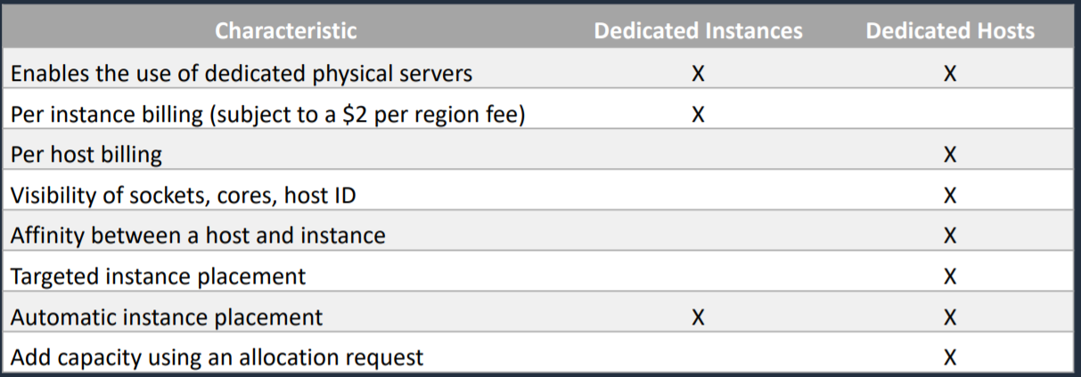

Note

To run Reporting application, runs for 6 hours a day, 4 days per week-> Scheduled RI

Architecture Pattern – Amazon EC2

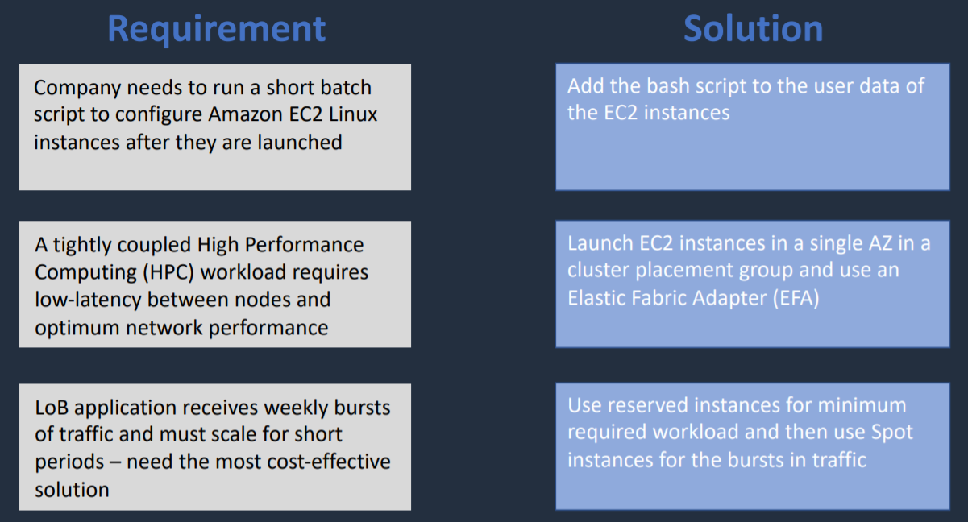

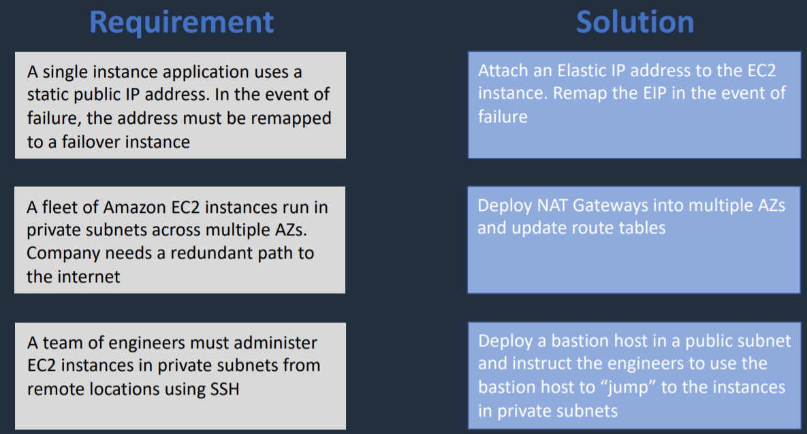

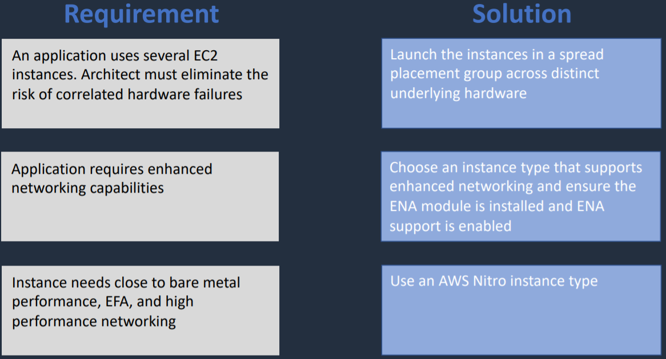

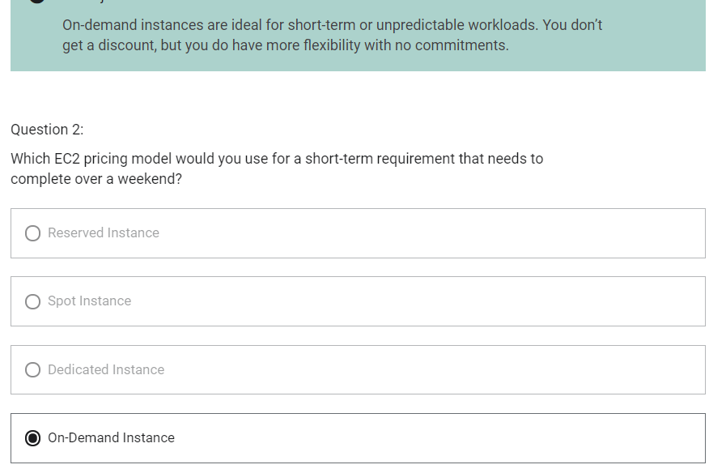

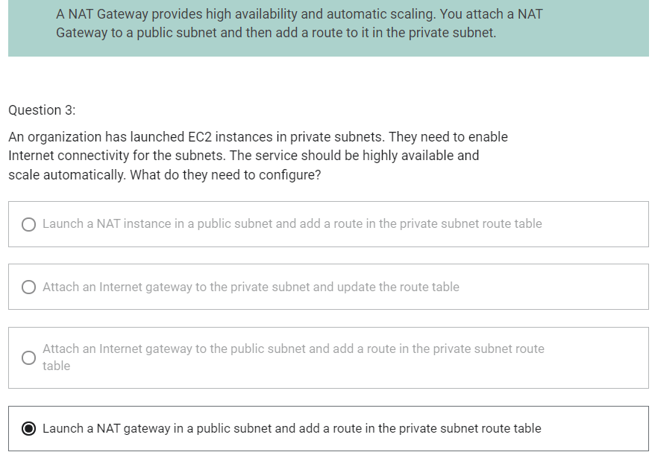

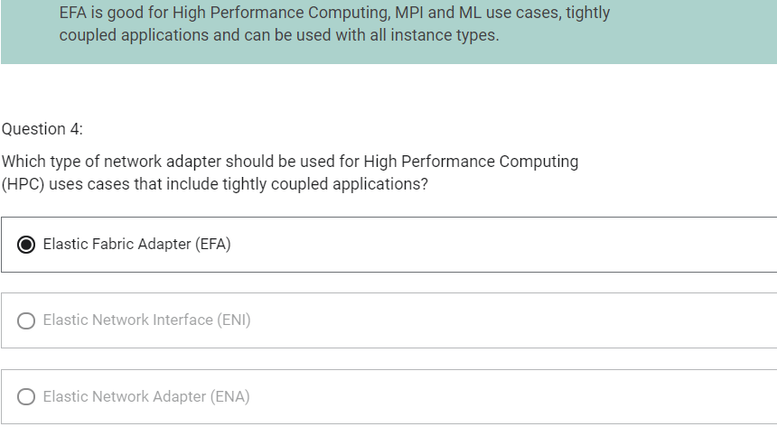

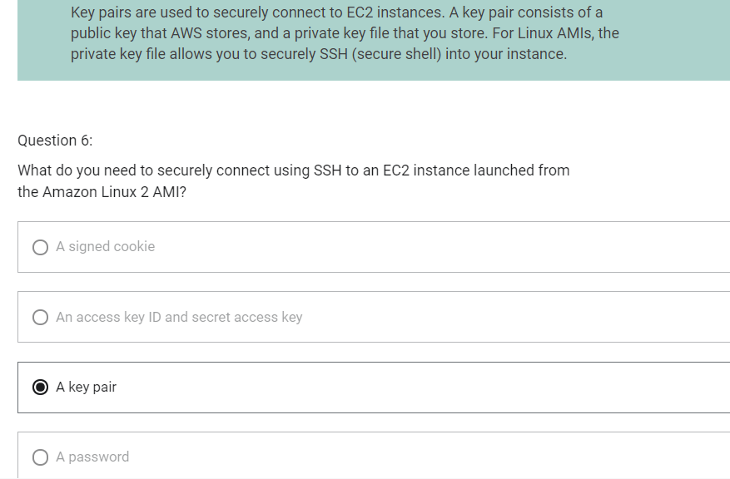

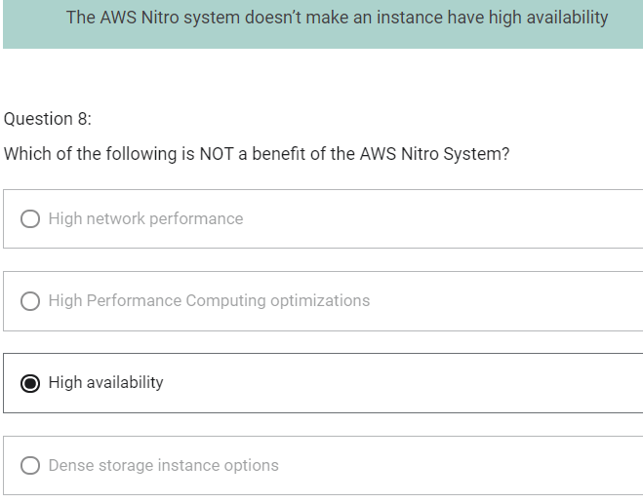

Elastic Load Balancing vs Load Balancing

Scaling Up vs Scaling Out

1. Scaling Up
   1. Scaling Up means adding resources to the instance
   2. Limitation is that you have a single point of failure
   3. Has limitation
2. Scaling Out
   1. Scaling Out means adding more number of instances
   2. Provides greater resiliency
   3. Can be used to add almost unlimited capacity

EC2 Auto Scaling

1. EC2 Auto Scaling launches and terminates instances dynamically
2. Scaling is horizontal
3. Provides elasticity and scalability
4. Responds to EC2 status checks and CloudWatch metrics
5. Can scale based on demand (performance) or on a schedule
6. Scaling Policies define how to respond to changes in demand
7. It is possible to launch instances in ASG across multiple AZ

Configuration of ASG

1. Define launch template or launch configuration
2. Configure purchase options- on demand vs spot
3. Configure VPC and subnets
   1. ASG cannot span across VPC
4. Attach Load Balancer
5. Configure health checks EC2 and ELB
6. Define Group size and scaling policies

Health checks

1. EC2 – EC2 status checks
2. ELB – Uses ELB health checks in addition to EC2 status checks

Health Checks grace period

1. How long to wait before checking the health status of the instance
2. Auto Scaling does not act on health checks until grace period expires

Auto Scaling - Monitoring

Group Metrics (ASG)

1. Data points about the ASG
2. 1 minute granularity
3. No charge
4. Must be enabled on our own

Basic Monitoring (Instances)

1. Instances sending metrics to CloudWatch
2. 5 minute granularity
3. No charge

Detailed Monitoring (Instances)

1. Instances sending metrics to CloudWatch
2. 1 minute granularity
3. Charges apply

Additional Auto Scaling Settings

Cooldowns

1. Used with simple scaling policy to prevent AutoScaling from launching or terminating before effects of previous activities are visible
2. Default value is 300 seconds (5 minutes)

Termination Policy

1. Controls which instances to terinate first when a scale-in event occurs

Termination Protection

1. Prevents Auto Scaling from terminating protected instances

Standby State

1. Used to put an instance in the InService state into the Standby state
2. This gives you an opportunity to update or troubleshoot the instance without worrying about it getting terminated

Lifecycle Hooks

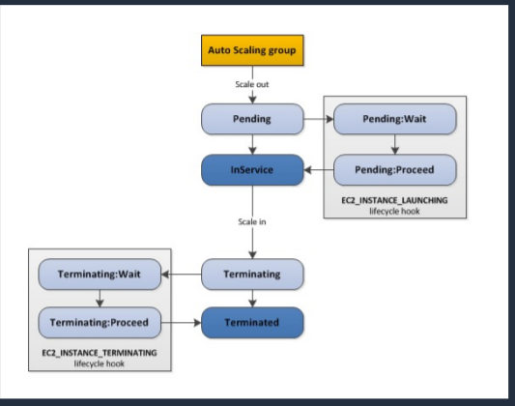

1. Used to perform custom actions by pausing instances as the ASG launches or terminates them
2. Use case
   1. Run a script to download and install software after launching
   2. Pause an instance to process data before a scale-in (termination)

Elastic Load Balancer (ELB)

1. Distributes incoming application traffic across multiple targets including
   1. Amazon EC2 instances
   2. Containers
   3. IP addresses
   4. Lambda functions
2. Provides fault tolerance for applications
3. Distributes incoming traffic a single AZ or multiple AZs
4. Only 1 subnet per AZ can be enabled for each ELB
5. Ensure at least /27 subnet and make sure there are at least 8 IP addresses available for ELB to scale
6. ELBs can be Internet facing or internal-only
7. Internet facing ELB
   1. ELB nodes have public IPs
   2. Routes traffic to the private IP addresses of the EC2 instances
   3. Need one public subnet in each AZ where the ELB is defined
8. Internal only ELB
   1. ELB nodes have private IPs
   2. Routes traffic to the private IP addresses of the EC2 instances

Types of Elastic Load Balancer

1. Application Load Balancer
   1. Operates at request level
   2. Routes based on control of request (layer 7)
   3. Supports path-based routing, host-based routing, query string parameter-based routing, and source IP address-based routing
   4. Supports instances, IP addresses, lambda functions and containers as targets
2. Network Load Balancer
   1. Operates at connection level
   2. Routes connections based on IP protocol data (layer 4)
   3. Offers ultra high performance, low latency and TLS offloading at scale
   4. Can have a static IP/ Elastic IP
   5. Supports UDP and static IP addresses as targets
3. Classic Load Balancer
   1. Performs routing at layer 4 and layer 7
4. Gateway Load Balancer
   1. Operates at layer 3-listens for all packets on all ports
   2. Forwards traffic to the target group specified in listener rules
   3. Used in front of virtual appliances such as firewalls, IDS/IPS, and deep packet inspection systems
   4. Exchanges traffic with appliances using the GENEVE protocol on port 6081

ELB Features

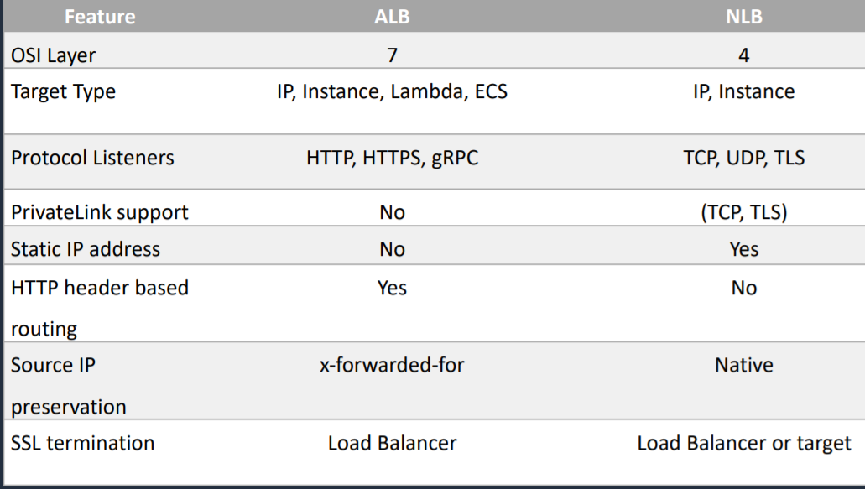

ELB Use Cases

Application Load Balancer

1. Web applications with layer 7 routing (HTTP/HTTPS)
2. Microservices architectures (e.g. Docker containers)
3. Lambda targets

Network Load Balancer

1. TCP and UDP based applications
2. Ultra-low latency
3. Static IP addresses
4. VPC endpoint services

Gateway Load Balancer

1. Load balance virtual appliances such as
   1. Intrusion detection system
   2. Intrusion prevention system
   3. Next generation firewalls
   4. Web application firewalls
   5. Distributed denial of service protection systems
2. Integrate with Auto Scaling groups for elasticity
3. Apply network monitoring and logging for analytics

Cross Zone Load Balancing

1. When cross-zone load balancing is enabled
   1. Each load balancer node distributes traffic across the registered targets in all enabled AZs
2. When cross-zone load balancing is disabled
   1. Each load balancer node distributes traffic only across the registered targets in its AZ
3. With ALB, cross-zone load balancing is always enabled
4. With NLB and GLB, cross-zone load balancing is disabled by default

Session State and Session Stickiness

Session State

1. Session-state data can be stored in DynamoDB Table.
2. It can also be stored in ElastiCache

Session Stickiness

1. Cookie is generated and client is bound to instance for cookie lifetime
2. If the instance is failed, session state is lost. In this case we can use session state in combination with session stickiness

Architecture Patterns – Auto Scaling and ELB

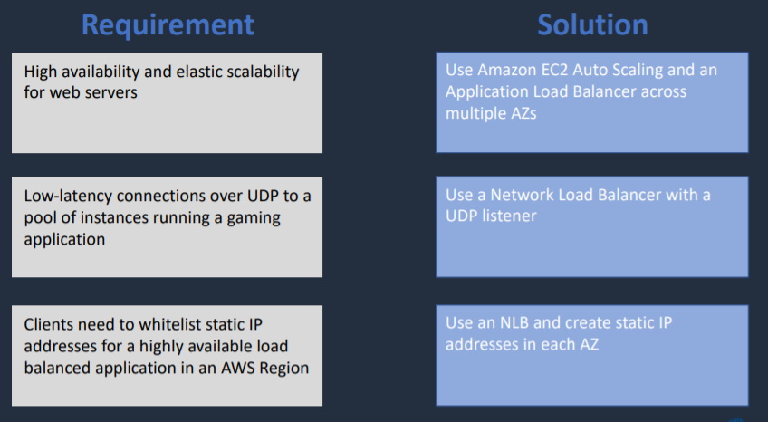

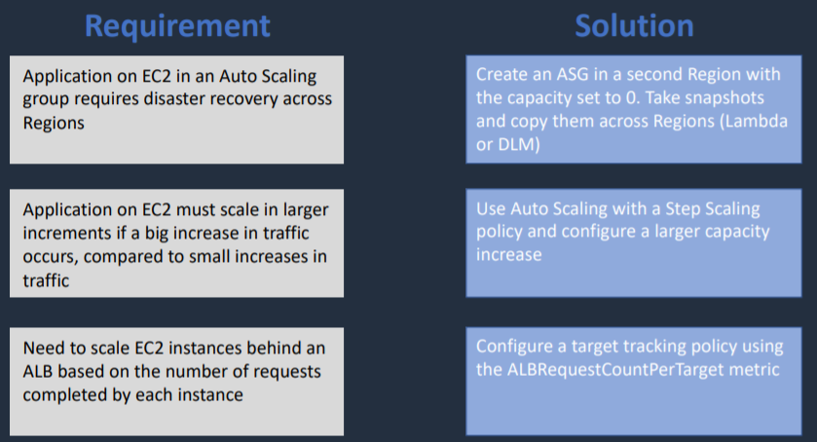

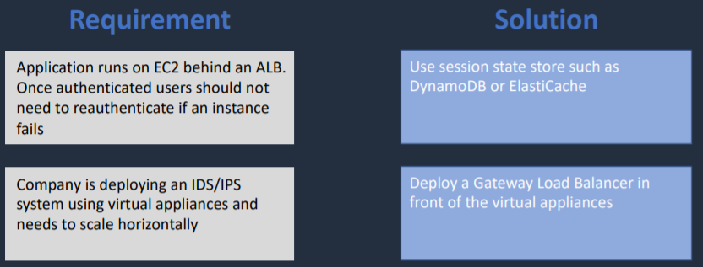

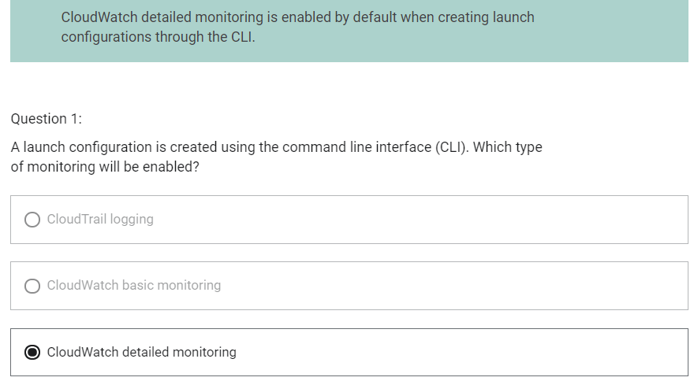

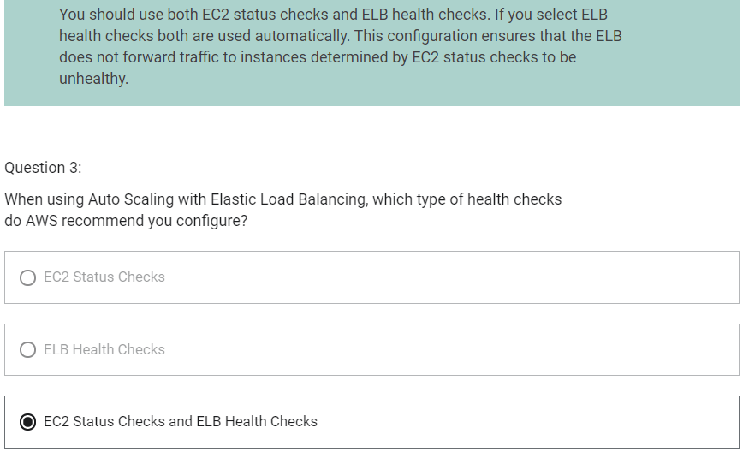

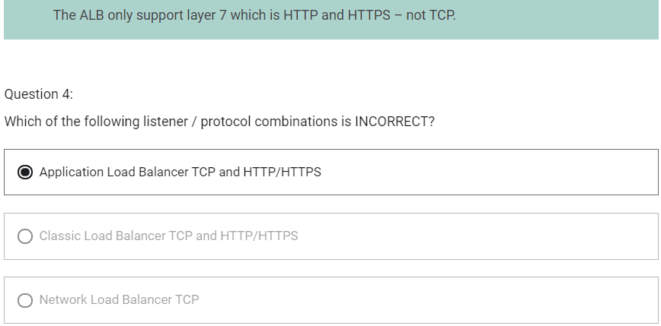

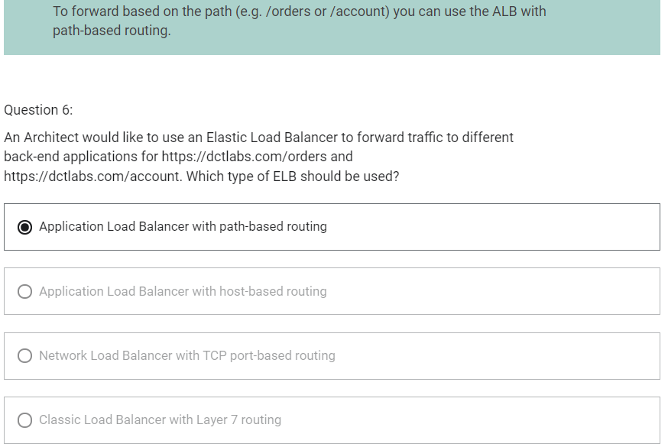

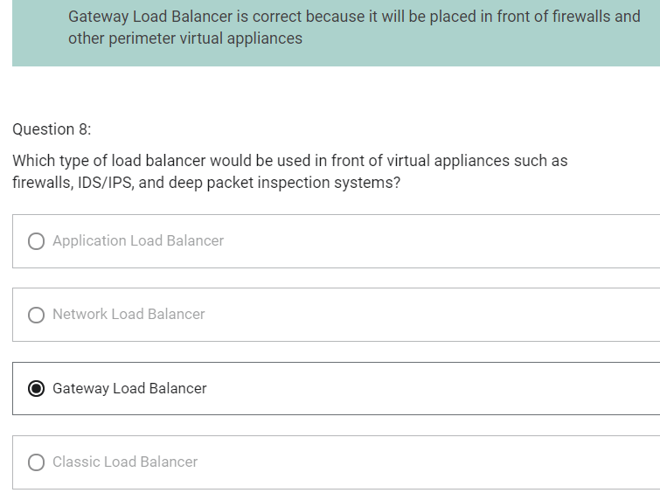

AWS Organizations

AWS Organizations

1. Allows you to consolidate multiple AWS accounts into an organization that you create and centrally manage
2. Available in two features
   1. Consolidate billing
   2. All features
3. Includes root accounts (management account/master account) and organizational units
4. Policies are applied to root accounts or OUs
5. Consolidated billing includes
   1. Paying account – independent and cannot access resources of other accounts
   2. Linked accounts – all linked accounts are independent
6. You can
   1. Create accounts programmatically using Organizations API
   2. Enable CloudTrail in management account and apply to members
   3. Enable AWS SSO using on-prem directory
7. Pricing benefits from aggregated usage
8. Limit of 20 linked accounts for consolidated billing (default)
9. Unused reserved EC2 instances are applied across the group
10. Paying accounts should be used for billing purposes only
11. Accounts can be migrated between organizations. Use AWS Organizations console if there are few accounts. Use the AWS Organizations API or AWS CLI if there are many accounts to migrate

Service Control Policies (SCP)

1. SCPs control the maximum available permissions
2. Can be applied to accounts or OUs
3. Policies can be assigned at different points in the hierarchy
4. SCPs affect only IAM users and roles – not resources policies
5. SCPs do not affect any action performed by the management account. Users in management account are not restricted
6. Deny list strategy
   1. Uses the FullAWSAccess SCP
   2. Attached to every OU and account
   3. Overrides the implicit deny
   4. Explicitly allows all permissions to flow down from the root
   5. Create additional SCPs to explicitly deny permissions
7. Allow list strategy
   1. FullAWSAccess SCP is removed
   2. No APIs are permitted anywhere unless you explicitly allow them
   3. Create SCPs to allow permissions
   4. SCPs must be attached to target account and every OU above it including root

Architecture Patterns – AWS Organizations

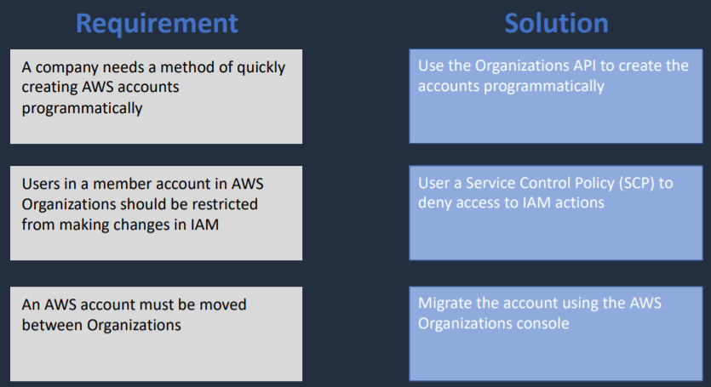

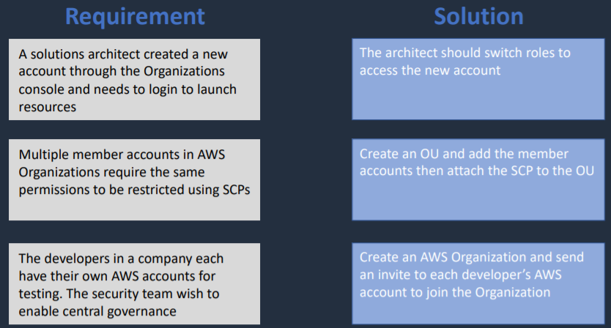

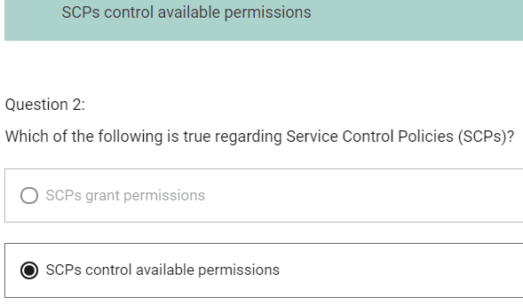

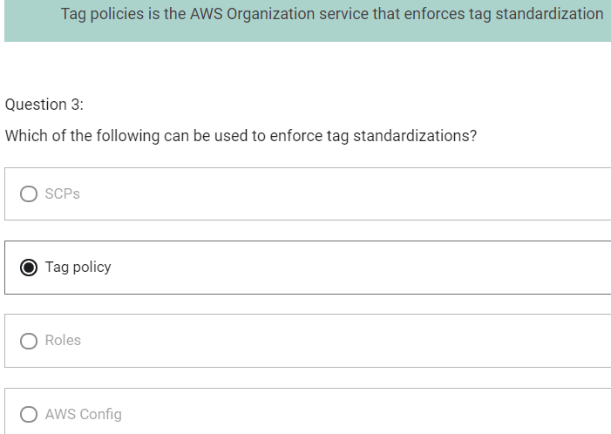

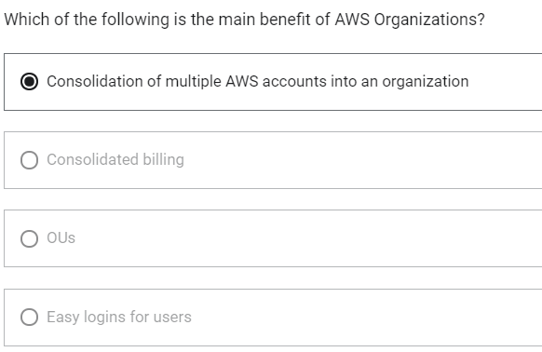

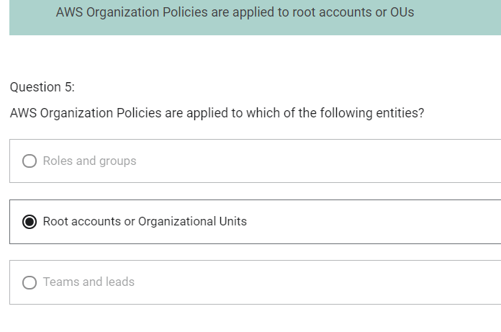

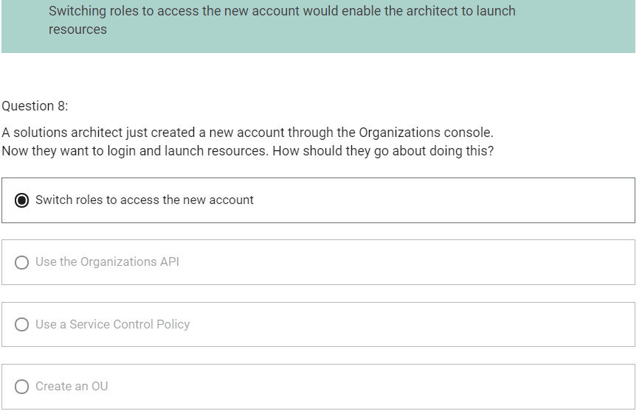

Amazon VPC (Virtual Private Cloud)

VPC

1. VPC is regional service
2. By default, you can create up to 5 VPCs per region
3. A default VPC is created in each region with a subnet in each AZ
4. VPC spans across multiple AZ
5. Subnet cannot span across multiple AZ
6. Public Subnets are subnets that have
   1. “Auto-assign public IPv4 address” set to “Yes”
   2. The subnet route table has an attached Internet Gateway

CIDR – Rules and Guidelines

1. CIDR block size can be between /16 and /28
2. The CIDR block must not overlap with any existing CIDR block associated with the VPC
3. You cannot increase or decrease the size of an existing CIDR block
4. The first four and last IP address are not available for use
5. AWS recommends you use CIDR blocks from the RFC 1918

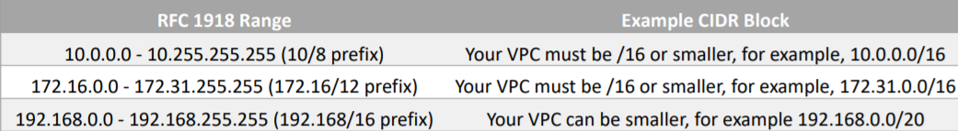

VPC Peering

1. Does not use Internet. Makes use of AWS Global Network
2. It enables routing between two VPCs using private IPv4 or IPv6 addresses
3. CIDR blocks cannot overlap
4. It does not support transitive peering
5. VPCs can be in different accounts and regions

VPC Endpoints

1. Way to connect instances in private subnet to public AWS service using a private IP
2. Each interface endpoint can connect to one of many AWS services or you can connect to an AWS PrivateLink powered service

AWS Client VPN

1. Way to connect your client computer to the AWS data center, to a VPC via a VPN connection

AWS Site-to-Site VPN

1. Connect a customer data center into AWS and have a private network established over the Internet
2. Virtual Private Gateway is deployed on AWS side
3. Customer Gateway is deployed on the customer side
4. When you have these two components, you can then establish an encrypted VPN connection over the Internet
5. VPN connection supports static routes or BGP peering/routing

AWS VPN CloudHub

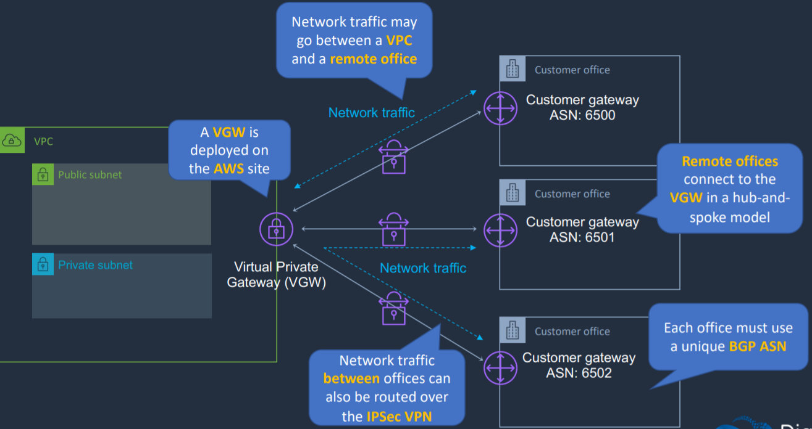

1. Connecting multiple customer gateways to a single virtual private gateway so that customer data center can communicate with AWS and also with other customer data center

AWS Direct Connect (DX)

1. Establish private connection
2. Physical fiber connection is established running at either 1 or 10 GB per second
3. Speeds from 50Mbps to 500Mbps can also be accessed via an APN partner
4. 100 Gbps is now featuring in selected locations
5. Benefits
   1. Private connectivity between AWS and your data center
   2. Low latency
   3. High bandwidth/throughput
   4. Lower costs for organizations that transfer large volumes of data
   5. Supports BGP peering and routing
6. Takes time to provision
7. DX connections are not encrypted
8. We can use IPSec s2s VPN connection over this connection to add encryption in transit

AWS Direct Connect Gateway

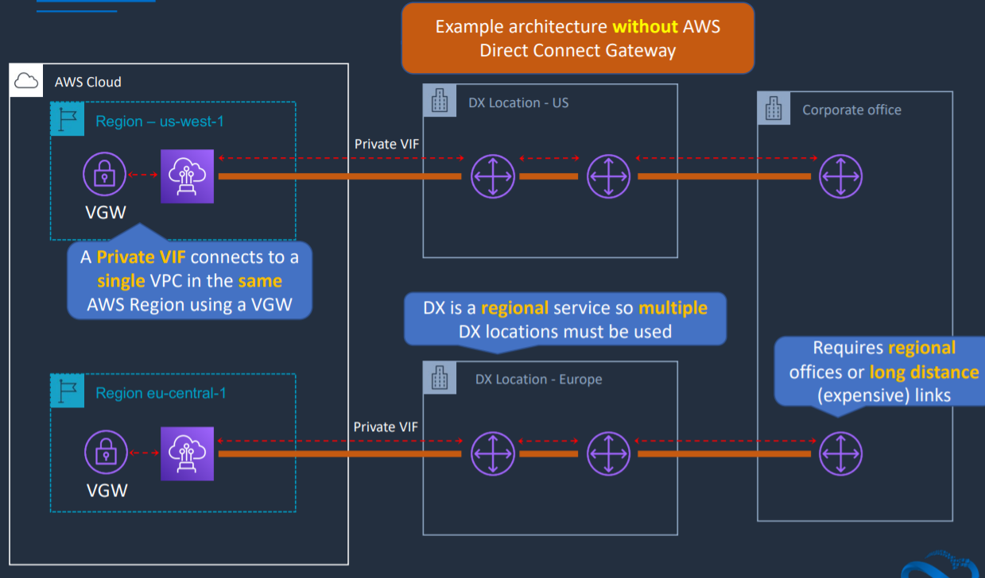

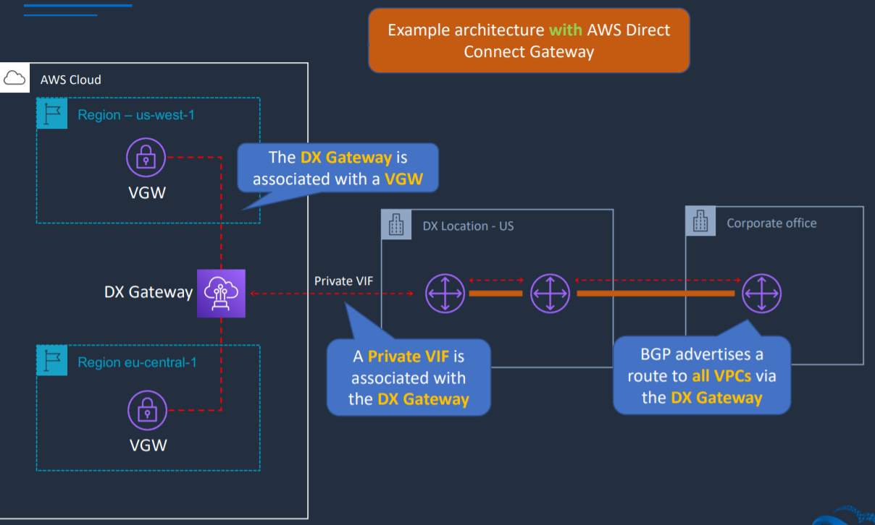

AWS Transit Gateway

1. It is a network transit hub that interconnects VPCs and on-premises networks
2. Transit Gateways can be attached to VPNs, Direct Connect Gateways, 3rd party appliances and Transit Gateways in other region/accounts

DX +VPN

1. Using AWS Transit Gateway and DX Gateway supports full transitive routing between on-premises, TGW and VPCs
2. IPsec VPN connection over Direct Connect
3. Used when additional security of encrypted tunnels is required over Direct Connect
4. More secure than Direct Connect alone

Acrhitecture Patterns – Amazon VPC

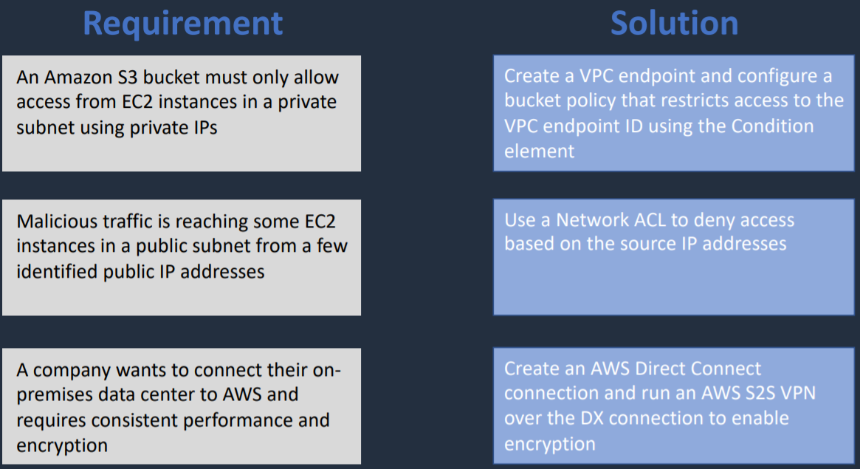

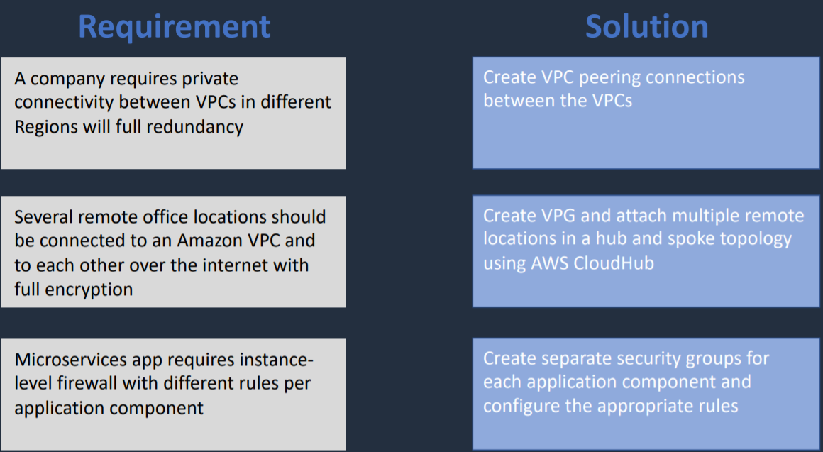

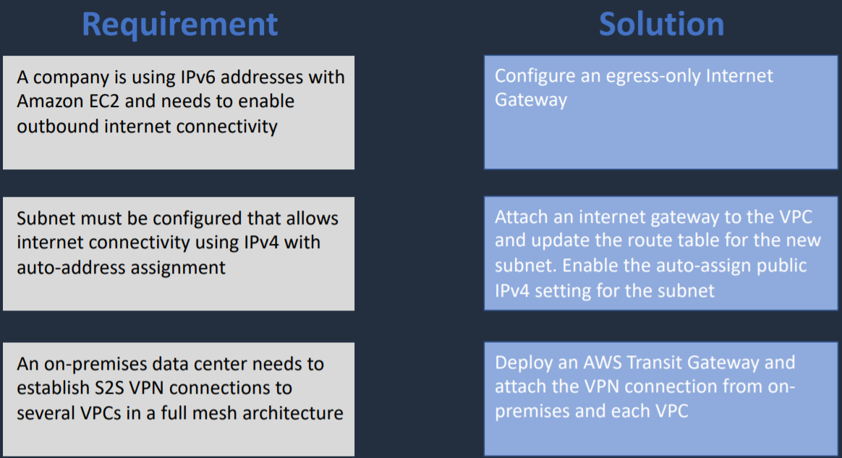

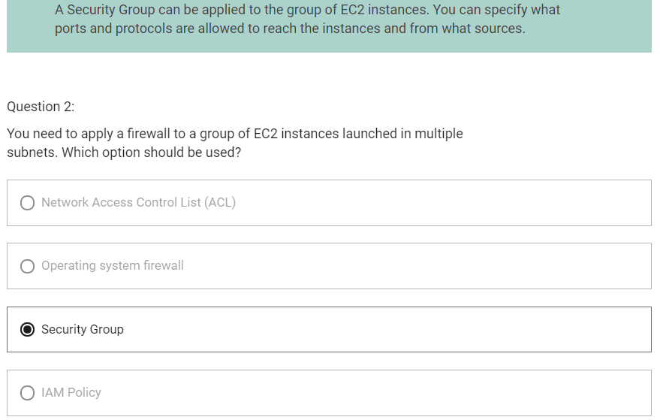

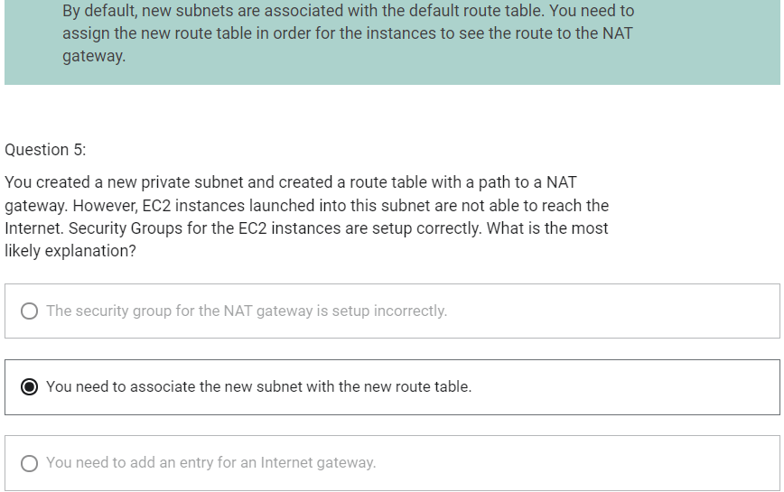

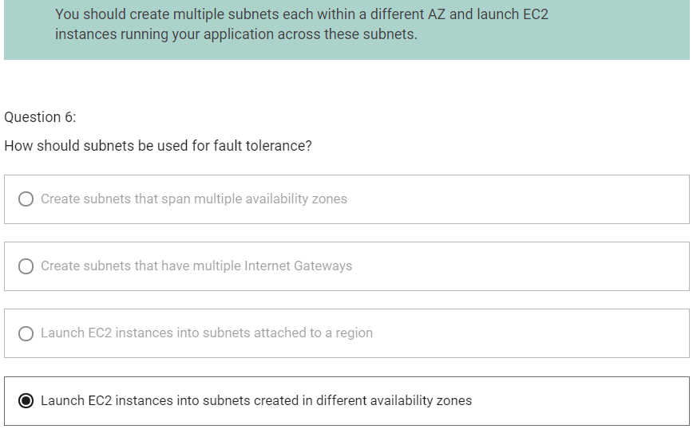

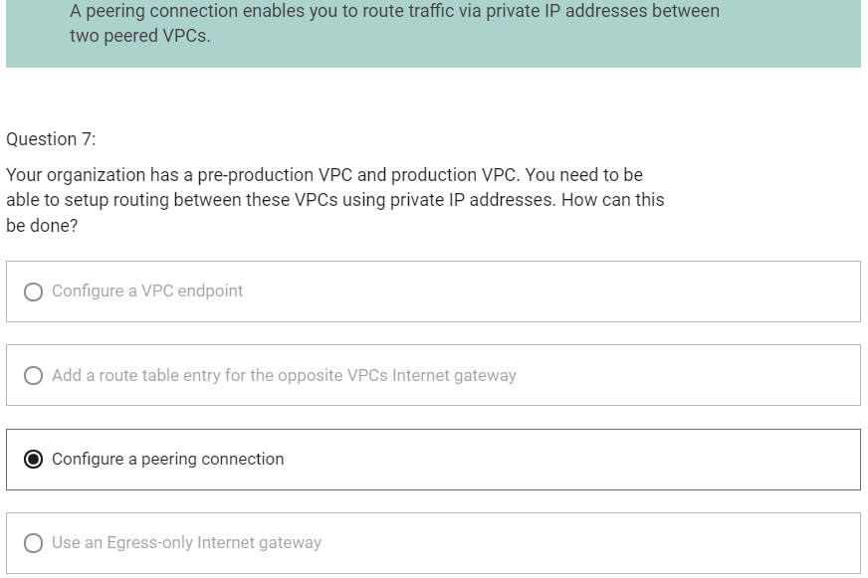

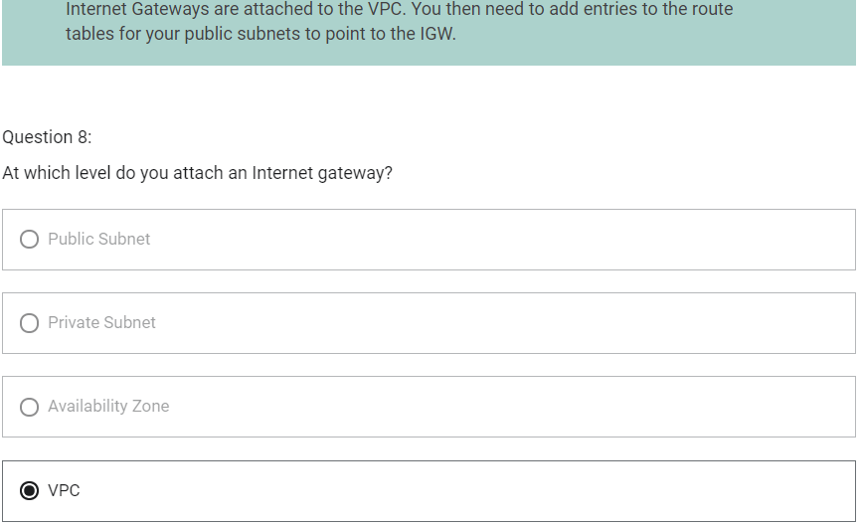

Amazon Simple Storage Service (S3)

1. Delivers strong read-after-write consistency
2. Folders can be created within folders
3. Buckets cannot be created within other buckets
4. Amazon S3 is a public service
5. To connect to S3 using private connection, S3 Gateway Endpoint can be used
6. 100 buckets per account by default
7. Objects remain in the region they are stored unless you setup replication
8. Storage class is set at object level

IAM Policies, Bucket Policies and Access Control List

IAM Policies

1. IAM Policies are identity-based policies that are attached to IAM users, groups or roles
2. Principal element is not required in the policy
3. Specify what actions are allowed on what AWS resources

Bucket Policies

1. Bucket Policies are resource-based policies
2. Can only be attached to Amazon S3 buckets
3. Has principal element

S3 Access Control Lists (ACLs)

1. AWS generally recommends using S3 bucket policies or IAM policies rather than ACLs
2. Can be attached to a bucket or directly to an object

Authorization process

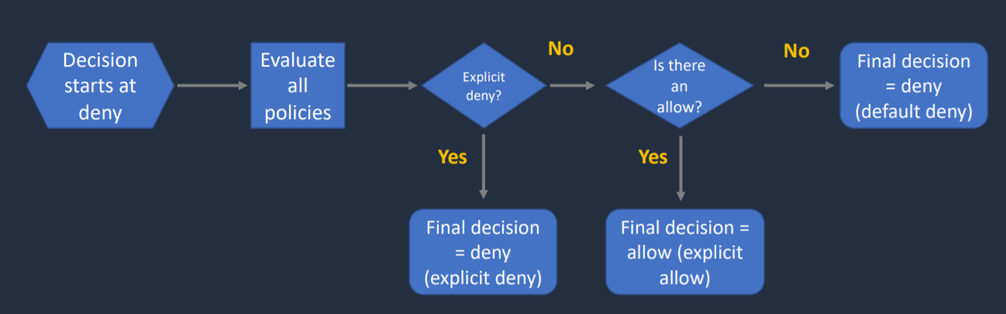

S3 Lifecycle Management

There are two types of actions:

1. Transition actions – define when objects transition to another storage class
2. Expiration actions – define when objects expire (deleted by S3)

S3 Supported Transitions

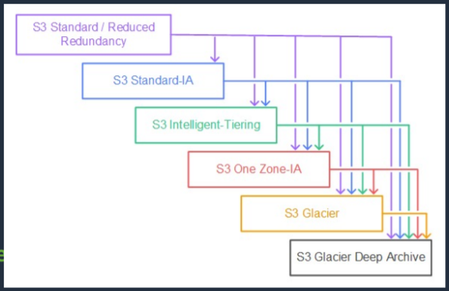

S3 Unsupported Transitions

1. You cannot transition from
   1. Any storage class to the S3 Standard storage class
   2. Any storage class to the Reduced Redundancy storage class

MFA with Amazon S3

S3 Multi-Factor Authentication Delete (MFA Delete)

1. Adds MFA requirement for bucket owners to the following operations
   1. Changing the versioning state of a bucket
   2. Permanently deleting an object version
2. The x-amz-mfa request header must be included in the above request
3. The second factor is a token generated by a hardware device or software program
4. Requires versioning to be enabled on the bucket
5. Versioning can be enabled by
   1. Bucket owners (root account)
   2. AWS account that created the bucket
   3. Authorized IAM users
6. MFA delete can be enabled by
   1. Bucket owner (root account)

MFA-Protected API Access

1. Used to enforce another authentication factor (MFA code) when accessing AWS resources (not just S3)
2. Enforced using the aws:MultiFactorAuthAge key in a bucket policy

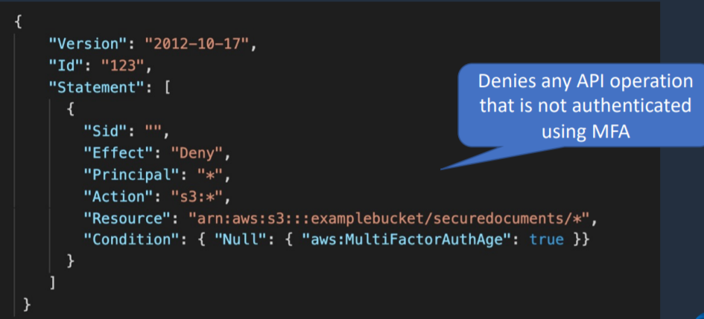

S3 Default Encryption

1. Amazon S3 default encryption provides a way to set the default encryption behaviour for an S3 bucket
2. You can set default encryption on a bucket so that all new objects are encrypted when they are stored in the bucket
3. The objects are encrypted using server-side encryption
4. Amazon S3 encrypts objects before saving them to disk and decrypts them when the objects are downloaded
5. There is no change to the encryption of objects that existed in the bucket before default encryption was enabled

Prevent uploads of unencrypted objects

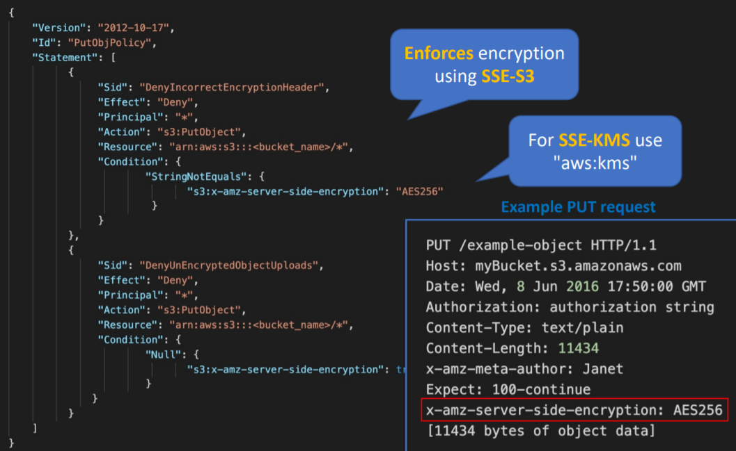

S3 Event Notifications

1. Sends notifications when events happen in buckets
2. Destinations include:
   1. Amazon Simple Notification Service (SNS) topics
   2. Amazon Simple Queue Service (SQS) topics
   3. AWS lambda

Presigned URLs

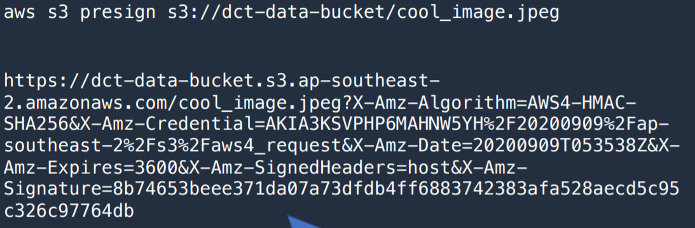

1. Give access to AWS services for limited time period
2. By default, URL expires after 1 hour. This time can be changed

S3 Multipart Upload

1. Multipart upload uploads objects in parts independently, in parallel and in any order
2. Performed using the S3 Multipart upload API
3. It is recommended for objects of 100 MB or larger
4. Can be used for objects from 5 MB up to 5 TB
5. Must be used for objects larger than 5 GB

S3 Transfer Acceleration

1. Uses CloudFront edge locations to improve performance of transfers from the client to S3 bucket
2. AWS only charges if there is a performance improvement
3. It is enabled at the bucket level
4. Enables fast, easy and secure transfers of files
5. Leverages Amazon CloudFront Edge Location
6. Used to accelerate object uploads to S3 over long distances (latency)
7. It is as secure as direct upload to S3
8. You are charged only if there was a benefit in transfer times
9. Need to enable transfer acceleration on the S3 bucket
10. Cannot be disabled, can only be suspended

S3 Copy API

1. Copy objects up to 5 GB in size
2. The copy operation can be used to
   1. Generate additional copies of objects
   2. Rename objects
   3. Change the copy’s storage class or encryption at rest status
   4. Move objects across AWS locations/regions
   5. Change object metadata

S3 Select and Glacier Select

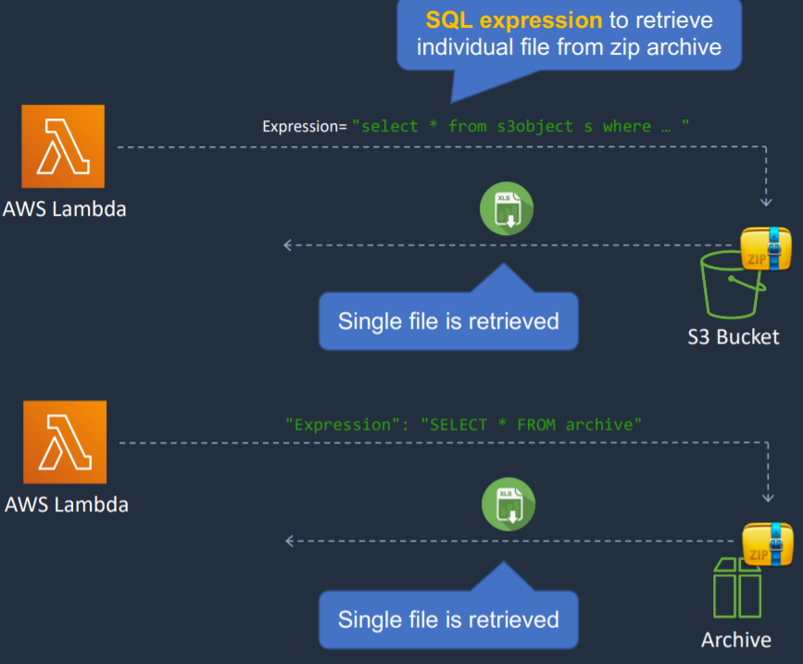

1. They are two methods of using SQL expressions to access objects and objects within objects like a zip file on S3

Server Access Logging

1. Provides detained records for the requests that are made to a bucket
2. Details include the requester, bucket name, request time, request action, response status and error code (if applicable)
3. Disabled by default
4. Only pay for the storage space used
5. Must configure a separate bucket as the destination (can specify a prefix)
6. Must grant write permissions to the Amazon S3 Logs Delivery group on destination bucket

Cross-Origin Resource Sharing (CORS)

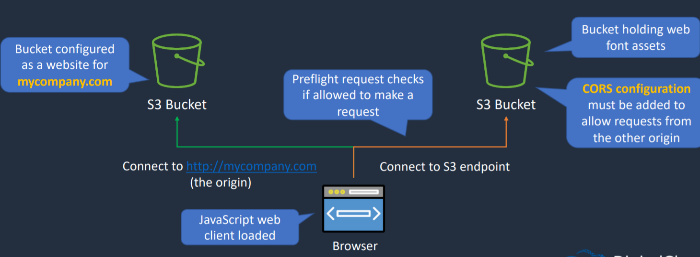

1. Allows requests from an origin to another origin
2. Origin is defined by DNS name, protocol and port
3. This is enabled through settings
   1. Access-Control-Allow-Origin
   2. Access-Control-Allow-Methods
   3. Access-Control-Allow-Headers
4. These settings are defined using rules
5. Rules are added using JSON files in S3
6. We don’t implement CORs configuration on the origin, it is implemented on the other bucket that you are trying to connect to

CORS Rule

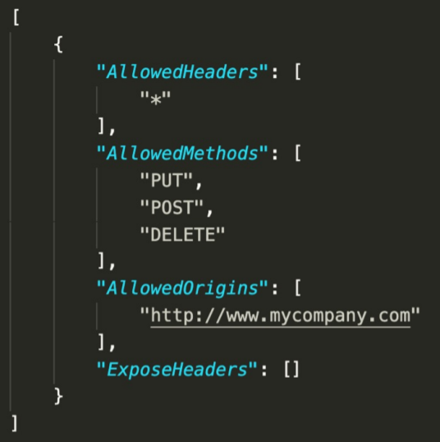

Cross Account Access

1. Console Account Access Methods
   1. Resource based policies and IAM Policies for programmatic-only access to S3 bucket objects
   2. Resource-based ACL and IAM policies for programmatic-only access to S3 bucket objects
   3. Cross-account IAM roles for programmatic and console access to S3 bucket objects

Architec

ture Patterns – Amazon S3

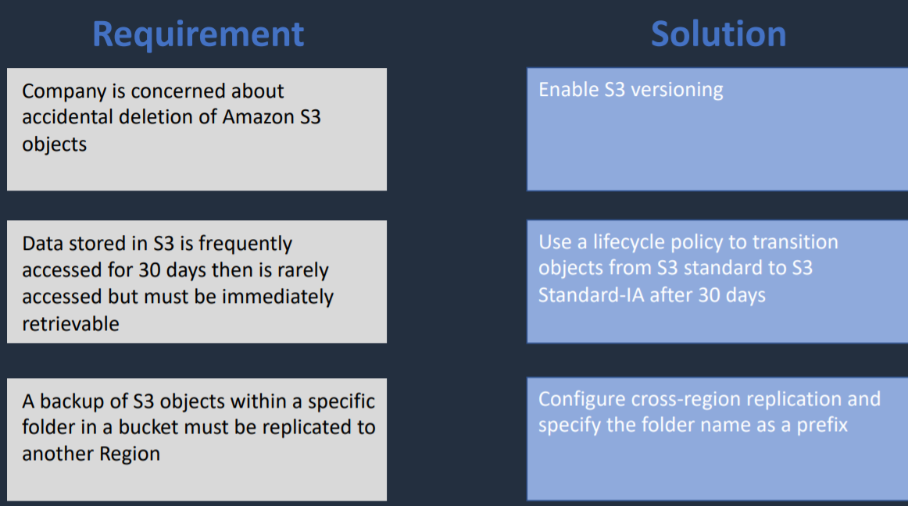

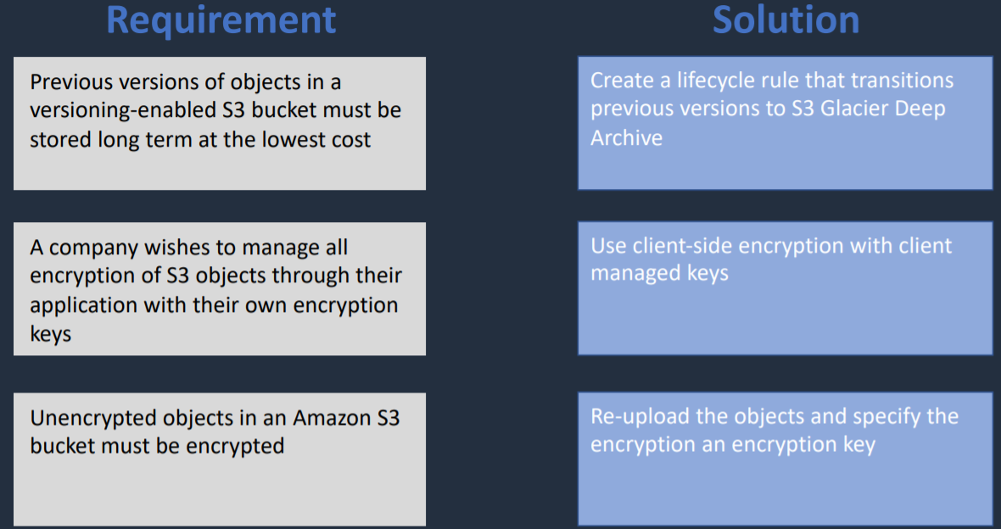

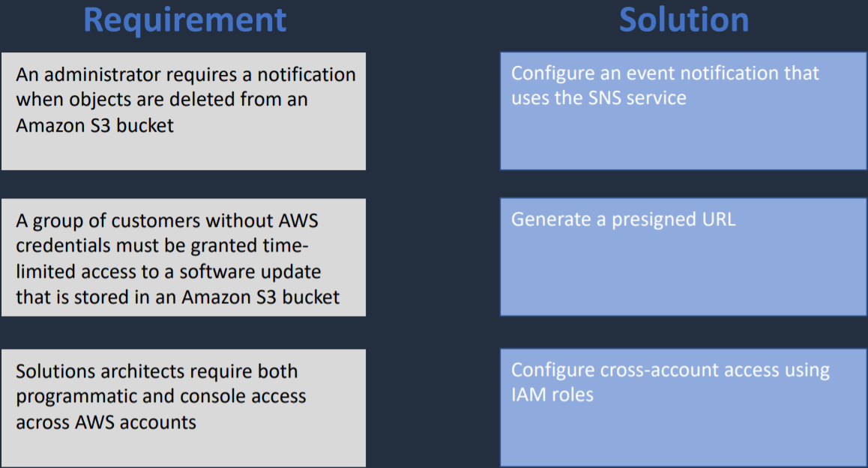

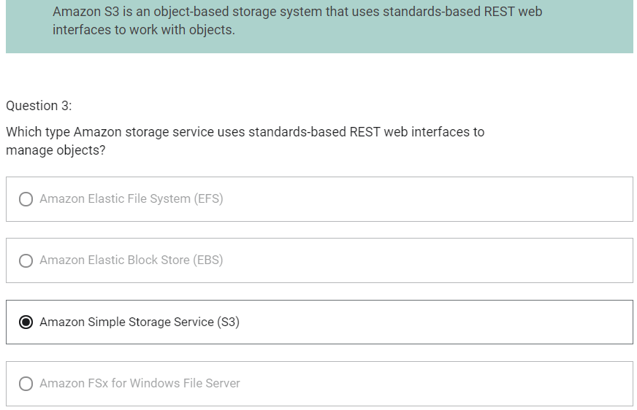

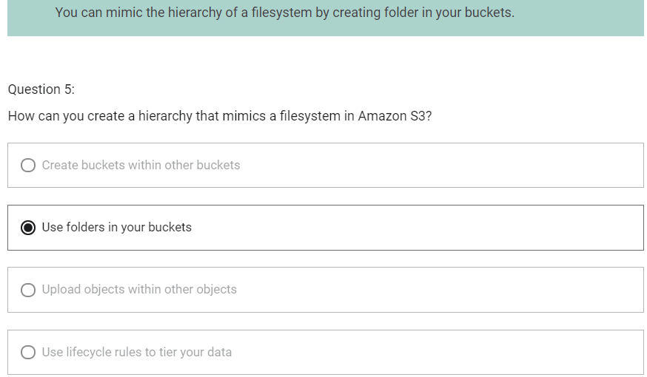

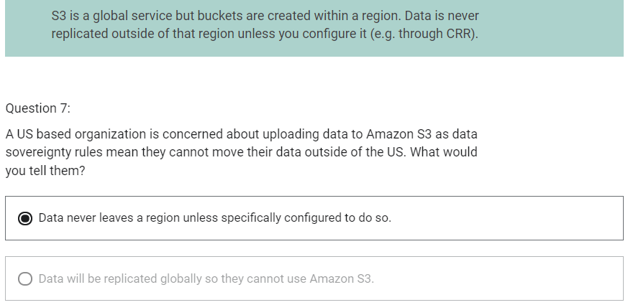

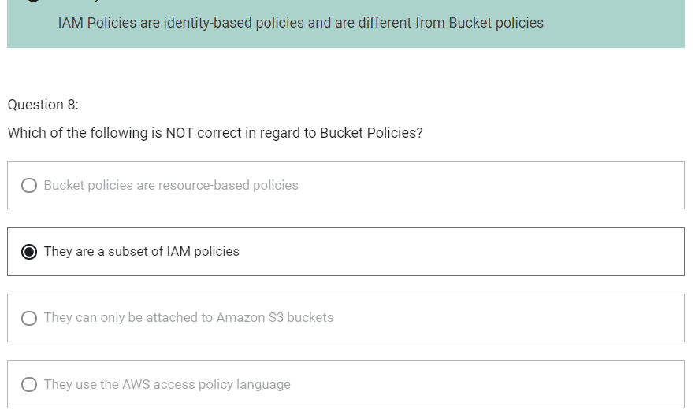

DNS, Caching and Performance Optimization

Amazon Route 53

1. You can transfer domains to Route 53 only if the Top-Level Domain (TLD ) is supported
2. You can transfer a domain from Route 53 to another registrar by contacting AWS Support
3. You can transfer a domain to another account in AWS (does not migrate zone by default)
4. Can have a domain registered in one account and the hosted zone in another AWS account
   1. Amazon Route 53 Features
   2. Domain Registration
   3. Hosted Zone
   4. Health Checks
   5. Traffic Flow
   6. DNS Resolution

Amazon Route 53 Hosted Zones

1. In hosted zone, we can create our DNS records, like A record for example example.com that resolves to an IP address and has a time to live associated with it
2. Collection of records for a specified domain
3. There are two type of zones
   1. Public hosted zone – determines how traffic is routed on the Internet
   2. Private hosted Zone for VPC – determines how traffic is routed within VPC
4. For private hosted zones you must set the following VPC settings to “True”
   1. enableDnsHostname
   2. enableDnsSupport

CNAME vs Alias Records

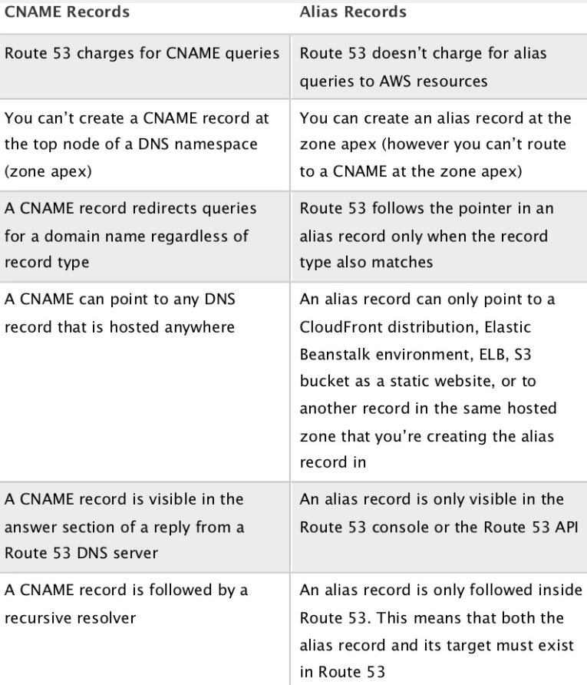

Route 53 Health Checks

1. health checks check the instance health by connecting to it
2. health checks can be pointed at
   1. endpoints
   2. status of other health checks
   3. status of a CloudWatch alarm

Migrate to/from Route 53

1. You can migrate from another DNS provider and can import records
2. You can migrate a histed zone to another AWS account
3. You can migrate from Route 53 to another registrar
4. You can also associate a Route 53 hosted zone with a VPC in another account
   1. Authorize association with VPC in the second account
   2. Create an association in second account

Route 53 Routing Policies

Route 53 Resolver

1. It enables us to work either our on-premises DNS Server and our Route 53 DNS Servers so that we can bring the two together and get resolution of domain names that are either in hosted zones and Route 53 or in our internal DNS Servers
2. Types of Route 53 Resolver
   1. Outbound Endpoints
   2. Inbound Endpoints

Regional Edge Cache

It sits between CloudFront Origins and Edge Location.

There are 12 regional edge caches.

CloudFront Caching

1. Object is cahed for TTL (default 24 hours)
2. Decreasing the TTL is best for dynamic content
3. Increasing TTL is better for performance and reduces load on origin
4. You can define a maximum Time to Live (TTL) and a default TTL
5. TTL is defined at the behaviour level
6. This can be used to define different TTLs for different file types (e.g. png vs jpg)
7. After expiration, CloudFront checks the origin for any new requests (check the file is the latest version)
8. Headers can be used to control the cache:
   1. Cache-Control max-age=(seconds) – specify how long before CloudFront gets the object again from the origin server
   2. Expires – specify an expiration date and time

CloudFront Path Patterns

1. Great way to forward request to different origins
2. Default origin is then used for any requests that don’t match a specified path pattern

Caching based on Request Headers

1. You can configure CloudFront to forward headers in the viewer request to the origin
2. CloudFront can then cache multiple versions of an object based on the values in one or more request headers
3. Controlled in a behaviour to do one of the following
   1. Forward all headers to your origin (objects are not cached)
   2. Forward a whitelist of headers that you specify
   3. Forward only the default headers (does not cache objects based on values in request headers)

CloudFront Signed URLs

1. Signed URLs provide more control over access to content
2. We can specify beginning and expiration date and time, IP addresses/ranges of user that are allowed to use this signed URL
3. Signed URLs should be used for individual files and clients that don’t support cookies

CloudFront Signed Cookies

1. Similar to Signed URLs
2. Use signed cookies when you don’t want to change URLs
3. Can also be used when you want to provide access to multiple restricted files (Signed URLs are for individual files)

CloudFront Origin Access Identity (OAI)

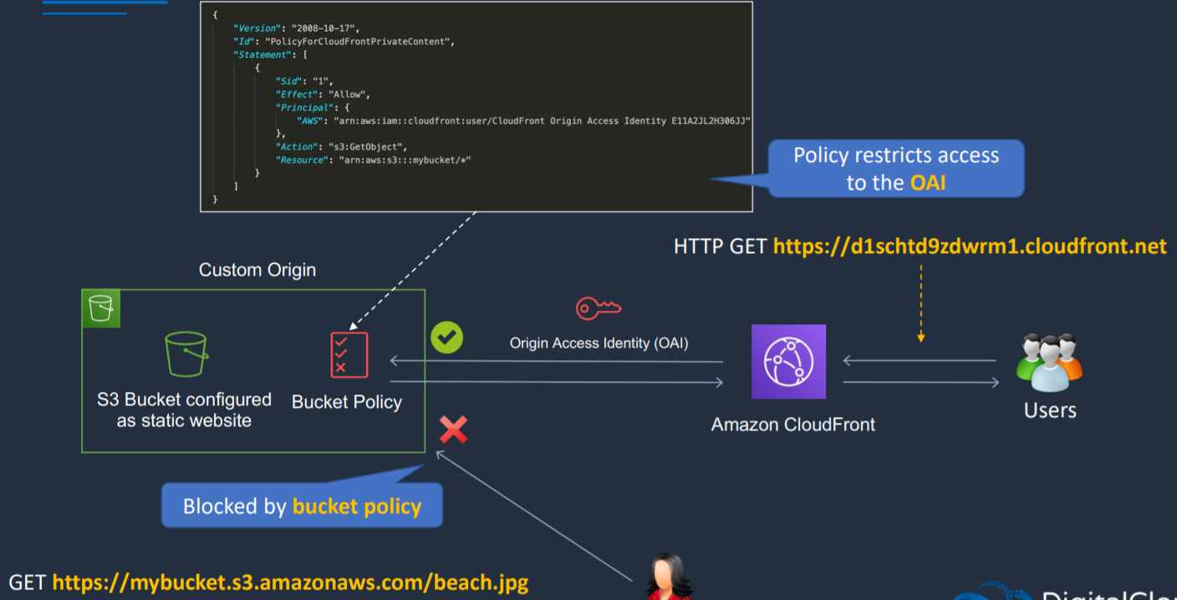

1. Way to make sure that content is served by a CloudFront and no one is able to circumvent CloudFront and go to origin
2. OAI is used with S3
3. It is not used with EC2

CloudFront SSL/TLS and SNI (Server Name Identification)

Lambda@Edge

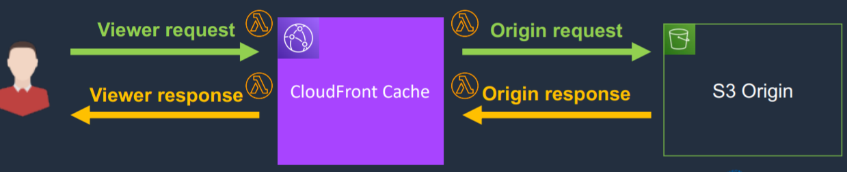

1. Run node.js and python lambda functions to customize the content CloudFront delivers
2. Executes functions closer to the viewer
3. Can be run at the following points
   1. After CloudFront receives a request from a viewer (viewer request)
   2. Before CloudFront forwards the request to the origin (origin request)
   3. After CloudFront receives the response from the origin (origin response)
   4. Before CloudFront forwards the response to the viewer (viewer response)

Architecture Patterns – DNS, Caching and Performance Optimization

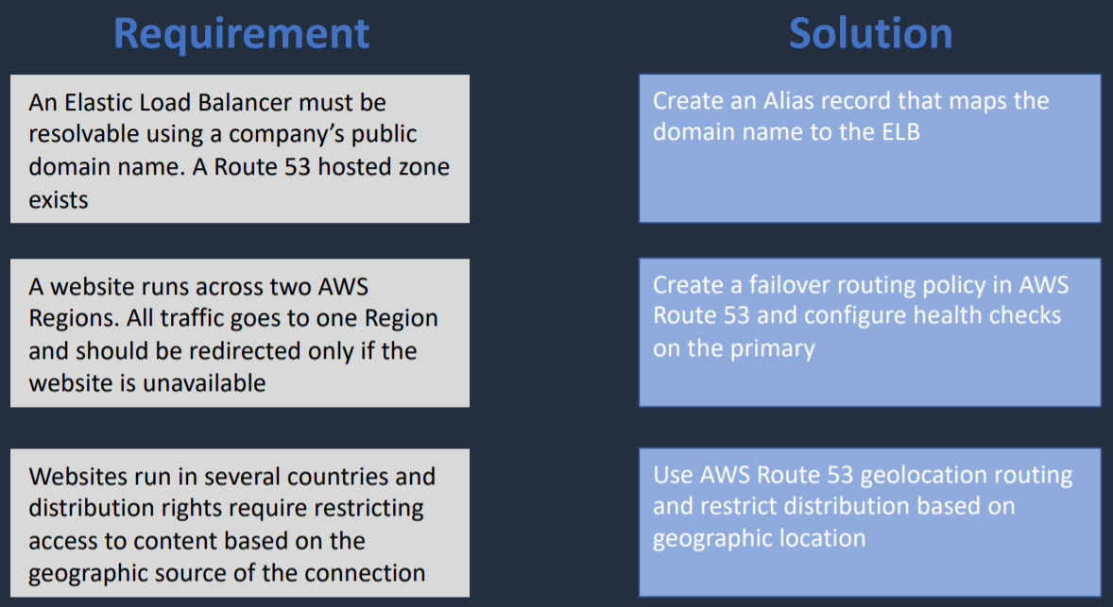

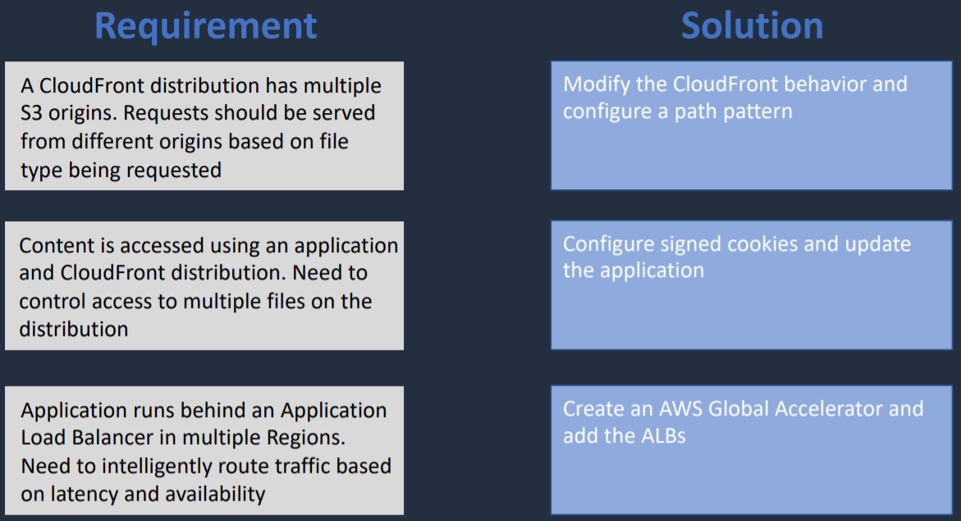

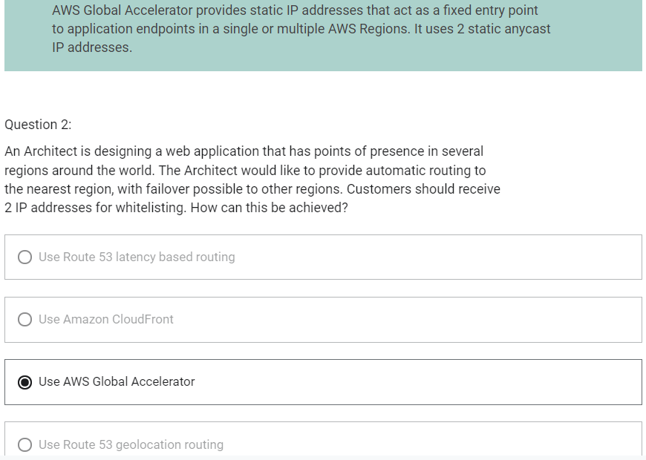

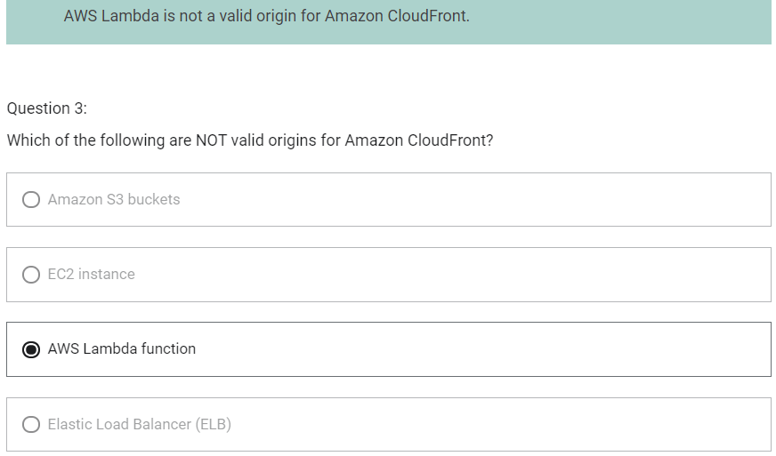

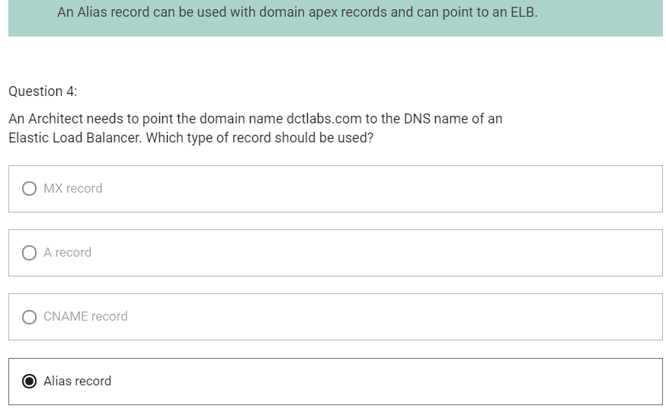

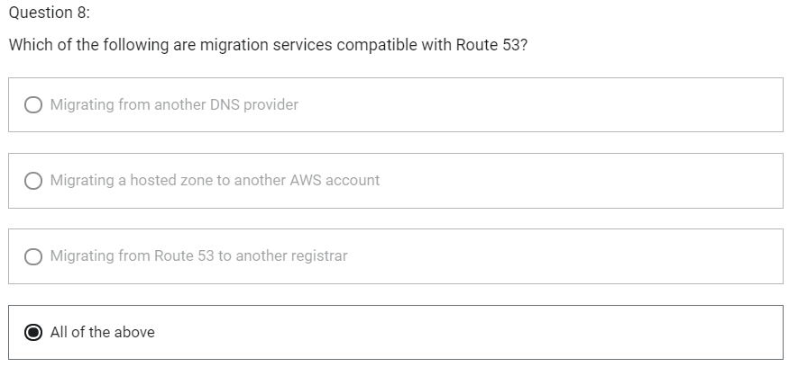

Block and File Storage

EBS

1. When we launch EC2 instances, the default is to have an EBS volume attached that is a gp2 General Purpose SSD.
2. EBS Volume data persists independently of the life of the instance
3. EBS Volumes do not need to be attached to an instance
4. You can attach multiple EBS volumes to an instance
5. You can use multi-attach to attach a volume to multiple instances but with some constraints
6. EBS volumes must be in the same AZ as the instances they are attached to
7. Root EBS Volumes are deleted on termination by default
8. Extra non-boot volumes are not deleted on termination by default

Amazon EBS Multi-Attach

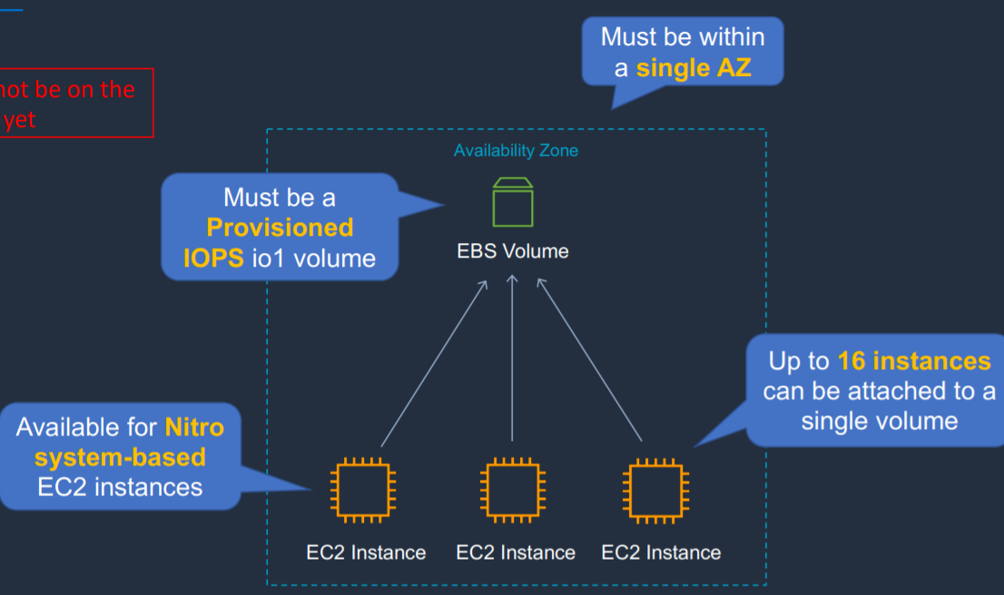

1. It possible to attach single EBS volume to multiple EC2 instances. But, this only available for Nitro-system based EC2 instances
2. Up to 16 instances can be attached to a single volume
3. EBS Volume must be a Provisioned IOPS io1 volume
4. EBS Volume and Instances must be within a single AZ

Amazon EBS SSD-Based Volumes

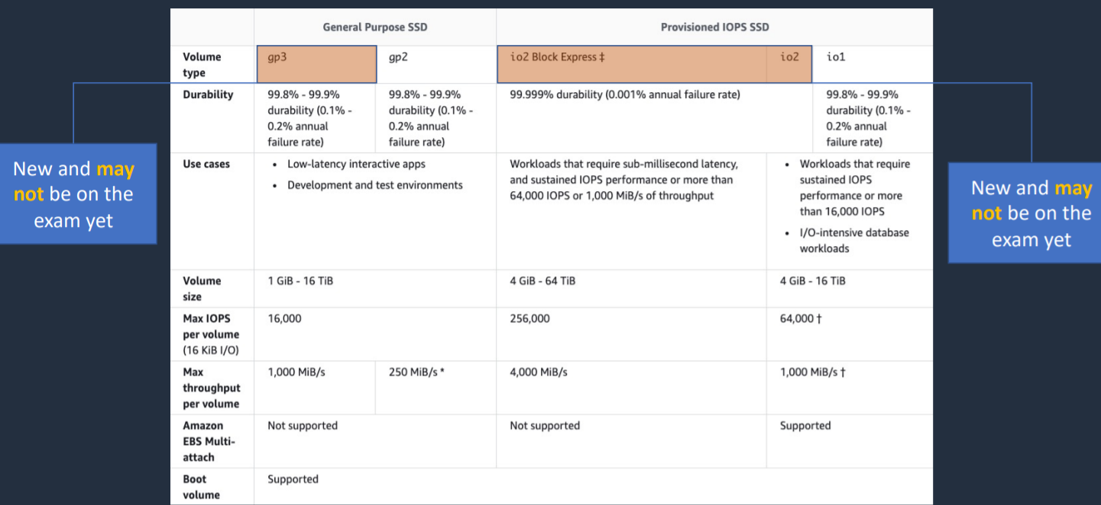

Amazon EBS HDD-Based Volumes

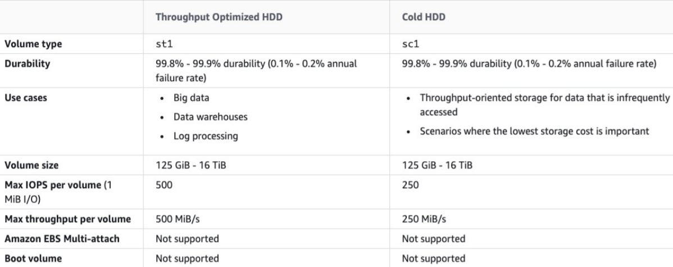

Amazon EBS Copying, Sharing and Encryption

Copying and Sharing AMIs and Snapshots

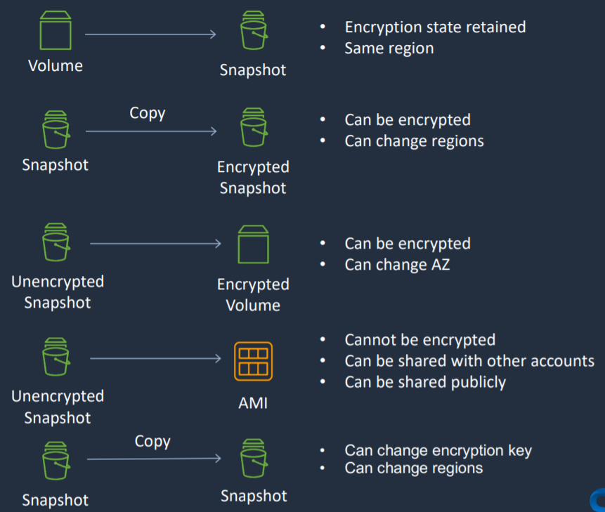

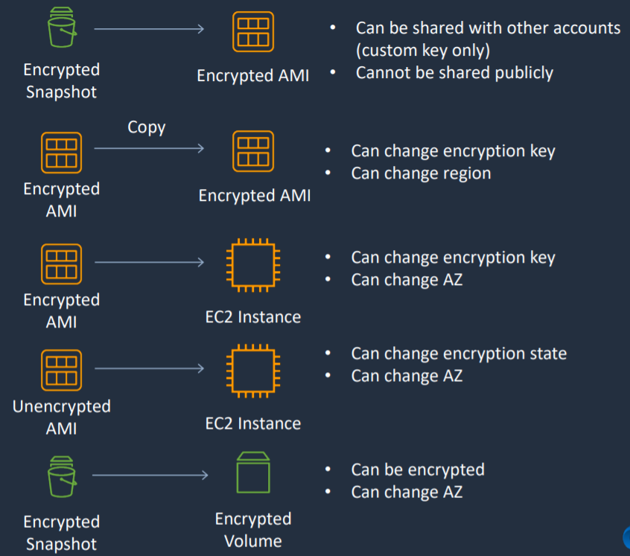

1. When a snapshot is created from EBS Volume, encryption state is retained and the snapshot is in same region. I won’t be in AZ now but will be in same region.
2. If we take a snapshot and then we want to copy it and create an encrypted snapshot, we can do that. We now have a encrypted snapshot and while we do this we can also optionally change the region in which we want the encrypted snapshot.
3. If we have an unencrypted snapshot, we can create an encrypted volume. So at the time we create a volume from the snapshot, we can choose to enrypt it. And we can also change the AZ, but not the region.
4. If we have an unencrypted snapshot, we can also create an AMI. However, it cannot be encrypted. When we create an AMI it is backed by the snapshot. In other words, this AMI is connected to this snapshot and this is not encrypted, so the AMI cannot be encrypted. You can share AMI with other accounts and share it publicly as well
5. If we have a snapshot and we want a copy to create another snapshot. In this case, we can change the encryption key if it is encrypted and we can change regions.
6. From an encrypted snapshot, we can create an encrypted AMI. This can be shared with other account, but only if you have a custom encryption key. They cannot be shared publicly
7. From an encrypted AMI, we can copy it to create another encrypted AMI. When we do that we can change encryption key and region.
8. From encrypted AMI we can create EC2 Instance. You can change the encryption key and AZ as you create the instance.
9. From unencrypted AMI we can create EC2 Instance. You can change the encryption key and AZ as you create the instance.
10. From encrypted snapshot, encrypted volume can be created. You can change AZ at this time

DLM (Data Lifecycle Management)

1. Way to automate our backup, so it creates the snapshots and AMIs from our EBS volumes automatically for us
2. Automates the creation, retention and deletion of EBS Snapshots and EBS-backed AMIs
3. DLM helps with the following
   1. Protects valuable data by enforcing a regular backup
   2. Create standardized AMIs that can be refreshed at regular intervals
   3. Retain backups as required by auditors or internal compliance
   4. Reduce storage costs by deleting outdated backups
   5. Create disaster recovery backup policies that back up data to isolated accounts

Instance Store

1. Instance store volumes are high performance local disks that are physically attached to the host computer on which an EC2 instance runs
2. Instance Stores are ephemeral which means the data is lost when powered off (non-persistent)
3. Instance Stores are ideal for temporary storage of information that changes frequently, such as buffers, caches or scratch data
4. Instance store volume root devices are created from AMI templates stored on S3
5. Instance store volumes cannot be deleted/reattached

Amazon Machine Image (AMIs)

1. Provides the information required to launch an instance
2. An AMI includes the following
   1. One or more EBS snapshots
   2. Launch permissions that control which AWS accounts can use the AMI to launch instances
   3. A block device mapping that specifies the volumes to attach when it is launched
3. AMIs come in three main categories
   1. Community AMI
   2. AWS Marketplace AMIs
   3. My AMIs

EBS Snapshots

1. Snapshots capture a point-in-time state of an instance
2. Cost-effective and easy backup strategy
3. Can be used to migrate a system to a new AZ or region
4. Can be used to convert an unencrypted volume to an encrypted volume
5. Snapshots are stored on Amazon S3
6. EBS volumes are AZ specific but snapshots are region specific

EC2 Image Builder

1. Tool that we can use to actually create, customize, manage and distribute our EC2 images

RAID with EBS

Using RAID with EBS

1. RAID stands for Redundant Array of Independent disks
2. Not provided by AWS, you must configure through your OS
3. RAID 0 and RAID 1 are potential options on EBS
4. RAID 5 and RAID 6 are not recommended by AWS
5. RAID 0 is used for striping data across disks (performance)
   1. Use 2 or more disks
   2. If one disk fails, the entire RAID set fails
6. RAID 1 is used for mirroring data across disks (redundancy/fault tolerance)
   1. If one disk fails, the other disk is till working
   2. Data gets sent to two EBS volumes at the same time

EBS Encryption

1. You can encrypt both the boot and data volumes of an EC2 instance
2. The following are encrypted
   1. Data at rest inside the volume
   2. All data moving between the volume and the instance
   3. All snapshots created from the volume
   4. All volumes created from those snapshots
3. Encryption is supported by all EBS volume types
4. All instance families support encryption

Amazon Elastic File System (EFS)

AWS DataSync

1. Provides a fast and simple way to securely sync existing file systems into Amazon EFS
2. Securely and efficiently copies files over the Internet or an AWS Direct Connect connection
3. Copies file data and file system metadata such as ownership, timestamps and access permissions

Amazon FSx

1. Amazon FSx provides fully managed third-party file systems
2. Amazon FSx provides you with two file systems to choose from
   1. Amazon FSx for Windows File Server for Windows based applications
   2. Amazon FSx for Lustre for compute-intensive workloads (HPC)
3. Amazon FSx for Windows File Server
   1. Provides fully managed native Microsoft Windows file system
   2. Full support for the SMB protocol, Windows NTFS and Microsoft Active Directory (AD) integration
   3. Supports Windows-native file system features
      1. Access Control Lists (ACLs), shadow copies and user quotas
      2. NTFS file systems that can be accessed from up to thousands of compute instances using the SMB protocol
   4. High availability: replicates data within an AZ
   5. Multi-AZ: file systems include an active and standby file server in separate AZs
4. Amazon FSx for Lustre
   1. High Performance file system optimized for fast processing of workloads such as
      1. Machine learning
      2. High Performance Computing (HPC)
      3. Video processing
      4. Financial processing
      5. Electronic design automation (EDA)
   2. Works natively with S3, letting you to transparently access your S3 objects as files
   3. Your S3 objects are presented as files in your file system, and you can write your results back to S3
   4. Provides a POSIX-complaint file system interface

AWS Storage Gateway

1. Service that enables you to connect your on-premises storage to AWS
2. Types of Gateway
   1. File Gateway
      1. Provides a virtual on-premises file server
      2. Store and retrieve files as objects in Amazon S3
      3. Use with on-premises applications, and EC2 based applications that need file storage in S3 for object-based workloads
      4. File gateway offers SMB or NFS based access to data in Amazon S3 with local caching
   2. Volume Gateway
      1. Supports block-based volumes
      2. Block storage
      3. iSCSI protocol
      4. Cached Volume Mode: the entire dataset is stored on S3 and a cache of the most frequently accessed data is cached on-site
      5. Stored Volume Mode: the entire dataset is stored on-site and is asynchronously backed up to S3
   3. Tape Gateway
      1. Used for backup with popular backup software
      2. Each gateway is preconfigured with a media changer and tape drives. Supported by NetBackup, Backup Exec, Veeam, etc
      3. When creating virtual tapes, you select one of the following sizes: 100GB, 200 GB, 400 GB, 800 GB, 1.5 TB and 2.5 TB
      4. A tape gateway can have up to 1500 virtual tapes with a maximum aggregate capacity of 1 PB
      5. All data transferred between the gateway and AWS storage is encrypted using SSL
      6. All data stored by tape gateway in S3 is encrypted server-side with Amazon S3-Managed Encryption Keys (SSE-S3)

Architecture Patterns- Block and File Storage

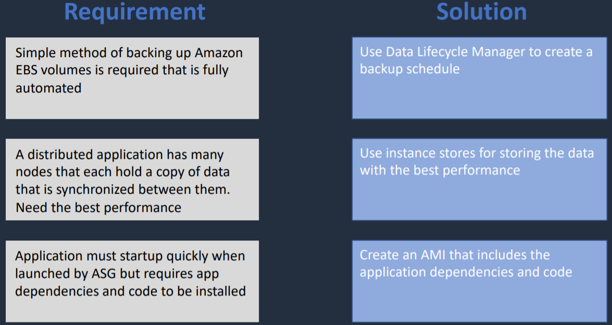

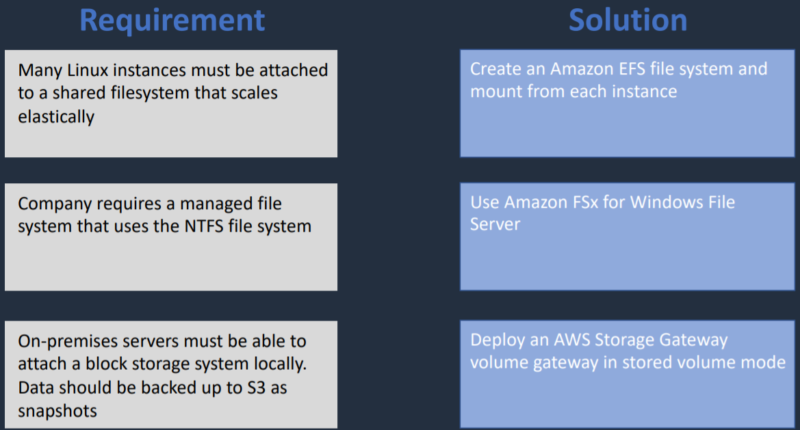

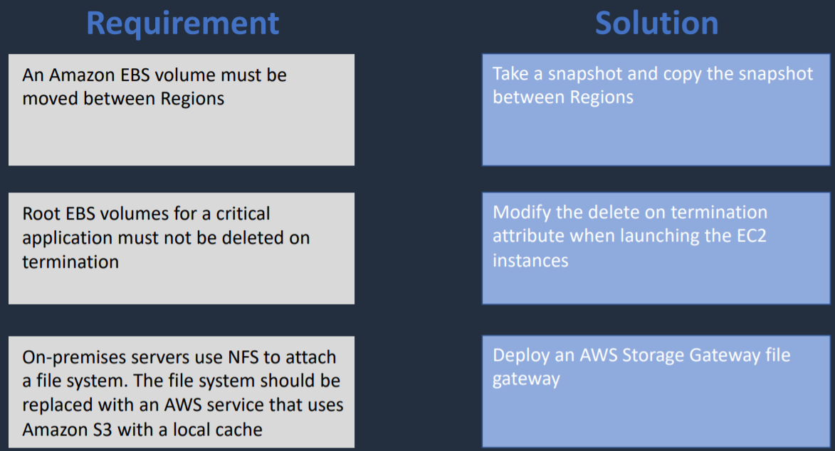

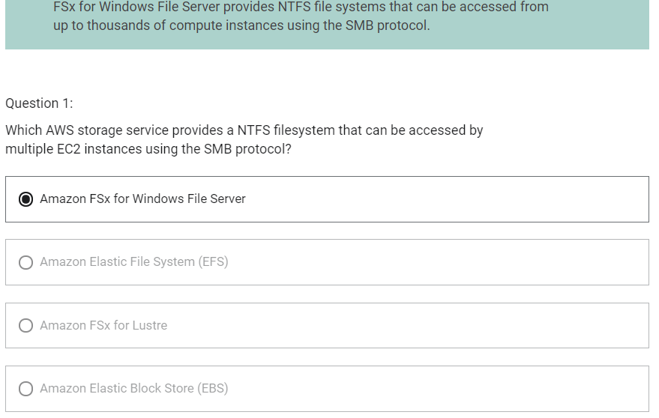

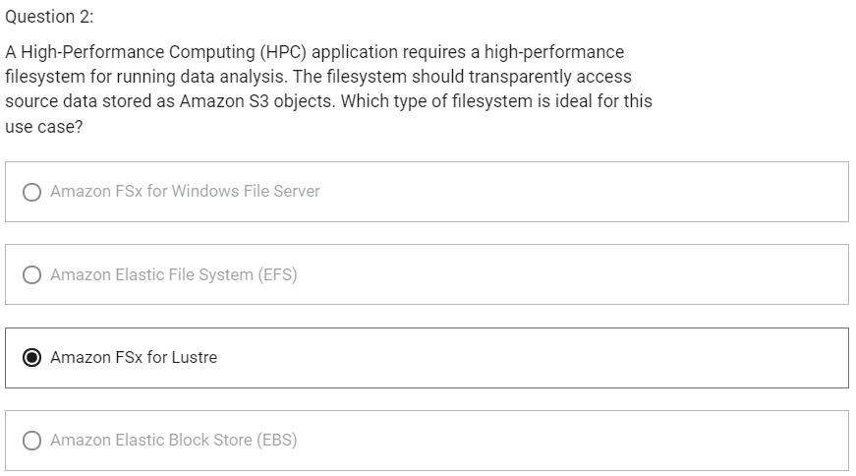

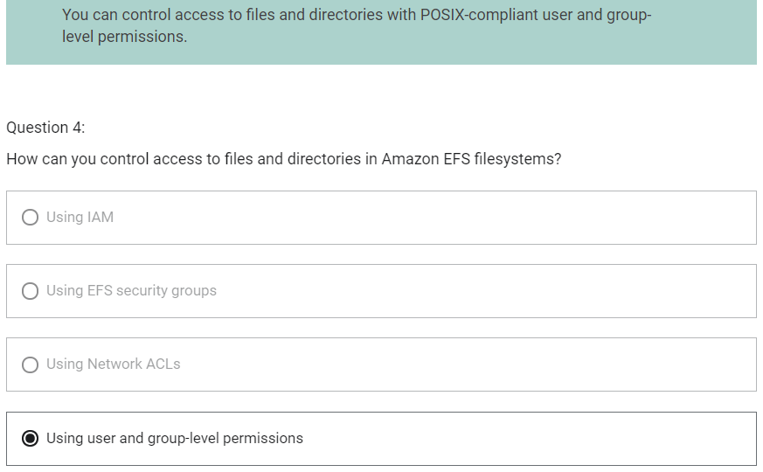

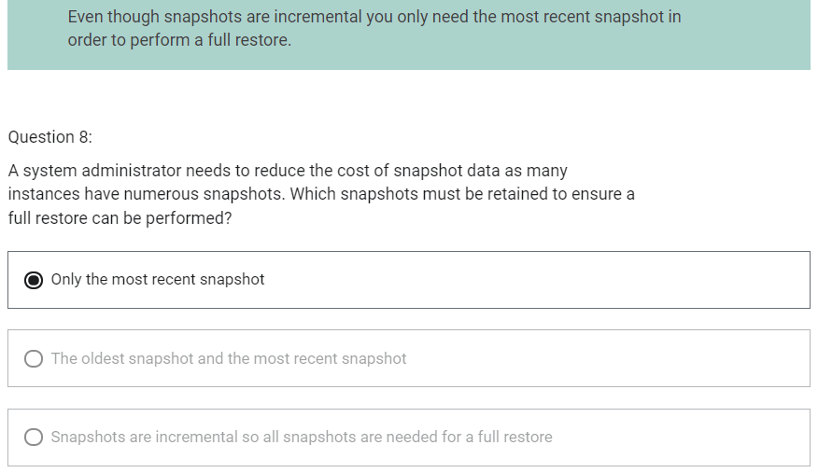

Docker Container and ECS

Amazon ECS Key Features

1. Serverless with AWS Fargate
2. Fully managed container orchestration
3. Docker support
4. Windows container support
5. ELB integration
6. Amazon ECS Anywhere – works on-premises

Amazon ECS Components

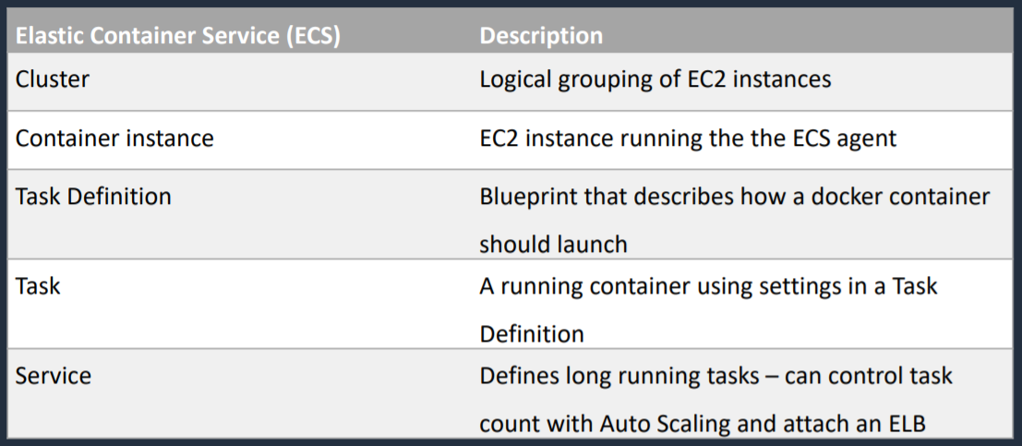

ECS Launch Type

1. Determines the type of infrastructure on which your tasks and services are hosted
2. EC2 Launch Type
   1. You explicitly provision EC2 Instances
   2. You are responsible for managing EC2 instances
   3. Charged per running EC2 instance
   4. There is support for few different storage services like Docker volumes, EFS and FSx for Windows File Server
   5. You handle cluster optimization
   6. More granular control over infrastructure
3. Fargate Launch Type
   1. Fargate automatically provisions resources
   2. Fargate provisions and manages compute
   3. Charged for running tasks
   4. EFS integration
   5. Fargate handles cluster optimization
   6. Limited control, infrastructure is optimized

ECS Images

1. Containers are created from a read-only template called an image which has the instructions for creating a Docker container
2. Images are built from a Dockerfile
3. Only Docker containers are currently supported
4. An image contains the instructions for creating a Docker container
5. Images are stored in a registry such as DockerHub or AWS Elastic Container Registry (ECR)
6. ECR is a managed AWS Docker Registry service that is secure, scalable and reliable

ECS Tasks

1. A task definition is required to run Docker containers in Amazon ECS
2. A task definition is a text file in JSON format that describes one or more containers, up to a maximum of 10
3. Task definitions use Docker images to launch containers
4. You specify the number of tasks to run (i.e. the number of containers)

ECS Clusters

1. ECS Clusters are a logical grouping of container instances that you can place tasks on
2. ECS allows the definition of a specified number (desired count) of tasks to run in the cluster
3. Clusters can contain tasks using the Fargate and EC2 launch type
4. Each container instance may only be part of one cluster at a time
5. You can create IAM policies for your clusters to allow or restrict users’ access to specific clusters

ECS Container Agent

1. The ECS container agent allows container instances to connect to the cluster
2. The container agent runs on each infrastructure resource on an ECS cluster
3. ECS container agent is included in the Amazon ECS optimized AMI
4. Linux and Windows based
5. For non-AWS linux instances to be used on AWS you must manually install the ECS container agent

IAM Role with ECS

1. IAM Instance Role
   1. Provide permissions to the host
2. IAM Task Role
   1. Provide permissions to the container
3. Container Instances have access to all of the permissions that are supplied to the container instance role through instance metadata

IAM Role with Fargate

1. IAM Task Role
   1. With Fargate launch type, only IAM task roles can be applied

AWS Backup

1. Service that you can use to create your schedules for backing up multiple different AWS resources.
2. It can be used for volumes, databases and file systems as well.

Auto Scaling for ECS

Two types of scaling

1. Service auto scaling

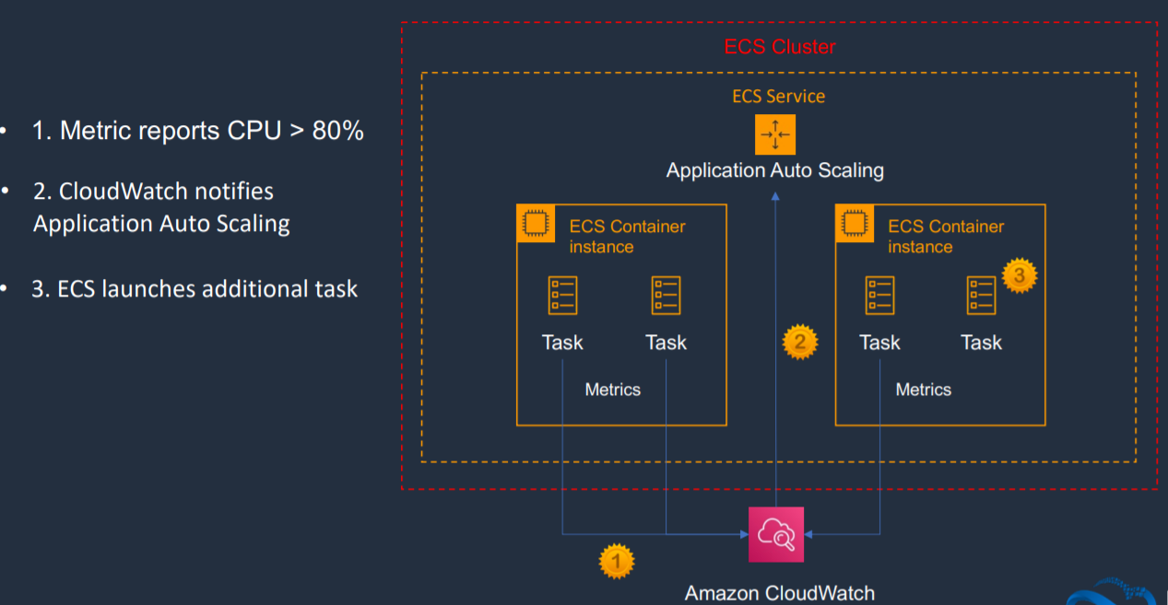

* 1. Automatically adjusts the desired task count up and down using Application Auto Scaling service
  2. Supports target tracking, step and scheduled scaling policies

1. Cluster auto scaling
   1. Uses a Capacity Provider to scale number of EC2 cluster instances using EC2 Auto Scaling
   2. Uses an ECS resource type called a Capacity Provider
   3. A Capacity Provider can be associated with an EC2 Auto Scaling Group (ASG)

Amazon ECS with ALB

1. With Amazon ECS, we can distribute incoming connection using Load Balancer

Amazon EKS

1. Use cases
   1. Use when you need to standardize container orchestration across multiple environments using a managed Kubernetes implementation
   2. Hybrid Deployment – manage Kubernetes clusters and applications across hybrid environment (AWS + on-premises)
   3. Batch processing
   4. Machine Learning
   5. Web Applications

ECS vs EKS

Architecture Pattern – ECS

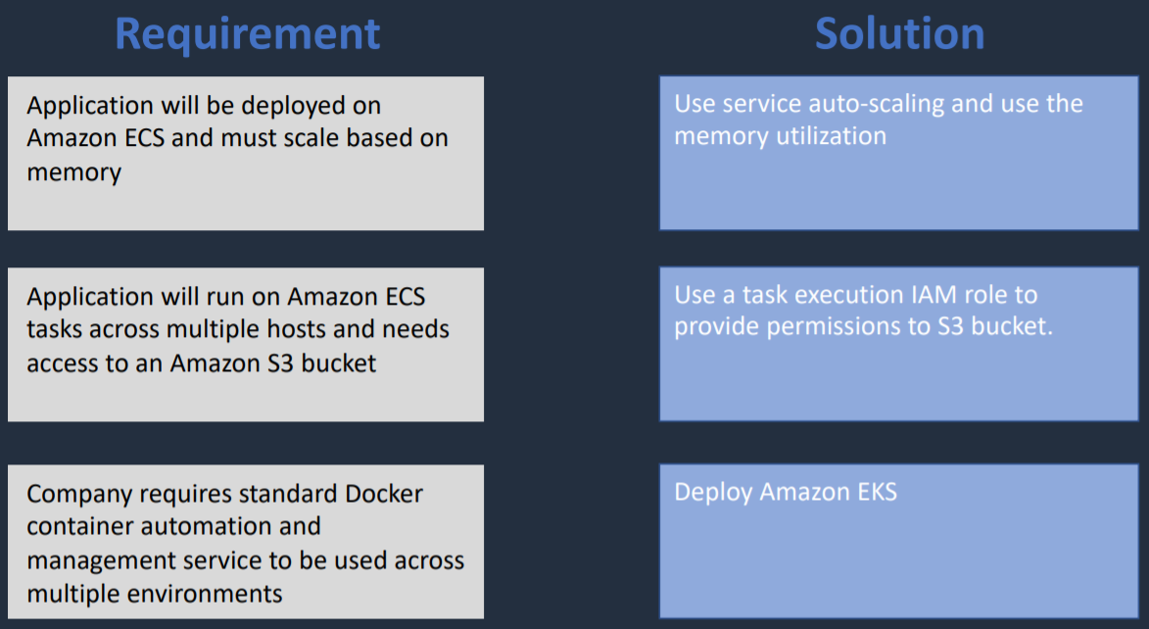

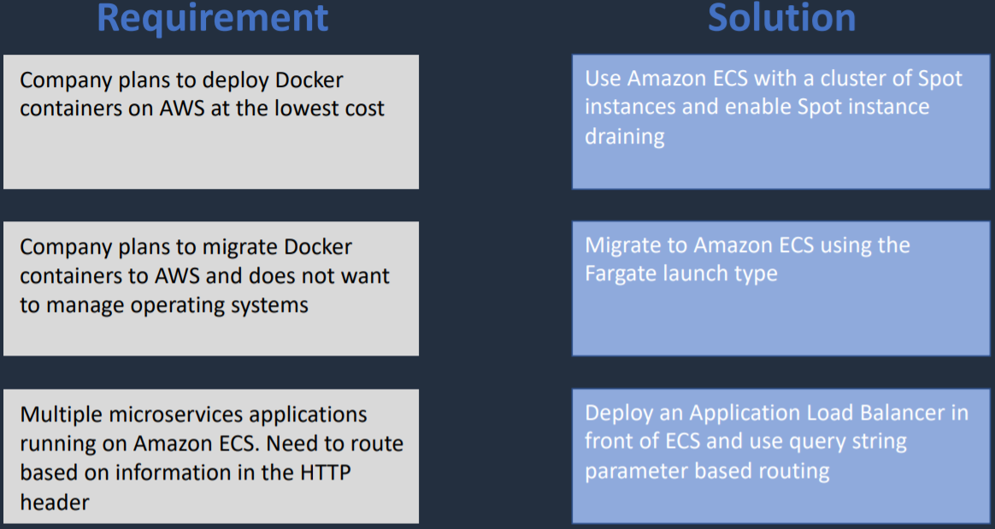

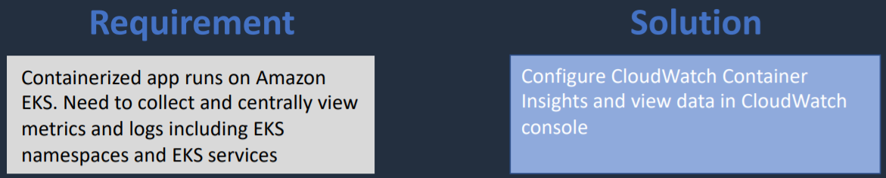

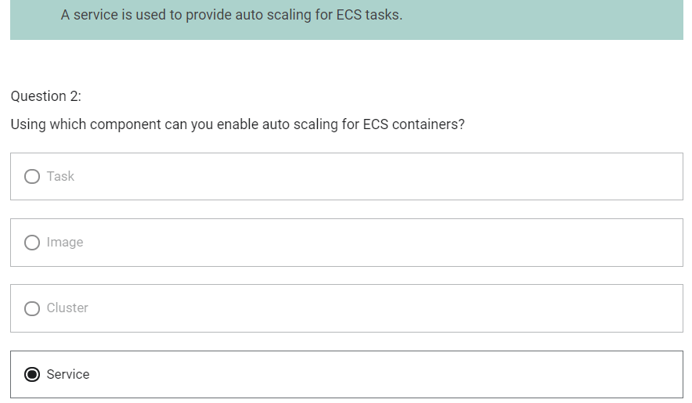

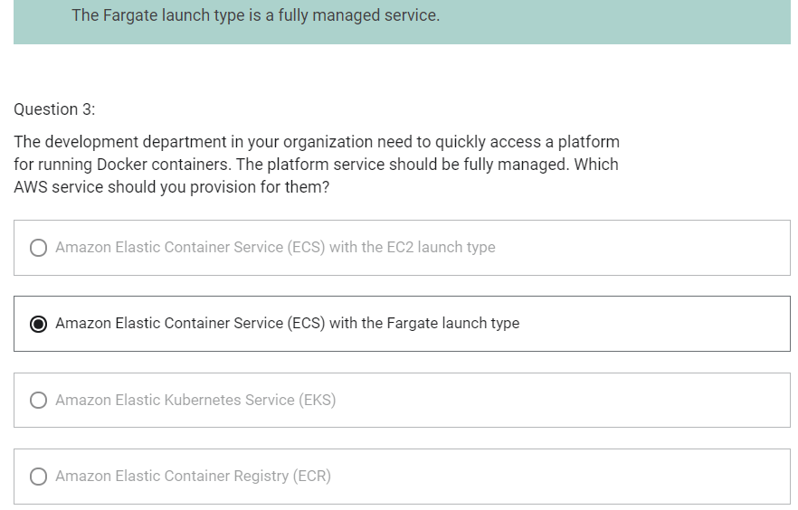

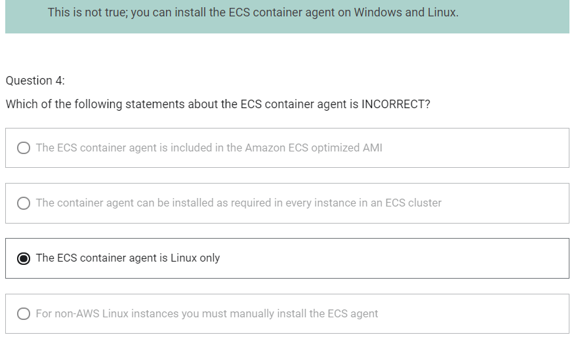

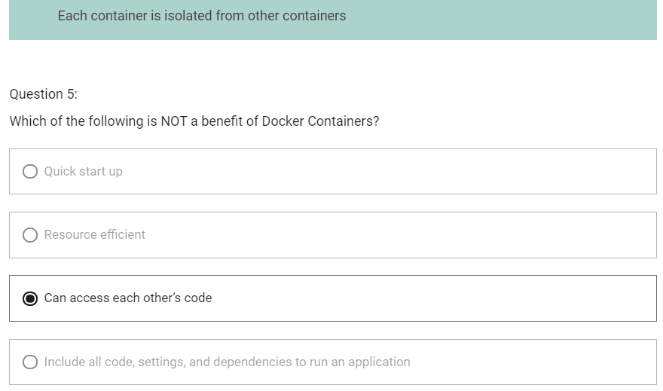

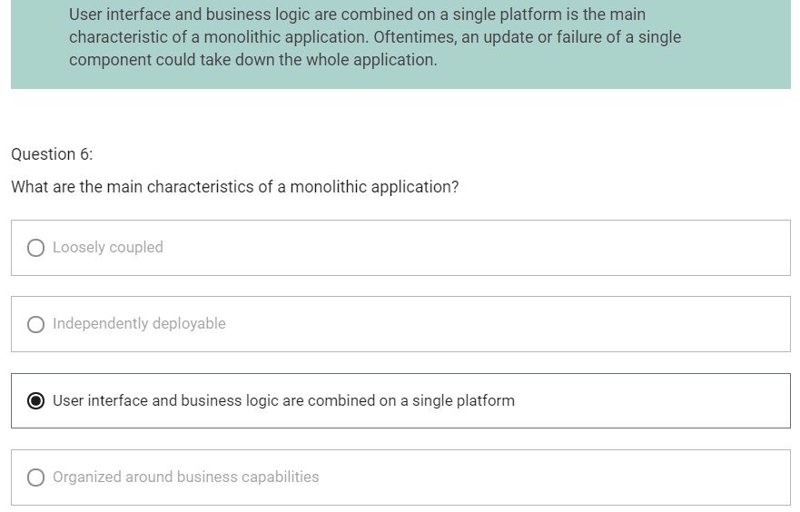

Serverless Architecture

Lambda

1. You specify the amount of memory you need to allocate to your lambda functions
2. AWS lambda allocates CPU power proportional to the memory you specify using the same ratio as a general purpose EC2 instance type
3. Lambda is an event driven compute service

Lambda Functions Invocations

1. Synchronous Invocation
   1. This can come from CLI, SDK, API Gateway
   2. Result is returned immediately
   3. Error handling must happen on the client side (retry, exponential backoff, etc)
   4. If it does not work, application should be coded to try again
   5. Exponential backoff-> try processing after some time
2. Asynchronous Invocation
   1. This can come from S3, SNS, CloudWatch Events
   2. Lambda will retry upto 3 times
   3. Processing must be idempotent (due to retries) -> should process same result each time processed
3. Event source mapping
   1. SQS, Kinesis Data Streams, DynamoDB Streams
   2. Lambda does polling
   3. Records are processed in order (except for SQS Standard)

Lambda Function Concurrency

1. More lambda functions will be executed as more function gets invoked without completion of prior invocation
2. Burst concurrency quotas
   1. Limit number of lambda invocations in parallel
   2. Count varies depending on which region you are in
   3. If the concurrency limit is exceeded throttling occurs with error “Rate exceeded” and 429 “TooManyRequestsException”

Application Integration Services

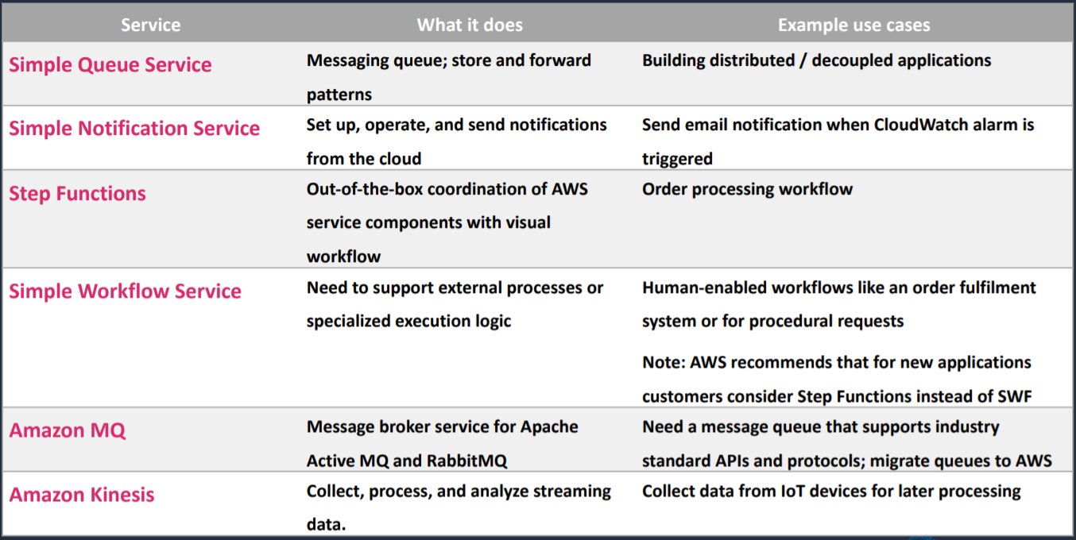

Kinesis vs SQS vs SNS

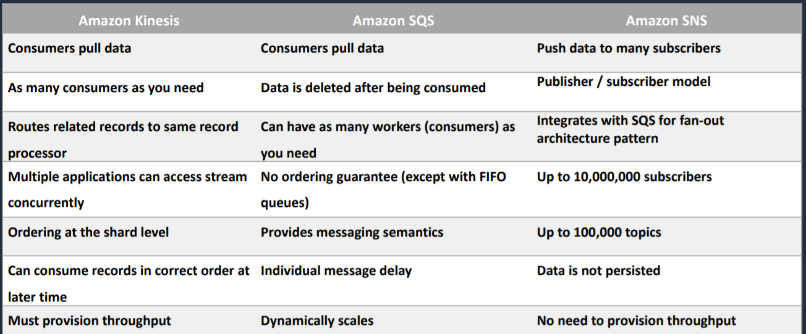

SQS

SQS Queue Types

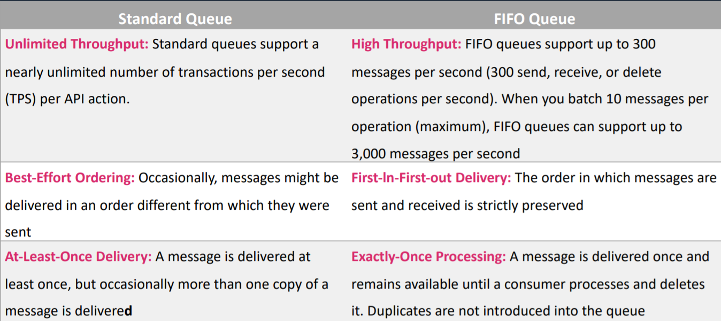

FIFO Queues require the Message Group ID and Message Duplication ID parameters to be added to messages

Message Group ID – the tag that specifies that a message belongs to a specific message group messages that belong to the same message group are guaranteed to be processed in a FIFO manner

Message Deduplication ID – The token used for deduplication of messages within the deduplication interval

SQS Dead Letter Queue

1. The main task of a dead letter queue is handling message failure
2. A dead-letter queue lets you set aside and isolate messages that cannot be processed correctly to determine why their processing did not succeed
3. It is not a queue type, it is a standard or FIFO queue that has been specified as dead-letter queue in the configuration of another standard or FIFO

SQS Long Polling vs Short Polling

1. SQS Long Polling is a way to retrieve messages from SQS queues – waits for messages to arrive
2. SQS Short Polling return immediately (eve if the message queue is empty)
3. SQS Long Polling can lower costs
4. SQS Long Polling can be enabled at the queue level or at API level using WaitTimeSeconds parameter
5. SQS Long Polling is in effect when the Receive Message Wait Time is a value greater than 0 seconds and up to 20 seconds

Amazon SQS + Amazon SQS Fan out

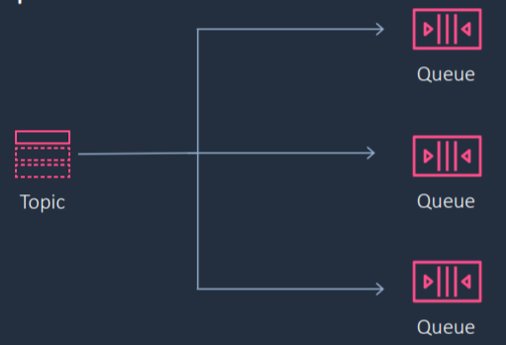

1. You can subscribe one or more Amazon SQS queues to an Amazon SNS topic
2. Amazon SQS manages the subscription and any necessary permissions
3. When you publish a message to a topic, Amazon SNS sends the message to every subscribed queue

AWS Step Functions

1. AWS Step Functions is used to build distributed applications as a series of steps in a visual workflow
2. You can quickly build and run state machines to execute the steps of your application
3. How it works
   1. Define the step of your workflow in the JSON based Amazon State Language. The visual console automatically graphs each step in the order of execution
   2. Start an execution to visualize and verify the steps of your application are operating as intended. The console highlights the real-time status of each step and provides a detailed history of every execution.
   3. AWS Step Functions operates and scales the steps of your application and underlying compute for you to help ensure your application executes reliably under increasing demand

Amazon EventBridge

1. Serverless event bus for building event-driven applications
2. Events are generated by custom applications, SaaS applications and AWS services
3. An event is a signal that a system’s state has changed
4. Route events to AWS service targets and API destinations (via HTTP endpoints)
5. AWS service targets include Lambda, SNS, SQS and API Gateway
6. With EventBridge, we have Event Sources which can be AWS Services, Custom Apps, third party SaaS Apps
7. State change on these resources get sent as events to EventBridge event bus
8. The information is then processed by rules
9. Those rules can then send information through to various destinations like Lambda functions, Kinesis data streams, or AWS Config. And those are known as targets.

Amazon API Gateway

1. Service that you can use to create application programming interfaces which are front door to your business logic or your applications on AWS
2. Supports restful APIs, including rest APIs and HTTP APIs as well as web socket APIs
3. Amazon API Gateway Deployment Types
   1. Edge-Optimized Endpoint
      1. Reduced latency for requests from around the world
   2. Regional Endpoint
      1. Reduced latency of requests that originate in the same region
      2. Can also configure your own CDN and protect with WAF
   3. Private Endpoint
      1. This will be fully within your VPC
      2. Securely expose your REST APIs only to other services within your VPC or connect via Direct Connect
4. API Gateway Integrations
   1. For a lambda function you can have
      1. Lambda proxy integration
      2. Lambda custom integration
   2. For an HTTP endpoint you can have
      1. HTTP proxy integration
      2. HTTP custom integration
   3. For an AWS service action you have the AWS integration of the non-proxy type only
5. API Gateway Caching
   1. You can add caching to API calls by provisioning an Amazon API Gateway cache and specify its size in gigabytes
   2. Caching allows you to cache the endpoint’s response
   3. Caching can reduce number of calls to the backend and improve latency of requests to the API
6. API Gateway – Throttling
   1. API Gateway sets a limit on a steady state and a burst of request submissions against all APIs in your account
   2. Limits
      1. By default, API Gateway limits the steady state request rate to 10,000 requests per second
      2. The maximum concurrent requests is 5000 requests across all APIs within an AWS account
      3. If you go over 10,000 requests per second or 5000 concurrent requests you will receive a 429 Too Many Requests error response
   3. Upon caching such exceptions, the client can resubmit the failed requests in a way this is rate limiting, while complying with the API Gateway throttling limits
7. API Gateway – Usage Plans and API Keys
   1. Usage plan can be Premium and Basic
   2. API Keys help to distinguish between premium plan and basic plan

Architecture Pattern – Serverless

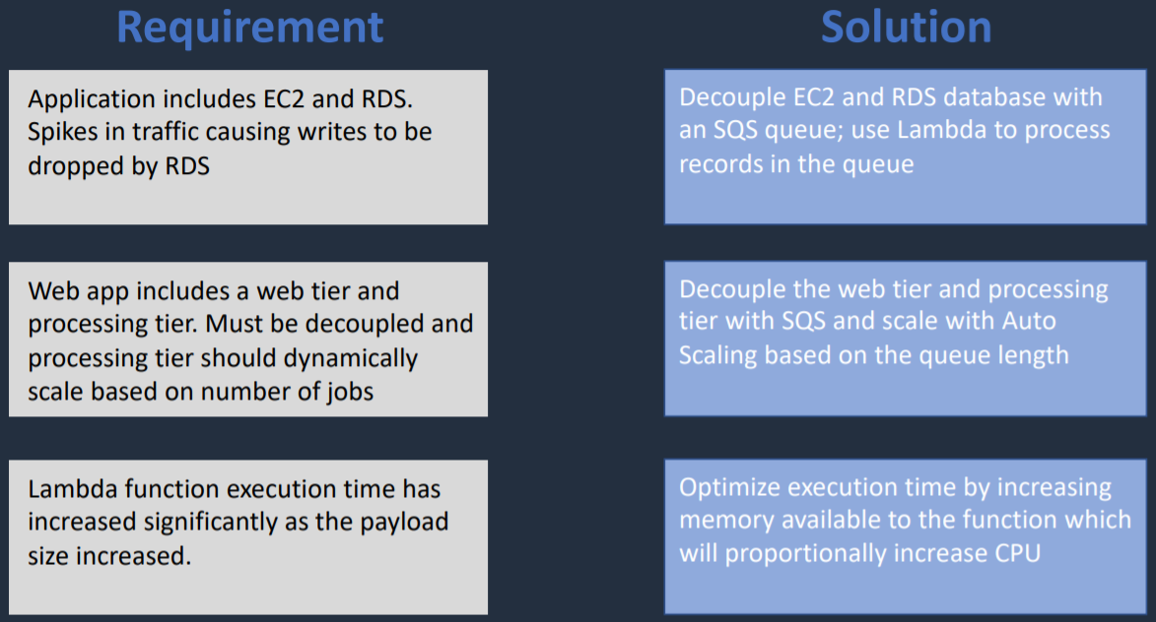

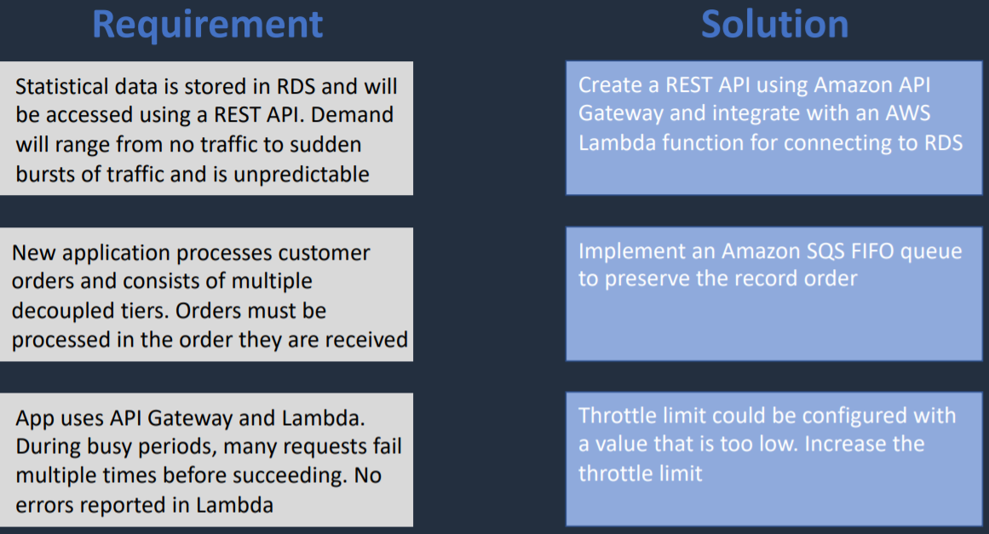

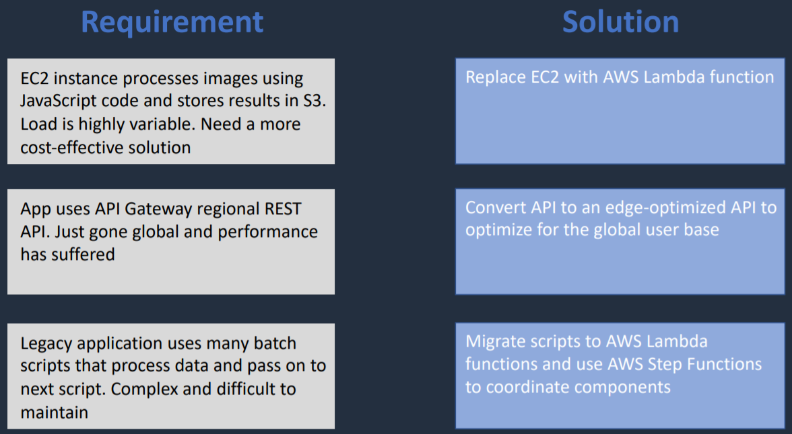

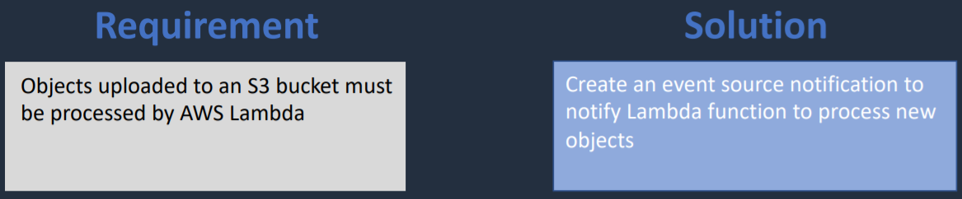

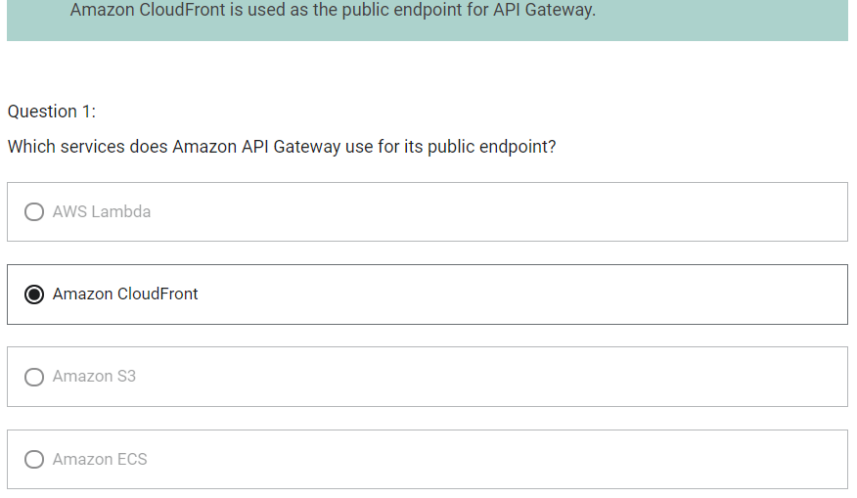

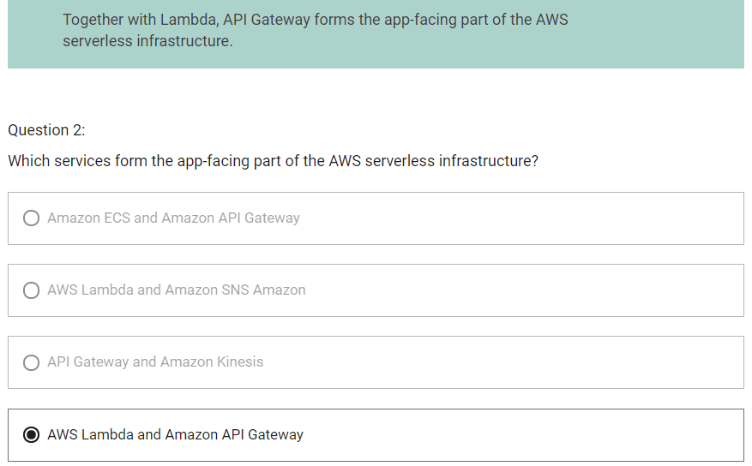

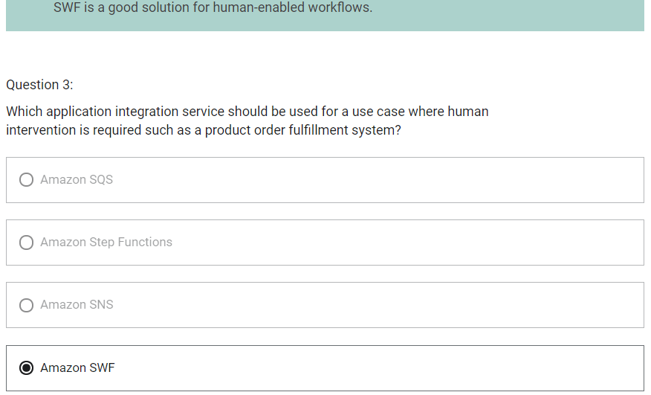

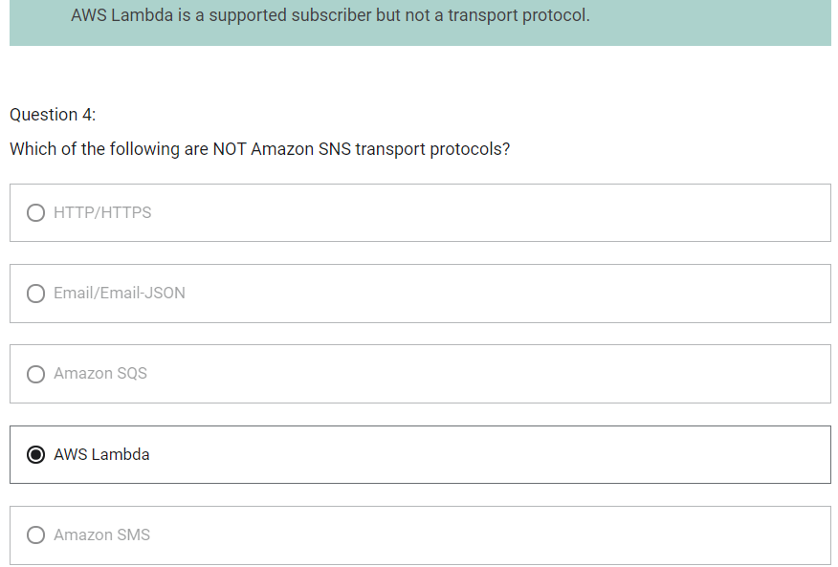

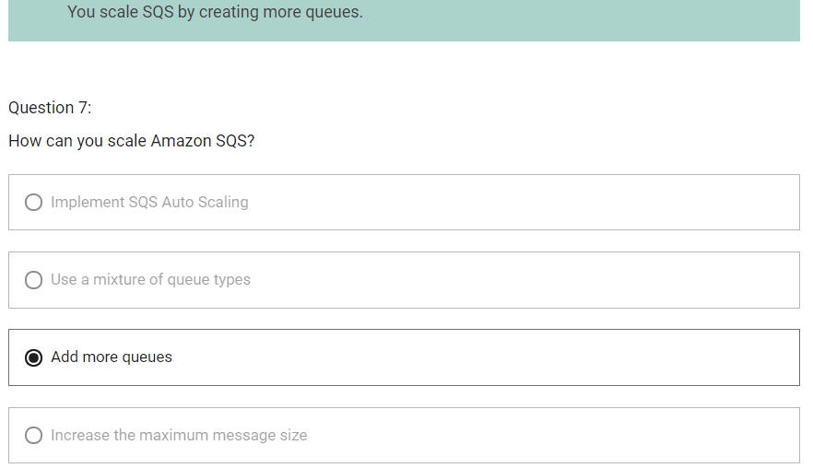

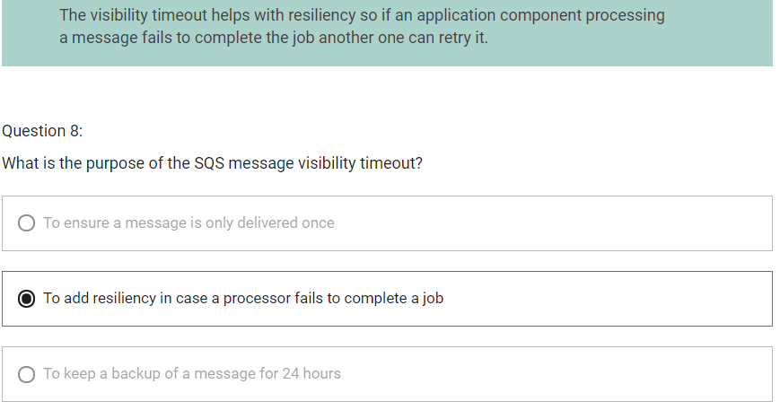

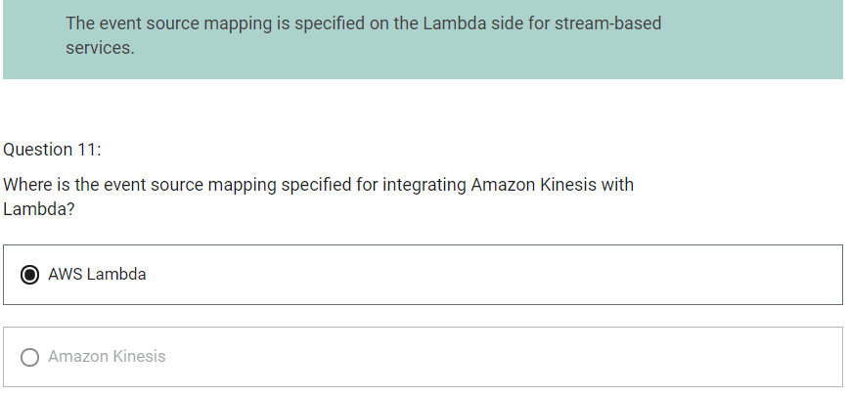

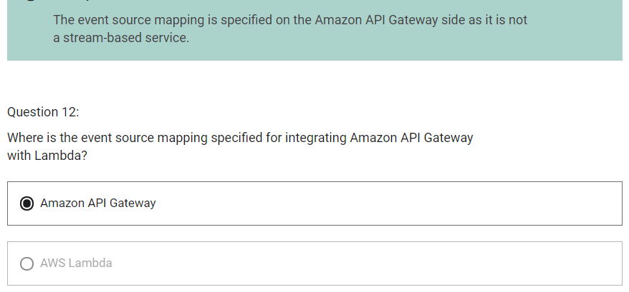

Databases and Analytics

Relational vs Non-relational

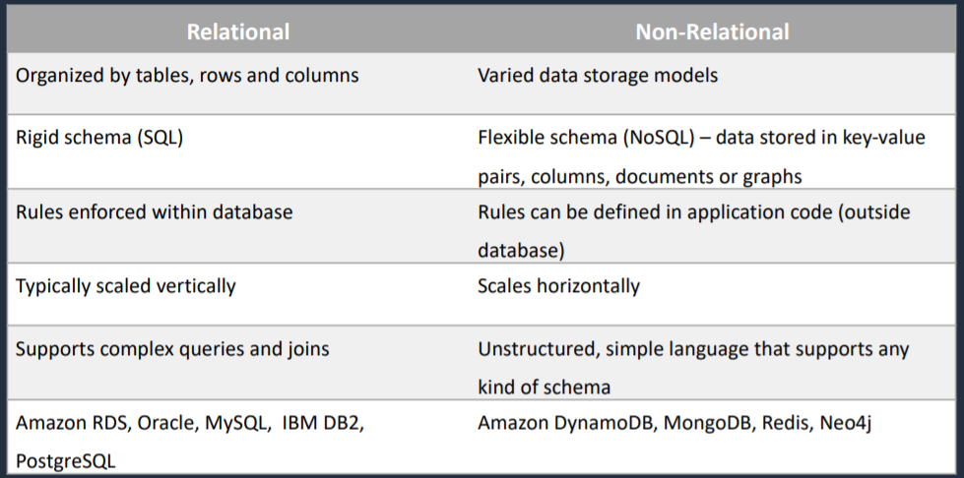

Operational vs Analytical

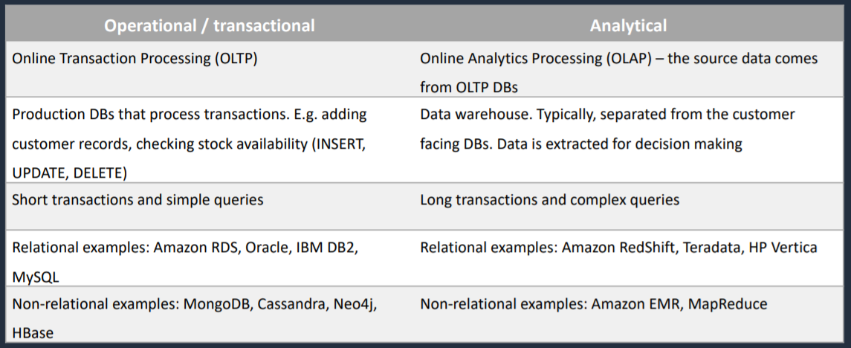

Amazon RDS

1. RDS uses EC2 instances, so you must choose an instance family/type
2. You can encrypt your Amazon RDS instances and snapshots at rest by enabling the encryption option for your Amazon RDS DB instance (during creation)
3. Encryption uses AWS Key Management Service (KMS)
4. Scales up by increasing instance size
5. Read Replicas option for read heavy workloads (scales out for reads/queries only)
6. Disaster Recovery with Multi-AZ option

Amazon RDS Multi-AZ and Read Replicas

|  |  |
| --- | --- |
| Multi-AZ Deployments | Read Replicas |
| a) Synchronous replication – highly durable | a) Asynchronous replication – highly scalable |
| b) only database engine on primary instance is active | b) All read replicas are accessible and can be used for read scaling |
| c) automated backups are taken from standby | c) No backups configured by default |
| d) Always span two AZ within a single region | d) can be within an AZ, Cross-AZ or Cross-Region |
| e) Database engine version upgrades happen on primary | e) Database engine version upgrade is independent from source instance |
| f) Automatic failover to standby when a problem is detected | f) Can be manually promoted to a standalone database instance |

Amazon RDS Manual Backups (Snapshot)

1. Backs up the entire database instance, not just individual databases
2. For single AZ database instances there is a brief suspension of I/O
3. For multi AZ Server, I/O activity is briefly suspended on primary
4. For Multi-AZ MariaDB, MySQL, Oracle and PostgreSQL the snapshot is taken from the standby
5. Snapshots do not expire (no retention period)

Amazon RDS Maintenance Windows

1. Operating system and database patching can require taking the database offline
2. These tasks take place during a maintenance window
3. By default, a weekly maintenance window is configured. But you can choose your own maintenance window.

Amazon RDS Security

1. Encryption at rest can be enabled – includes database storage, backups, read replicas and snapshots
2. You can only enable encryption for an Amazon RDS DB instance when you create it, not after the database instance is created
3. DB Instances that are encrypted cannot be modified to disable encryption
4. Uses AES 256 encryption and encryption is transparent with minimal performance impact
5. RDS for Oracle and SQL Server is also supported using Transparent Data Encryption (TDE) (may have performance impact)
6. You cannot have
   1. An encrypted read replica of an unencrypted database instance
   2. An unencrypted read replica of an encrypted database instance
7. Read replicas of encrypted primary instances are encrypted
8. The same KMS key is used if in the same region as the primary
9. If the read replica is in a different region, a different KMS key is used
10. You cannot restore an unencrypted backup or snapshot to an encrypted database instance

Amazon Aurora

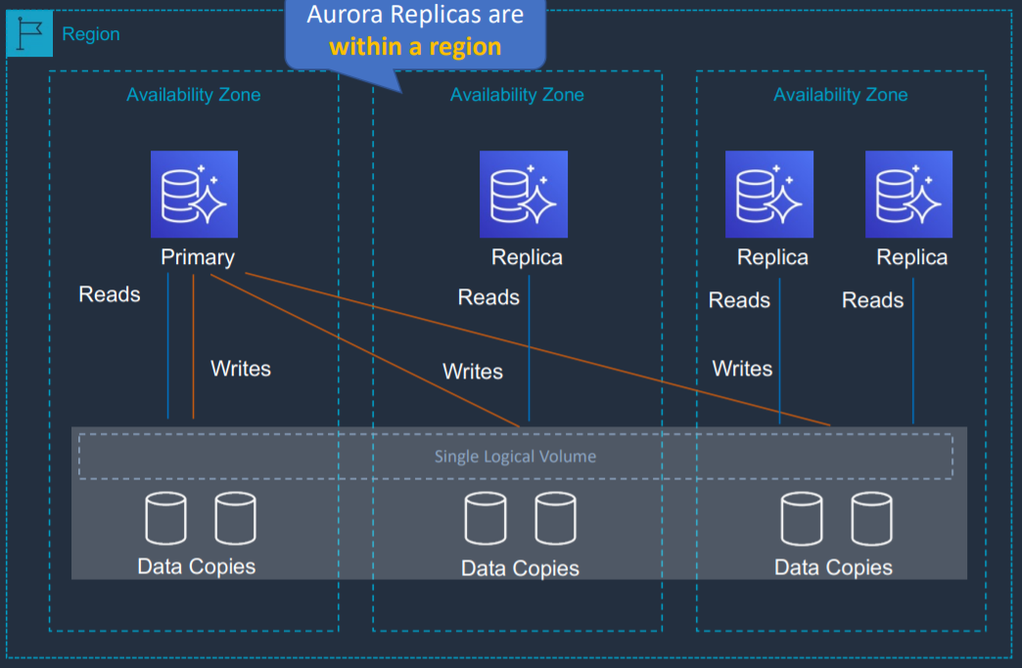

1. My-SQL and PostgreSQL compatible relational database built for the cloud
2. It is upto 5 times faster than standard MySQL databases and 3 times faster than standard PostgreSQL databases
3. Amazon Aurora features a distributed, fault-tolerant, self-healing storage system that auto scales up to 128 TB per database instance
4. Aurora replicas can be in different AZ but is in same region
5. Aurora Fault Tolerance
   1. Fault tolerance across 3 AZs
   2. Single logical volume
   3. Aurora Replicas scale-out read requests
   4. Up to 15 aurora replicas with sub-10 ms replica lag
   5. Aurora replicas are independent endpoints
   6. Can promote Aurora Replica to be a new primary or create new primary
   7. Set priority on Aurora Replicas to control order of promotion
   8. Can use Autoscaling to add replicas

Aurora Key Features

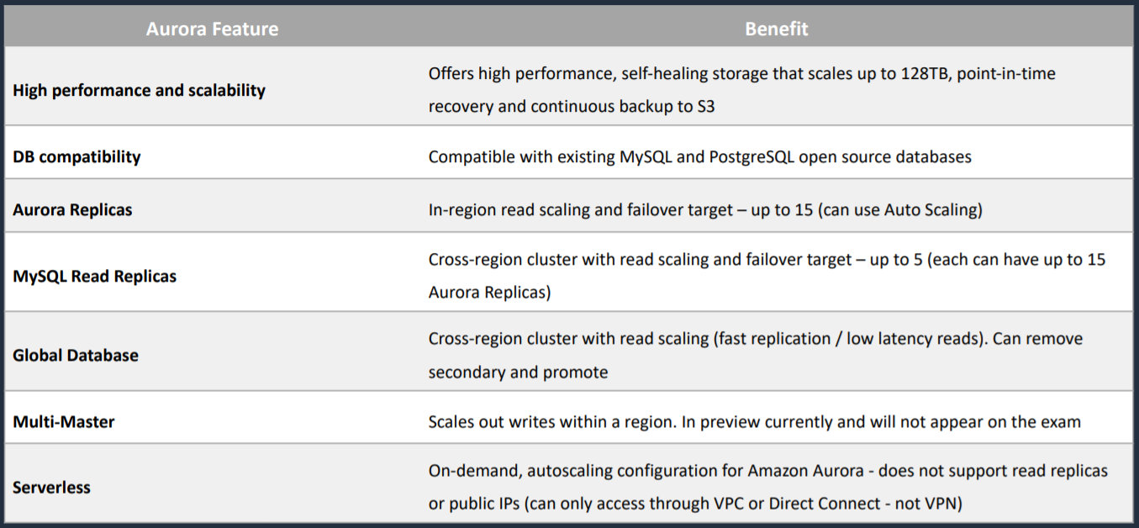

Amazon Aurora Replicas

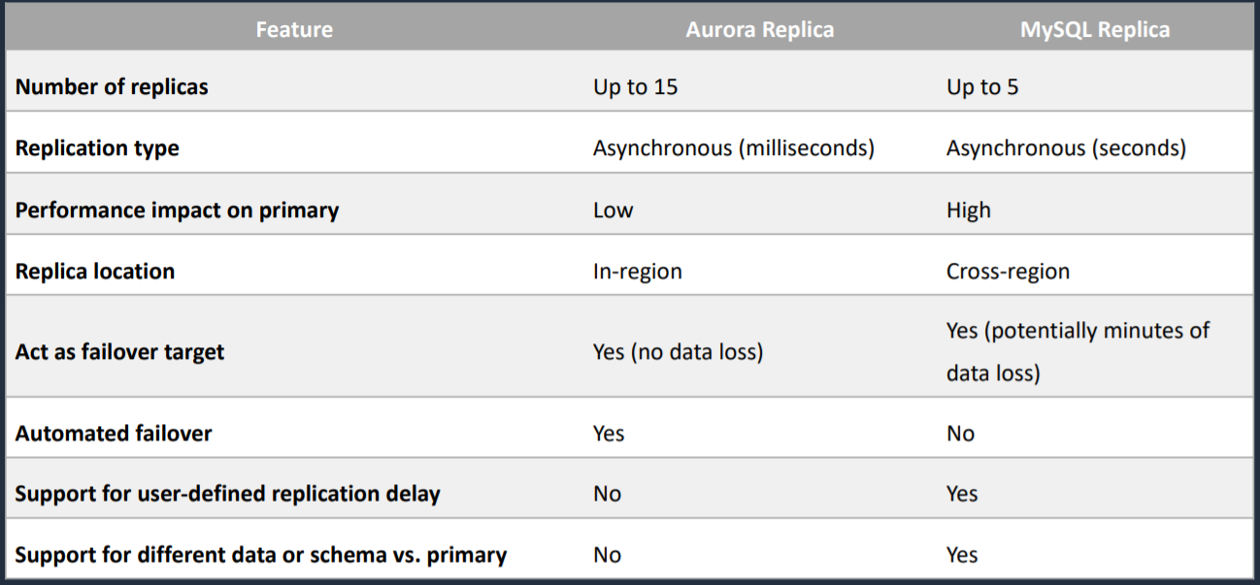

Aurora Global Database

1. We have a primary region and we have reads and writes happening and then a secondary region where you just have reads and then we have asynchronous replication
2. It is the way of having a database in multiple regions but it is only a read-only database in the secondary region

Aurora Multi-Master

1. All modes allow read/writes
2. Available for MySQL only
3. Up to four read/write nodes
4. Single region only
5. You cannot have cross region replicas
6. Can work with active-active and active-passive workloads
7. Can restart read/write database instance without impacting other insatnces

Amazon RDS Anti-Patterns and Alternatives

When not to use Amazon RDS

1. Anytime you need a database type other than
   1. MySQL
   2. MariaDB
   3. SQL Server
   4. Oracle
   5. PostgreSQL
2. You need root access to the OS (e.g. install software such as management tools)
3. Lots of large binary objects (BLOBs) -> S3
4. Automated Scalability -> DynamoDB
5. Name/Value data structure -> DynamoDB
6. Data is not well structured or unpredictable -> DynamoDB
7. Other database platforms like IBM DB2 or SAP HANA -> EC2
8. Complete control over the database -> EC2

Amazon ElastiCache

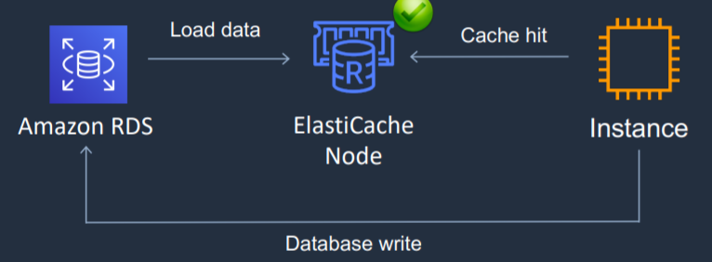

1. In-memory database and is used for caching data that comes from other database
2. Fully managed implementation of Redis and Memcached database engine
3. It is a key/value store
4. In-memory database offering high performance and low latency
5. Can be put in front of databases such as RDS and DynamoDB
6. ElastiCache nodes run on Amazon EC2 instances, so you do need to choose an instance type when you launch your database cluster
7. Use cases
   1. Data that is relatively static and frequently accessed
   2. Applications that are tolerant of stale data ‘data is slow and expensive to get compared to cache retrieval
   3. Data is slow and expensive to get compared to cache retrieval
   4. Require push-button scalability for memory, writes and reads
   5. Often used for storing session state

ElastiCache Redis vs Memcached

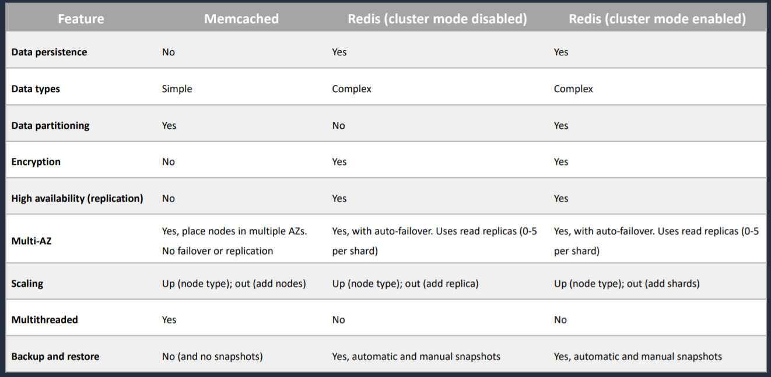

Scaling ElastiCache

Memcached

1. Add nodes to a cluster
2. Scale vertically – must create a new cluster manually

Redis

1. Cluster mode disabled
   1. Add replica or change node type – creates a new cluster and migrates data
2. Cluster mode enabled
   1. Online resharding to add or remove shards; vertical scaling to change node type
   2. Offline resharding to add or remove shards change node type or upgrade engine (more flexible than online)

Amazon DynamoDB

1. Serverless NoSQL database
2. Key/value store and document store
3. Non-relational, key-value type of database
4. Push button scaling
5. Can achieve ACID compliance with DynamoDB Transactions
6. Data is synchronously replicated across 3 AZs in a region
7. Provides two read models
   1. Eventually consistent reads (default)
   2. Strongly consistent reads
8. There are two pricing models for DynamoDB
   1. On-demand capacity mode: DynamoDB charges you for the data reads and writes your application performs on your tables
   2. Provisioned capacity mode: you specify the number of reads and writes per second that you expect your application to require (can use Auto Scaling)
9. DynamoDB Time to Live (TTL)
   1. TTL lets you define when items in a table expire so that they can be automatically deleted from the database
   2. With TTL enabled on a table, you can set a timestamp for deletion on a per-item basis
   3. No extra cost and does not use WCU (Write Capacity Unit)/RCU (Read Capacity Unit)
   4. Helps reduce storage and manage the table size over time

DynamoDB Features

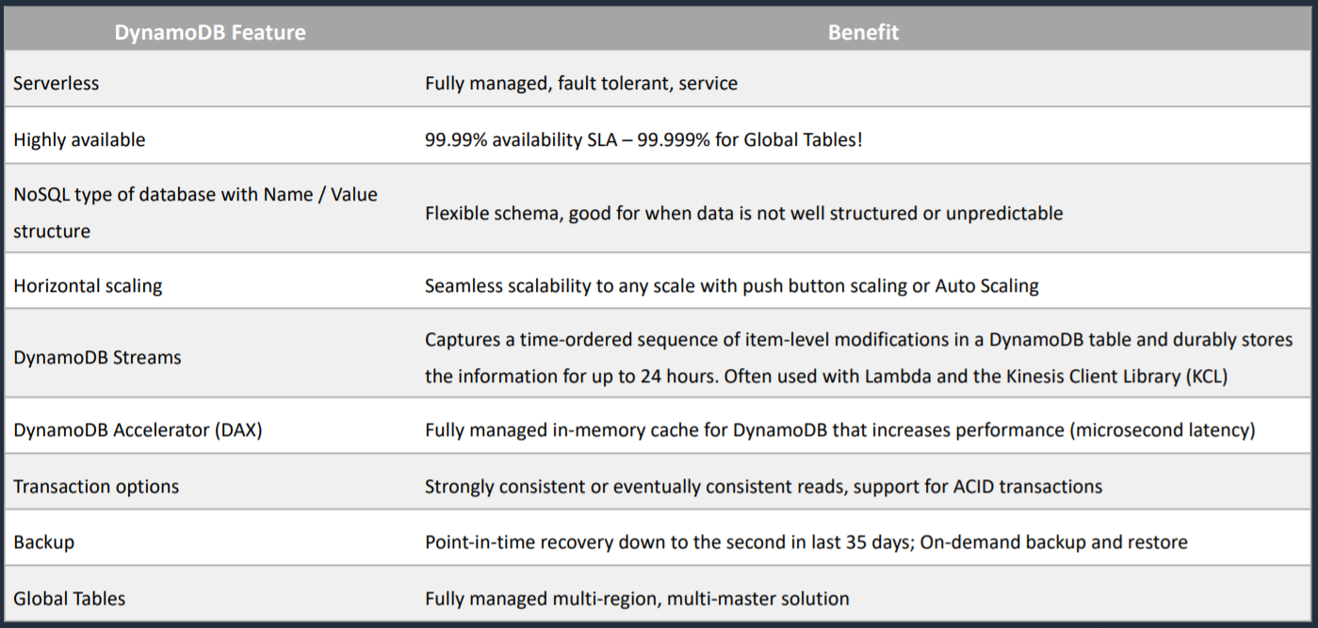

DynamoDB Global Tables

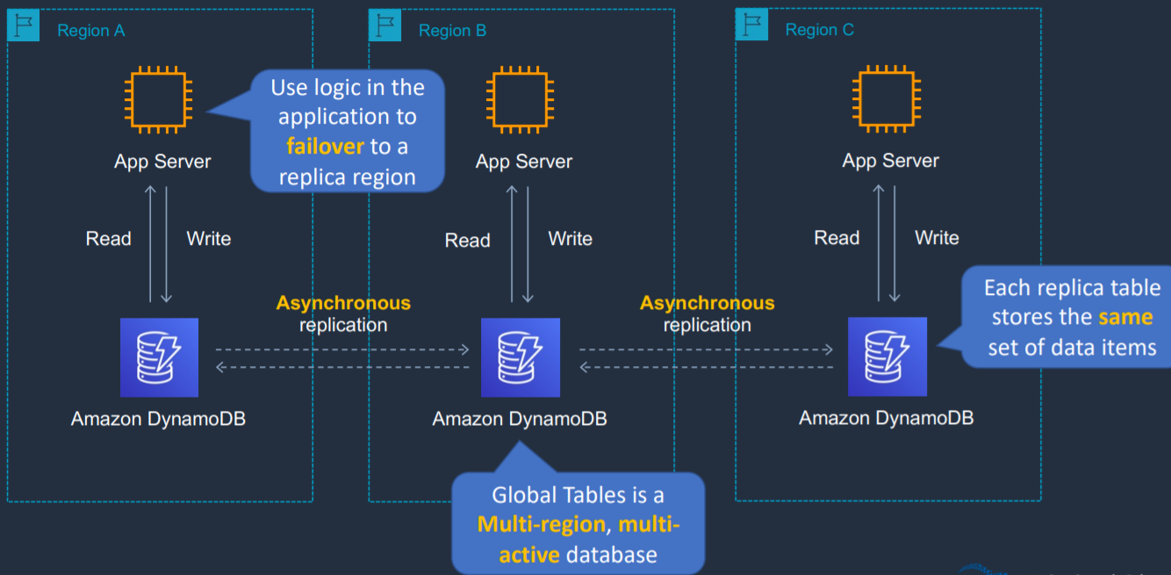

1. Global tables is where we have multiple regions and we can actually deploy DynamoDB in a region and have DynamoDB in multiple other regions and we are able to read and write to those regions
2. The replication is asynchronous and actually replies upon DynamoDB streams
3. We have this asynchronous replication ensuring that our database is synced between our different regions
4. Global tables is multi-region and also a multi-active database, sometimes known as multi-master

Amazon Redshift

1. It is a fast, fully managed data warehouse
2. Analyze data using standard SQL and existing BI tools
3. SQL based data warehouse used for analytics applications
4. Relational database used for OLAP use cases
5. Uses Amazon EC2 instances, so you must choose an instance family/type
6. Always keeps three copies of data
7. Provides continuous/incremental backups
8. Use cases
   1. Perform complex queries on massive collections of structured and semi-structured data and get fast performance
   2. Use spectrum for direct access of S3 objects in a data lake

DynamoDB Streams

1. Captures a time-ordered sequence of item-level modifications in any DynamoDB table and stores this information in a log for up to 24 hours
2. Can configure the information that is written to the stream
   1. KEYS_ONLY – only the key attributes of the modified item
   2. NEW_IMAGE – the entire item, as it appears after it was modified
   3. OLD_IMAGE – the entire item, as it appeared before it was modified
   4. NEW_AND_OLD_IMAGES – both the new and old images of the item

DynamoDB Accelerator (DAX)

1. Fully managed, highly available, in-memory cache for DynamoDB
2. Improves performance from milliseconds to microseconds
3. Can be a read-through cache and a write-through cache
4. Used to improve READ and WRITE performance
5. DAX is updated only if DynamoDB is successfully updated first
6. You do not need to modify application logic, since DAX is compatible with existing DynamoDB API calls

DAX vs ElastiCache

1. DAX is optimized for DynamoDB
2. With ElastiCache you have more management overhead (e.g. invalidation)
3. With ElastiCache you need to modify application code to point to cache
4. ElastiCache supports more datastores

Amazon Kinesis

Amazon Kinesis Data Streams

1. Producers send data to Kinesis, data is stored in shards for 24 hours (by default, up to 7 days)
2. Consumers then take the data and process it – data can then be saved into another AWS services
3. Kinesis data streams is real time (around 200 milliseconds)
4. Data Stream is real time while Firehouse is near real time
5. Kinesis Data Streams stores data for later processing by applications (key difference with Firehouse which delivers data directly to AWS services)
6. Kinesis Client Library (KCL)
   1. Helps you consume and process data from a Kinesis data stream
   2. Each shard is processed by exactly one KCL worker and has exactly one corresponding record processor
   3. One worker can process any number of shards, so it is fine if the number of shards exceeds the number of instances

Kinesis Data Firehouse

1. Captures, transforms and loads streaming data
2. Producers send data to Firehouse
3. There are no shards, completely automated (scalability is elastic). With data streams, you have to add shards when you need to scale
4. With Firehouse, the data is always loaded directly to the destination. It is not stored within firehouse itself. And optionally, you can transform it or process it with AWS Lambda before it is actually stored in the destination
5. Near real time delivery (~60 seconds latency)
6. Kinesis Data Firehouse destinations
   1. Redshift (via an intermediate S3 bucket)
   2. Elasticsearch
   3. Amazon S3
   4. Splunk
   5. Datadog
   6. MongoDB
   7. New Relic
   8. HTTP Endpoint

Kinesis Data Analytics

1. Provides real-time SQL processing for streaming data
2. Provides analytics for data coming in from Kinesis Data Streams and Kinesis Data Firehouse
3. Destinations can be Kinesis Data Streams, Kinesis Data Firehouse or AWS Lambda
4. You can quickly author and run powerful SQL code against streaming sources
5. Can ingest from Kinesis Strems and Kinesis Firehouse

Amazon Athena

1. Serverless service that we can use to run SQL queries against data in S3
2. Can be connected to other data sources with lambda
3. Athena can query data in CSV, TSV, JSON, Parquet and ORC formats
4. Uses a managed Data Catalog (AWS Glue) to store information and schemas about the databases and tables
5. SQL queries can also be run against these data sources. But we should use lambda function for this purpose to connect Athena to data source
   1. Amazon CloudWatch Logs
   2. Amazon CloudWatch Metrics
   3. Amazon DynamoDB
   4. Amazon Redshift
   5. MySQL
   6. Redis
   7. Apache HBase
   8. PostgreSQL

Optimizing Athena for Performance

1. Partition your data
2. Bucket your data – bucket the data within a single partition
3. Use compression – AWS recommend using either Apache Parquet or Apache ORC
4. Optimize file sizes
5. Optimize columnar data store generation – Apache Parquet and Apache ORC are popular columnar data stores
6. Optimize ORDER BY and Optimize GROUP BY
7. Use approximate functions
8. Only include the columns that you need

AWS Glue

1. Fully managed extract, transform and load (ETL) service
2. Used for preparing data for analytics
3. AWS Glue runs the ETL jobs on a fully managed, scale-out Apache Spark environment
4. AWS Glues discovers data and stores the associated metadata (e.g. table definition and schema) in the AWS Glue Data Catalog
5. Works with data lakes (e.g. data on S3), data warehouses (including Redshift) and data stores (including RDS or EC2 databases)
6. You can use crawler to populate the AWS Glue Data Catalog with tables
7. A crawler can crawl multiple data stores in a single run
8. Upon completion, the crawler creates or updates one or more tables in your Data Catalog
9. ETL jobs that you define in AWS Glue use the Data Catalog tables as sources and targets

Architectural Patterns – Databases and Analytics

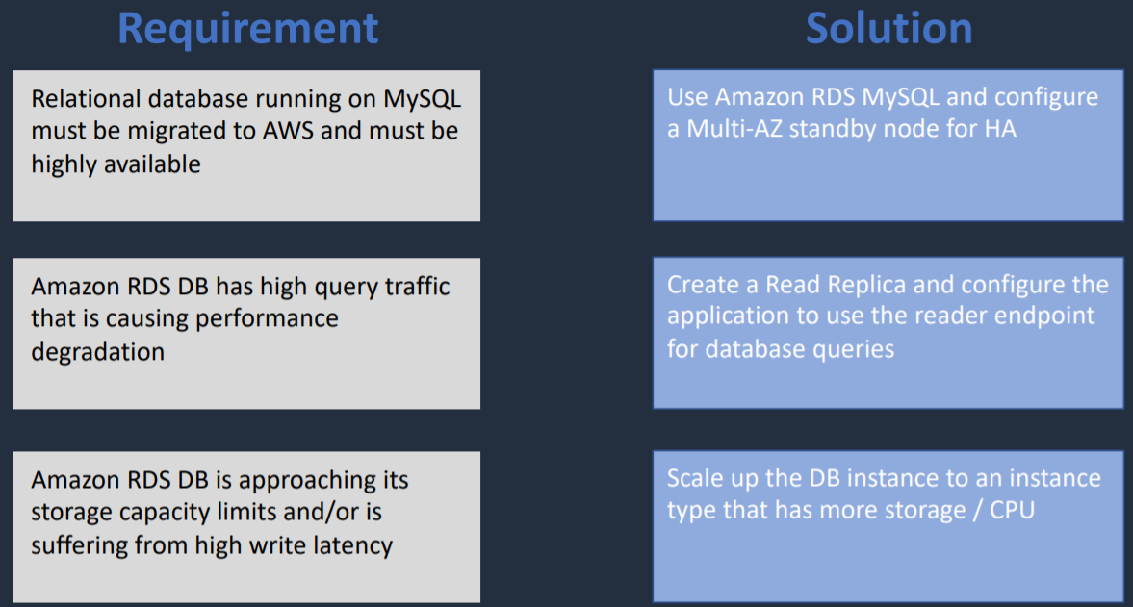

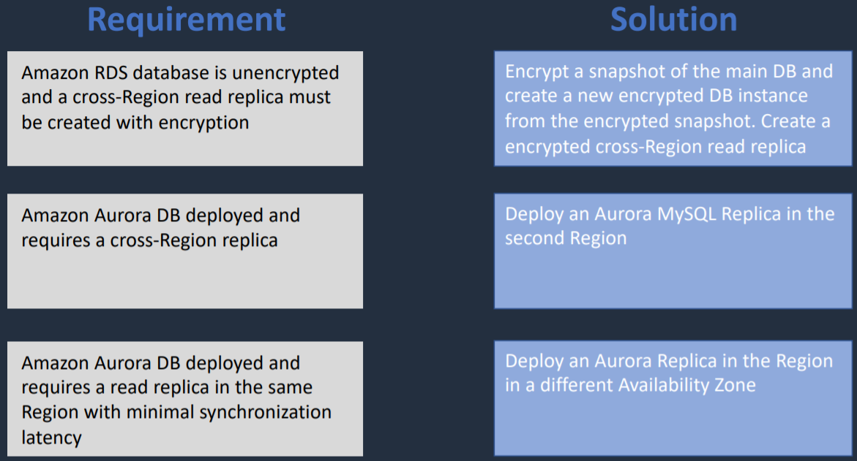

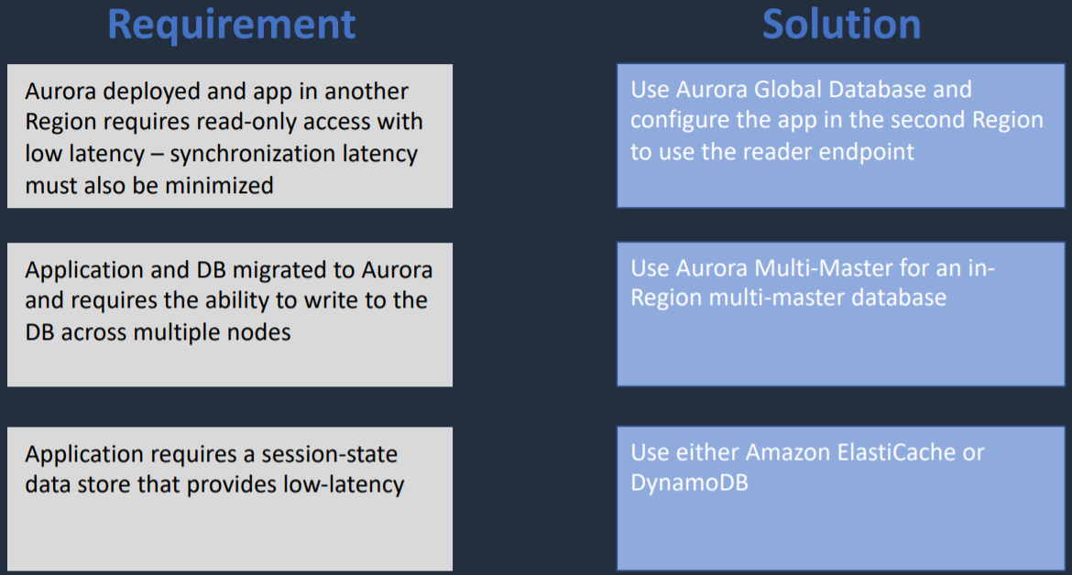

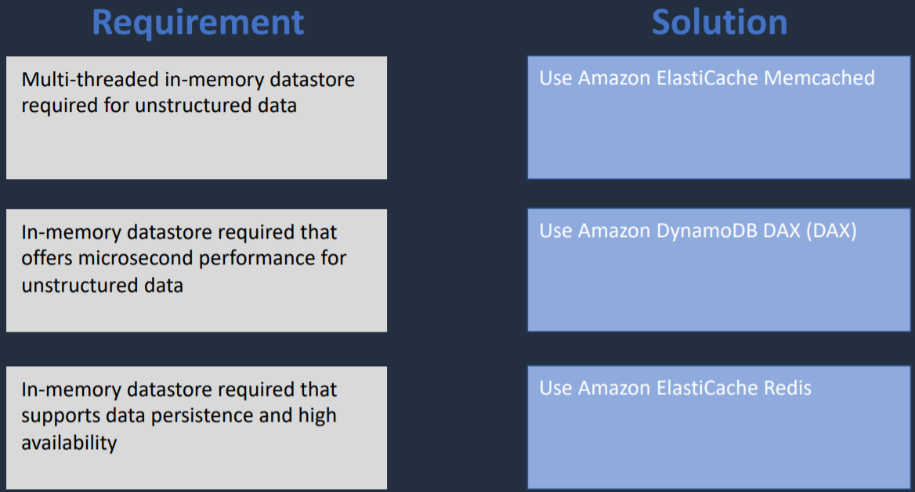

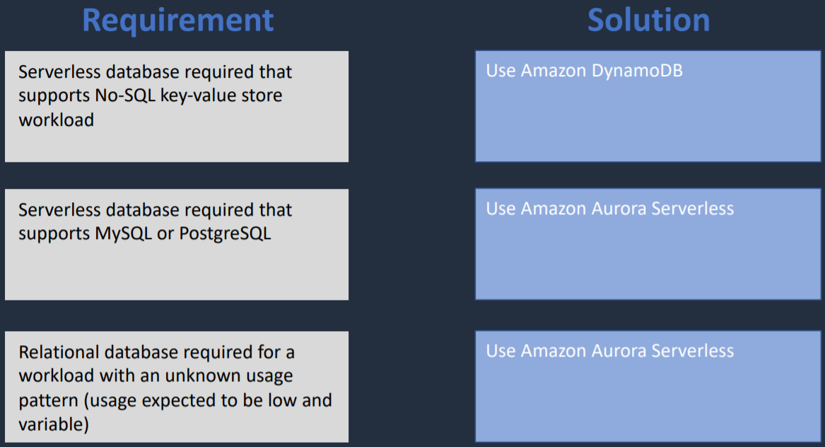

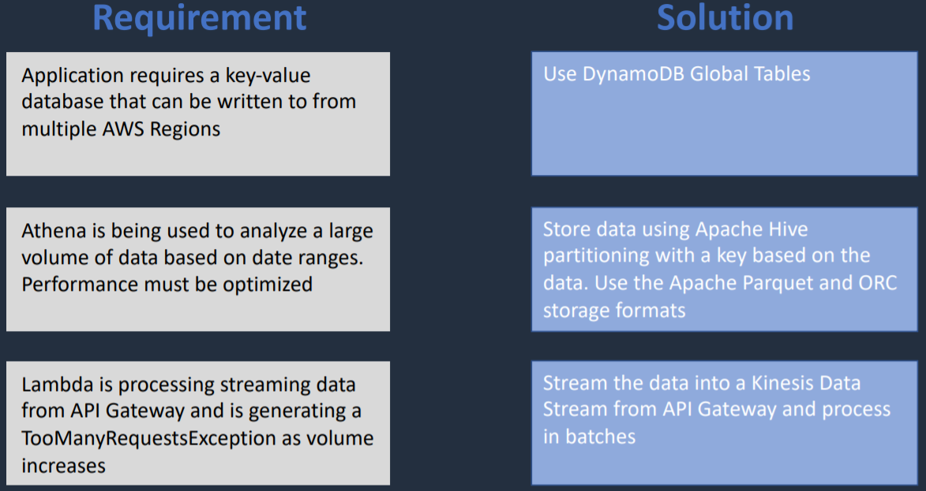

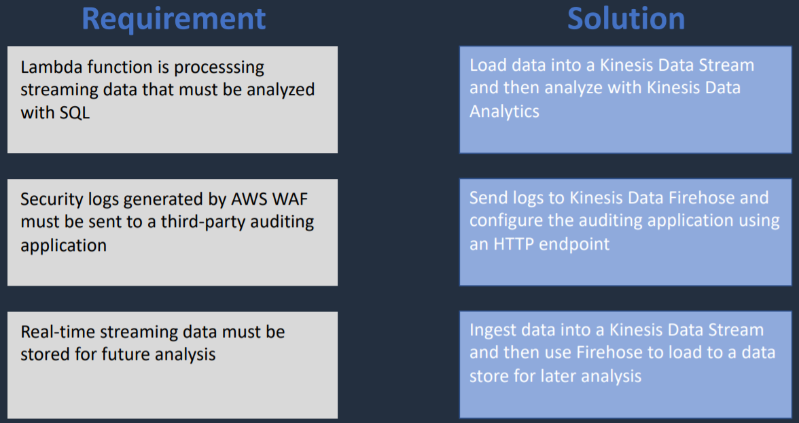

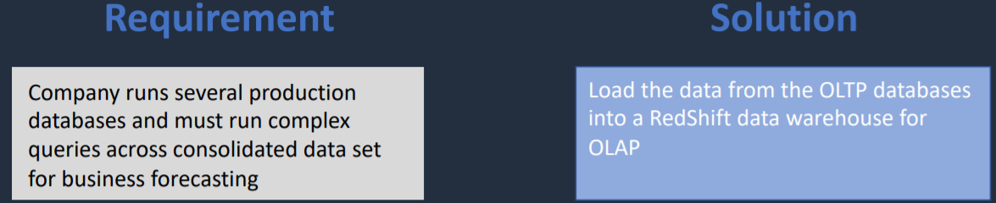

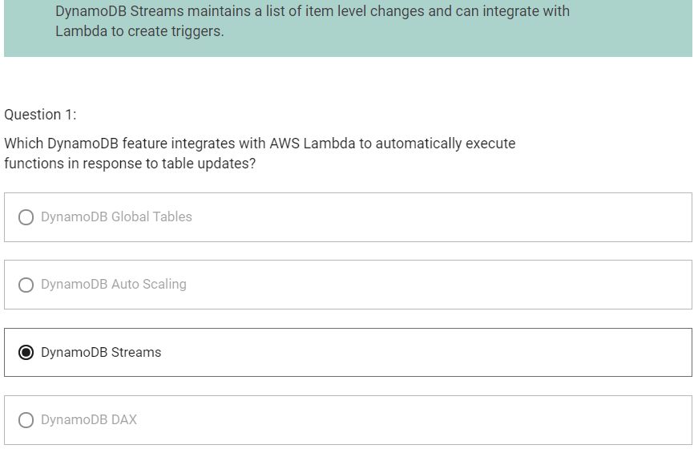

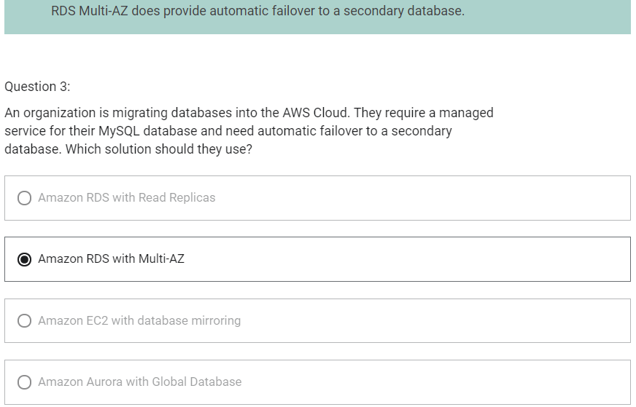

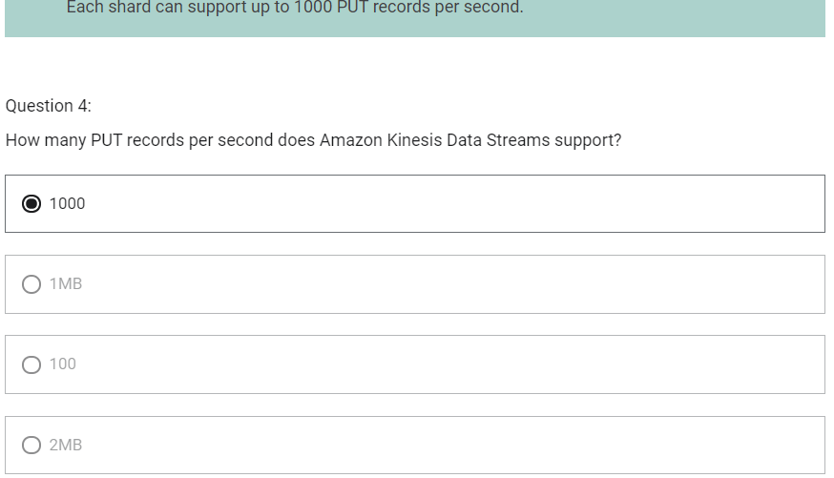

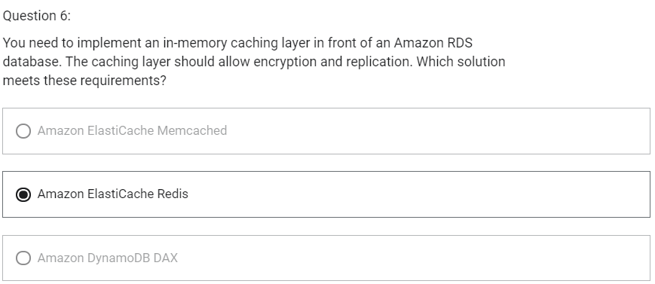

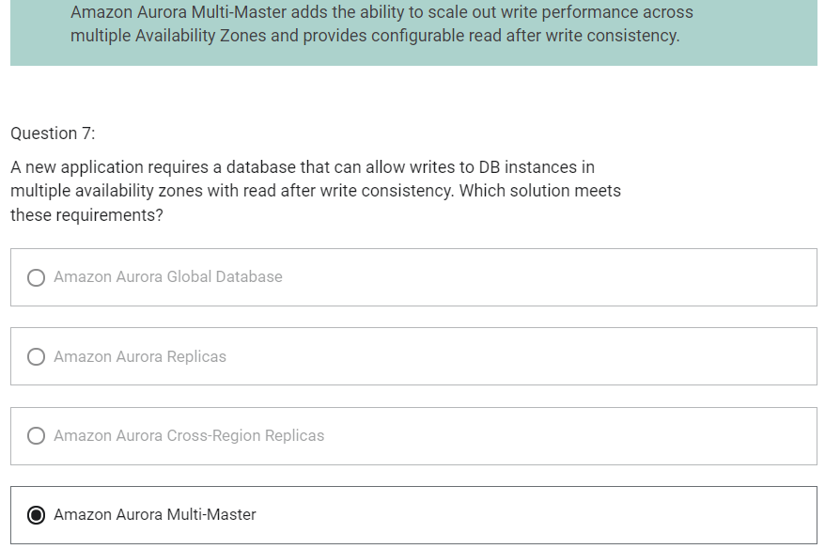

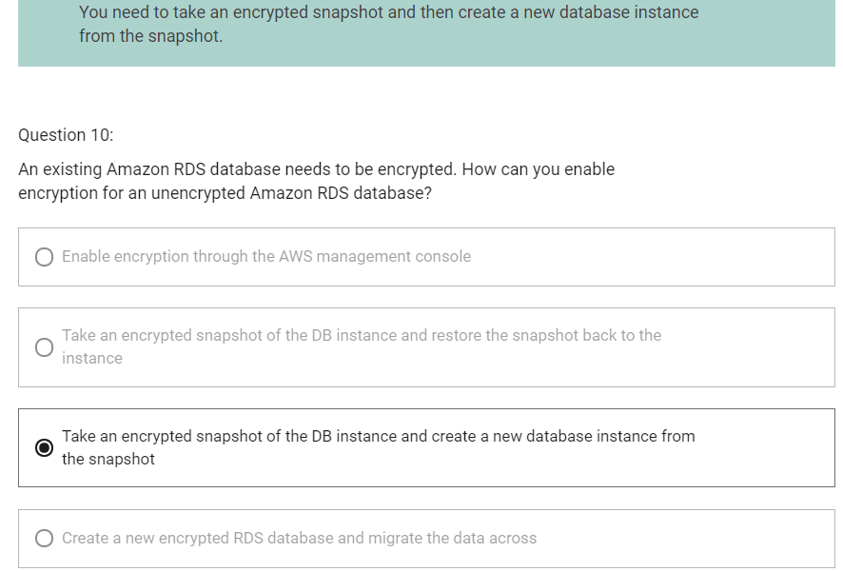

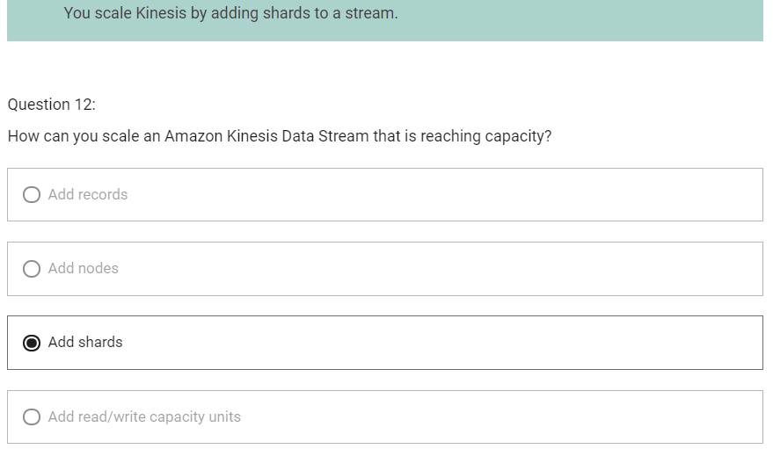

Deployment and Management

AWS CloudFormation

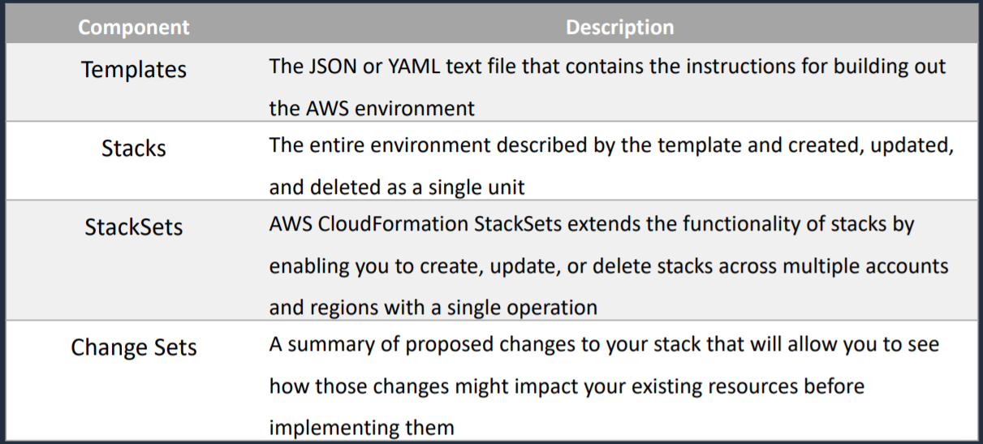

1. Infrastructure patterns are defined in a template file using code
2. JSON or YAML
3. CloudFormation builds your infrastructure according to the template
4. Benefits
   1. Infrastructure is provisioned consistently, with fewer mistakes
   2. Less time and effort than configuring resources manually
   3. You can use version control and peer review for your CloudFormation templates
   4. Free to use (you are only charged for the resources provisioned)
   5. Can be used to manage updates and dependencies
   6. Can be used to rollback and delete the entire stack as well

AWS Elastic Beanstalk

1. You can launch and manage both EC2 instances and Docker containers using Beanstalk
2. Supports Java, .NET, PHP, Node.js, Python, Ruby, Go and Docker web applications
3. Webservers are standard applications that listen for and then process HTTP requests, typically over port 80
4. Workers are specialized applications that have a background processing task listens for messages on an Amazon SQS queue
5. Workers should be used for long-running tasks

AWS System Manager – Parameter Store

1. Parameter Store provides secure, hierarchical storage for configuration data and secrets
2. Highly scalable, available, and durable
3. Store data such as passwords, database strings and license codes as parameter values
4. Store values as plaintext (unencrypted data) or ciphertext (encrypted data)
5. Reference values by using the unique name that you specified when you created the parameter
6. No native rotation of keys

AWS Config

1. Evaluate your AWS resource configurations against desired settings
2. You can get a snapshot of current configurations of resources that are associated with your AWS account
3. Retrieve configurations of resources that exist in your account
4. Retrieve historical configurations of one or more resources
5. Receive a notification whenever a resource is created, modified or deleted
6. View relationships between resources

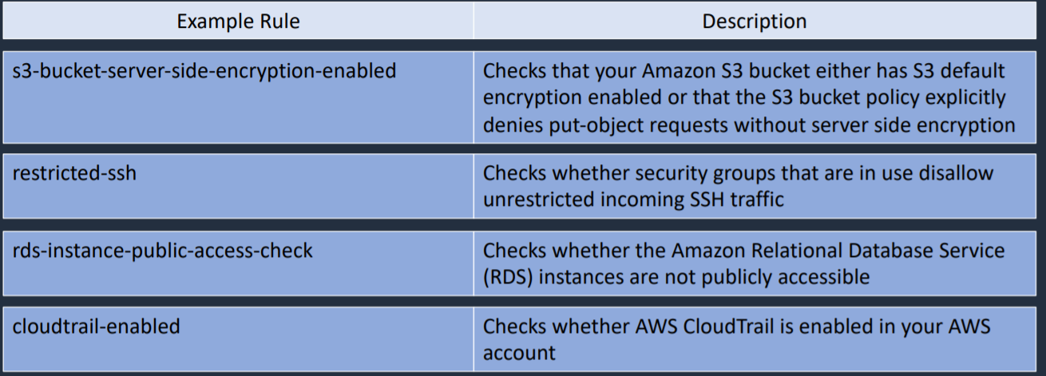

AWS Secrets Manager

1. Designed for storing secrets like database connection information or your passwords
2. It is similar to the SSM Parameter Store
3. Offers automatic rotation of credentials (built-in) for
   1. Amazon RDS (MySQL, PostgreSQL and Amazon Aurora)
   2. Amazon Redshift
   3. Amazon DocumentDB
4. For other services you can write your own AWS lambda function for automatic rotation

AWS Secrets Manager vs SSM Parameter Store

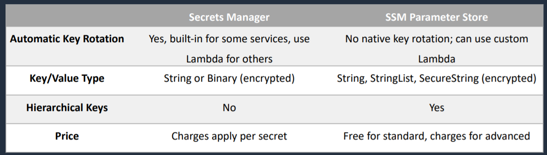

AWS OpsWorks

1. Configuration management service that provides managed instances of Chef and Puppet

AWS Resource Access Manager

1. Service that enables you to share AWS resources within your account or across accounts
2. You can chare things like subnets and databases and resource groups with other accounts or with different OUs in an AWS Organization
3. Resource shares are created with
   1. AWS RAM Console
   2. AWS RAM APIs
   3. AWS CLI
   4. AWS SDKs
4. RAM can be used to share
   1. AWS App Mesh
   2. Amazon Aurora
   3. AWS Certificate Manager Private Certificate Authority
   4. AWS CodeBuild
   5. Amazon EC2
   6. EC2 Image Builder
   7. AWS Glue
   8. AWS License Manager
   9. AWS Network Firewall
   10. AWS Outposts
   11. Amazon S3 on Outposts
   12. AWS Resource Groups
   13. Amazon Route 53
   14. AWS Systems Manager incident Manager
   15. Amazon VPC

Architecture Patterns – Deployment and Management

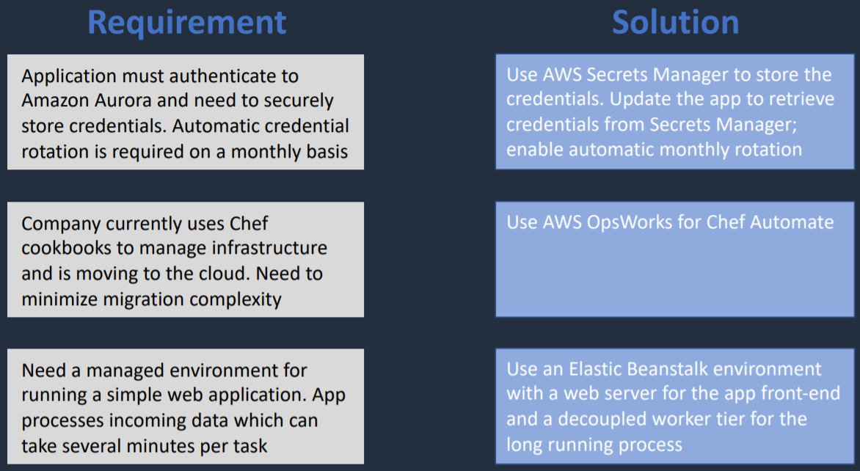

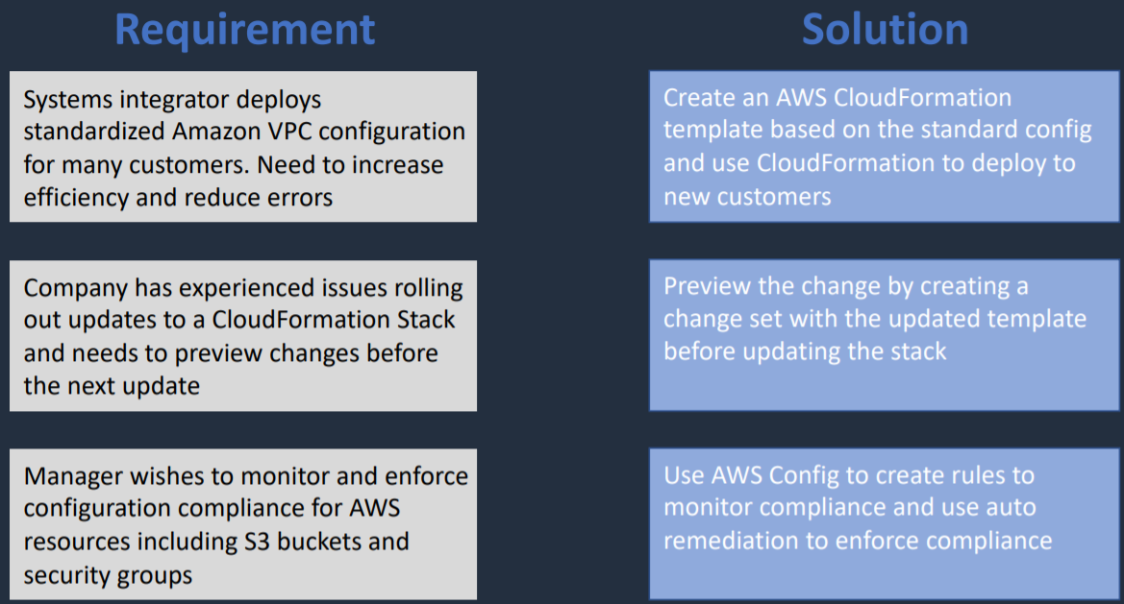

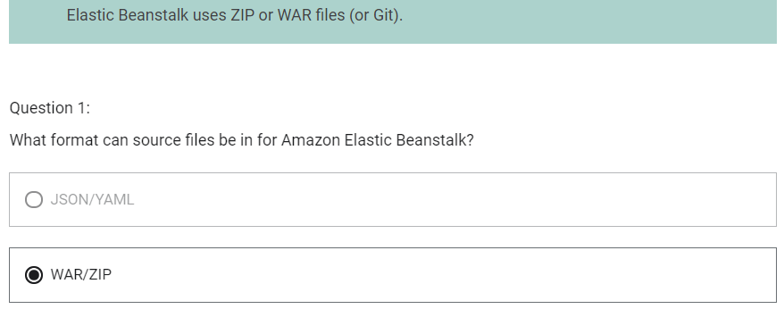

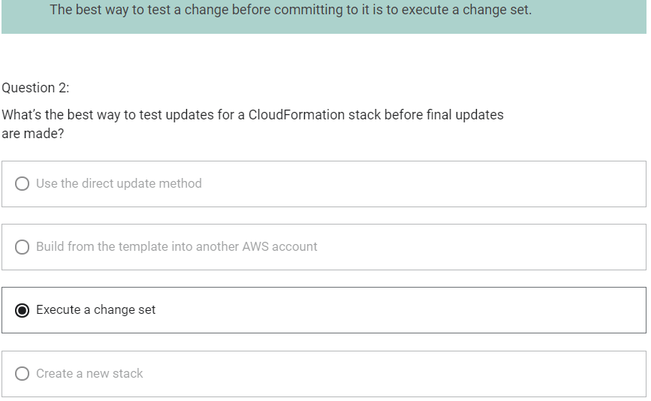

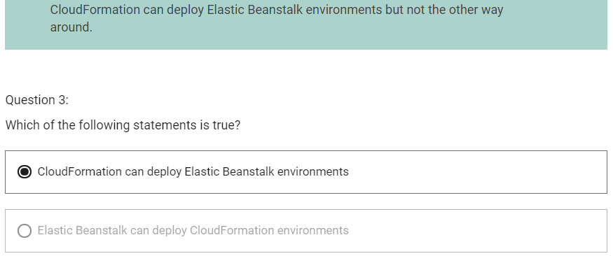

Monitoring, Logging and Auditing

CloudWatch

1. Features
   1. CloudWatch Metrics – services and time-ordered data points to CloudWatch
   2. CloudWatch Alarms – monitor metrics and initiate actions
   3. CloudWatch Logs – centralized collection of system and application logs
   4. CloudWatch Events – stream of system event describing changes to AWS resources and can trigger actions

Amazon CloudWatch Metrics

1. Metrics are sent to CloudWatch for many AWS services
2. EC2 metrics are sent every 5 minutes by default (free)
3. Detailed EC2 monitoring sends every 1 minute (chargeable)
4. Unified CloudWatch Agent sends system-level metrics for EC2 and on-premises servers
5. System-level metrics include memory and disk usage
6. Can publish custom metrics using CLI or API
7. Custom Metrics are one of the following resolutions
   1. Standard Resolution – data having a one-minute granularity
   2. High Resolution – data at a granularity of one second
8. AWS metrics are standard resolution by default

Amazon CloudWatch Alarms

1. Two types of alarms
   1. Metric Alarm – performs one or more actions based on a single metric
   2. Composite Alarm – uses a rule expression and takes into account multiple alarms
2. Metric alarm states
   1. OK – metric is within a threshold
   2. ALARM – metric is outside a threshold
   3. INSUFFICIENT_DATA – not enough data

Amazon CloudWatch Logs

1. Gather application and system logs
2. You can define expiration policies and KMS encryption
3. Can send los to various destinations like
   1. Amazon S3
   2. Kinesis Data Streams
   3. Kinesis Data Firehouse

Unified CloudWatch Agent

1. It enables you to do following
   1. Collect internal system-level metrics from Amazon EC2 instances
   2. Collect system level metrics from on-premises servers
   3. Retrieve custom metrics from your applications or services using the StatsD and collected protocols
   4. Collect logs from Amazon EC2 instances and on-premises servers (Windows/Linux)
2. Agent must be installed on the server
3. Can be installed on
   1. Amazon EC2 instances
   2. On-premises servers
   3. Linux, Windows Server or macOS
4. There are more metrics from Unified CloudWatch Agent than from Standard Metrics

AWS CloudTrail

1. Logs API activity for auditing
2. By default, management events are logged and retained for 90 days
3. A CloudTrail logs any events to S3 for indefinite retention
   1. Can enable log file integrity validation
4. Trail can be within region or all regions
5. CloudWatch Events can be triggered based on API calls in CloudTrail
6. Events can be streamed to CloudWatch Logs

CloudTrail – Types of Events

1. Management Events
   1. Provide information about management operations that are performed on resources in your AWS account
2. Data Events
   1. Provide information about the resource operations performed on or in a resource
3. Insights Events
   1. Identify and respond to unusual activity associated with write API calls by continuously analyzing CloudTrail management events

AWS EventBridge

Architecture Patterns – Monitoring, Logging and Auditing

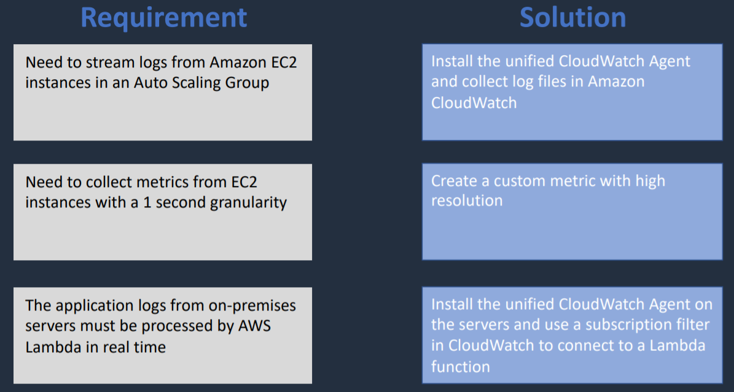

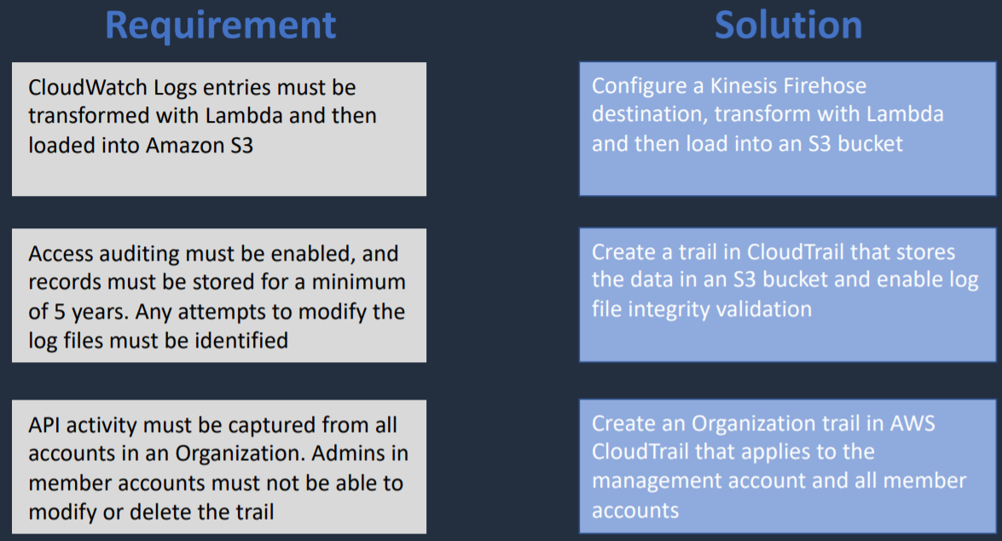

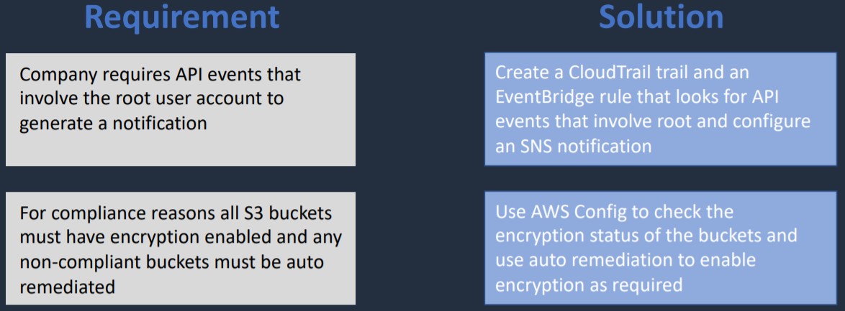

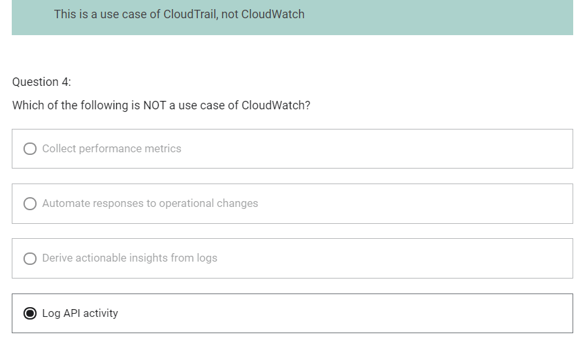

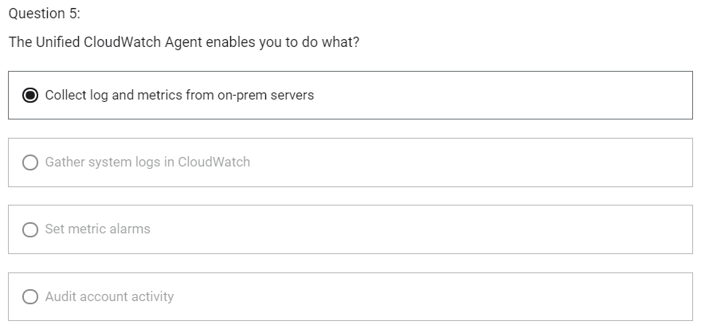

Security in the Cloud

AWS Managed Microsoft AD

1. Fully managed AWS service
2. Best choice if you have more than 5000 users and/or need as a trust relcationship set up
3. Can perform schema extensions
4. Can setup trust relationships to with on-premises Active Directories
   1. On-premise users and groups can access resources in either domain using SSO
   2. Requires a VPN or Direct Connect connection
5. Can be used as a standalone AD in the AWS cloud

AD Connector

1. Redirects directory requests to your on-premise Active Directory
2. Best choice when you want to use an existing AD with AWS services
3. AD Connector comes in two sizes:
   1. Small – designed for organizations up to 500 users
   2. Large – designed for organizations up to 5000 users
4. Requires a VPN or Direct Connect connection
5. Join EC2 instances to your on-premise AD through AD Connector
6. Login to the AWS Management Console using on-premise AD DCs for authentication

Simple AD

1. Inexpensive Active Directory-compatible service with common directory features
2. Standalone, fully managed, directory on the AWS cloud
3. Simple AD is generally the least expensive option
4. Best choice for less than 5000 users and do not need advanced AD features
5. Features include
   1. Manage user accounts/groups
   2. Apply group policies
   3. Kerberos-based SSO
   4. Supports joining Linux or Windows based EC2 instances

Identity Federation

Amazon Single Sign-On (SSO)

Amazon Cognito

1. Add user sign-up, sign-in and access control to your web and mobile apps
2. A user pool is a directory for managing sign-in and sign-up
3. Users can be stored in a User Pool or can sign in using social IdPs
4. Supports SAML and OIDC IdPs
5. Cognito acts as a identity Broker between the IdP and AWS
6. Identity Pools are used to obtain temporary, limited-privilege credentials for AWS services (using STS)
7. An IAM role is assumed, providing access to the AWS services

Asymmetric Encryption

1. Also known as public key cryptography
2. Messages encrypted with the public key can only be decrypted with the private key
3. Messages encrypted with the private key can be decrypted with the public key
4. Examples SSL/TLS and SSH

Symmetric Encryption

1. Same key is used for encryption and decryption

Customer Master Keys (CMKs)

1. CMKs are the primary resources in AWS KMS
2. The CMK also contains the key material used to encrypt and decrypt data
3. CMKs are created in AWS KMS
4. Symmetric CMKs and private keys of asymmetric CMKs never leave AWS KMS unencrypted
5. By default, AWS KMS creates the key material for a CMK
6. Can also import your own key material
7. A CMK can encrypt data up to 4KB in size
8. A CMK can generate, encrypt and decrypt Data Encryption Keys
9. Data Encryption Keys can be used for encrypting large amount of data

AWS Managed CMKs

1. Created, managed and used on your behalf by an AWS service that is integrated with AWS KMS
2. You cannot manage these CMKs, rotate them, or change their key policies
3. You also cannot use AWS managed CMKs in cryptographic operations directly; the service that creates them uses them on your behalf

Data Encryption Keys

1. Data keys are encryption keys that you can use to encrypt data, including large amounts of data and other data encryption keys
2. You can use AWS KMS customer master keys (CMKs) to generate, encrypt and decrypt data keys
3. AWS KMS does not store, manage or track your data keys, or perform cryptographic operations with data keys
4. You must use and manage data keys outside of AWS KMS

Difference between various CMKs

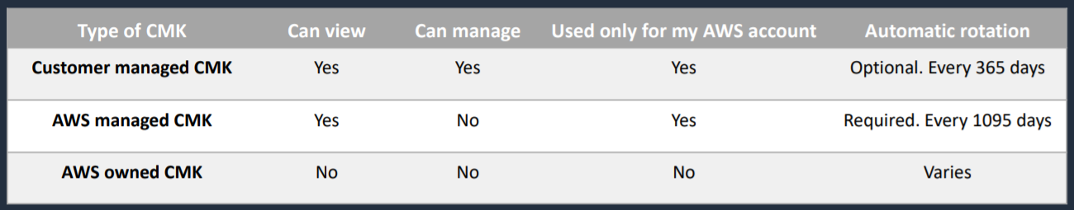

AWS CloudHSM

1. Service used for creating and managing encryption keys
2. Dedicated hardware
3. Generate and use your own encryption keys on the AWS Cloud
4. CloudHSM runs in your Amazon VPC
5. Uses FIPS 140-2 level 3 validated HSMs
6. Managed service and automatically scales
7. Retain control of your encryption keys – you control access (and AWS has no visibility of your encryption keys)

AWS CloudHSM vs KMS

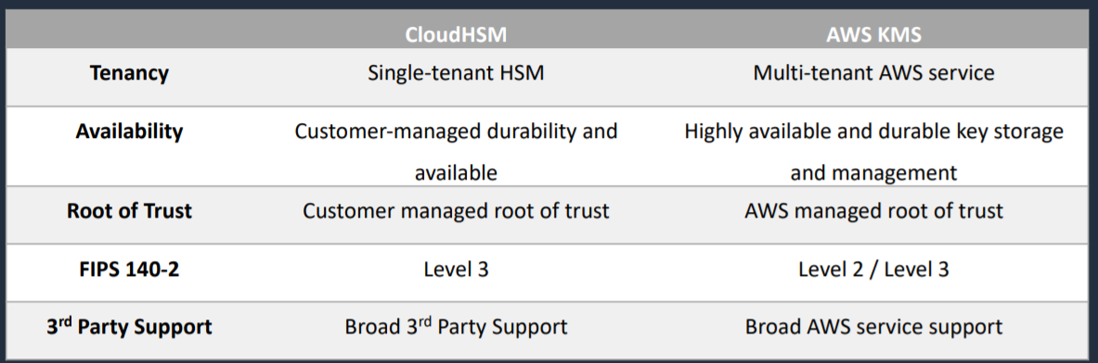

AWS Certificate Manager (ACM)

1. Service that we can use for issuing certificates
2. Those certificates are SSL/TLS certificates that we can then use for encryption in transit
3. Create, store and renew SSL/TLS X.509 certificates
4. You can have single domains, multiple domain names and wildcards on the certificates that you issue
5. Integrates with several AWS services including
   1. Elastic Load Balancing
   2. Amazon CloudFront
   3. AWS Elastic Beanstalk
   4. AWS Nitro Enclaves
   5. AWS CloudFormation
6. Public certificates are signed by the AWS public Certificate Authority
7. But you can also create your own private certificate authority within ACM. If you do that you can then issue private certificates
8. You can also import certificates from third party issuers

AWS WAF

1. Web Application Firewall
2. Lets you create rules to filter web traffic based on conditions that include IP addresses, HTTP headers and body or custom URIs
3. WAF makes it easy to create rules that block common web exploits like SQL injection and cross site scripting
4. Can be integrated with ALB, API Gateway, AppSync, CloudFront
5. Web ACLs
   1. You use a web access control list (ACL) to protect a set of AWS resources
6. Rules
   1. Each rule contains a statement that defines the inspection criteria, and an action to take if a web request meets the criteria
7. Rule groups
   1. You can use rules individually or in reusable rule groups
8. Regex pattern set
   1. It provides a collection of regular expressions that you want to use together in a rule statement
9. Rule action
   1. Tells AWS WAF what to do with a web request when it matches the criteria defined in the rule
   2. Count – AWS WAF counts the requests but doesn’t determine whether to allow it or block it. With this action, AWS WAF continues processing the remaining rules in the web ACL
   3. Allow – AWS WAF allows the request to be forwarded to the AWS resource for processing and response
   4. Block – AWS WAF blocks the request and the AWS resource responds with an HTTP 403 (forbidden) status code
10. Match statements compare the web request or its origin against conditions that you provide

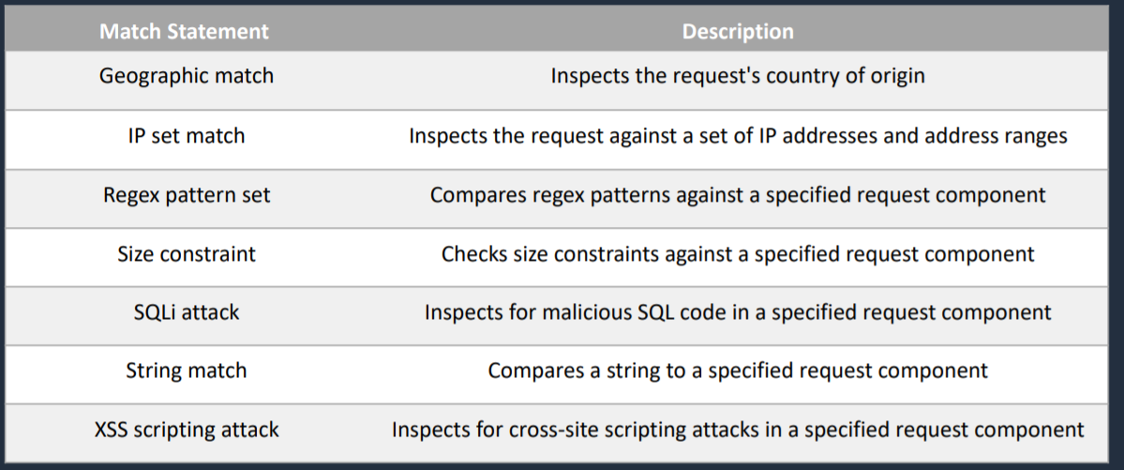

AWS Shield

1. Service that you can use to protect against distributed denial of service attacks
2. Two tiers
   1. Standard – no cost
   2. Advanced - $3000 USD per month and 1 year commitment
3. Integrated with Amazon CloudFront(standard included by default)

Architecture Patterns – Security in the Cloud

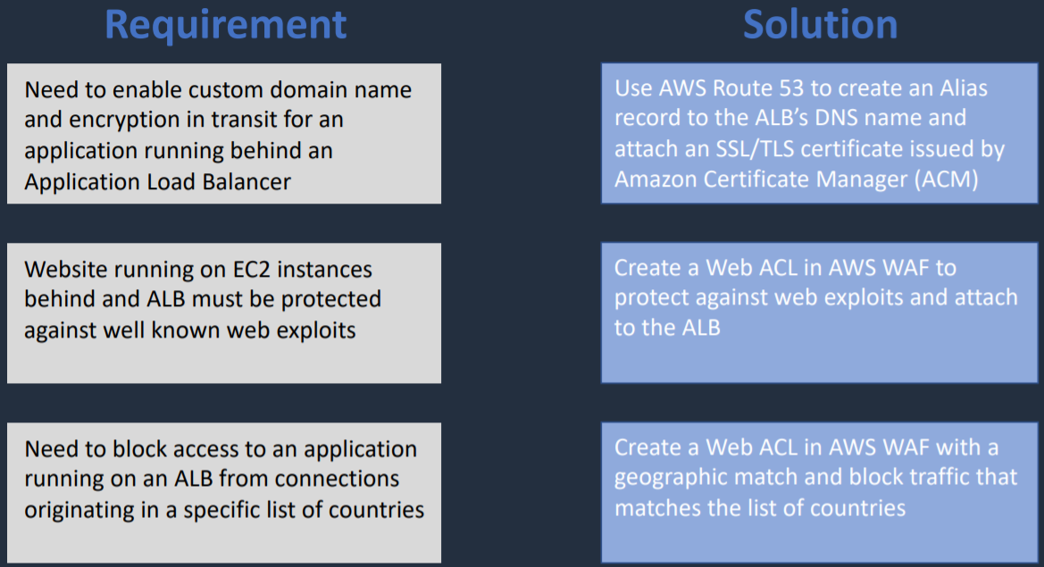

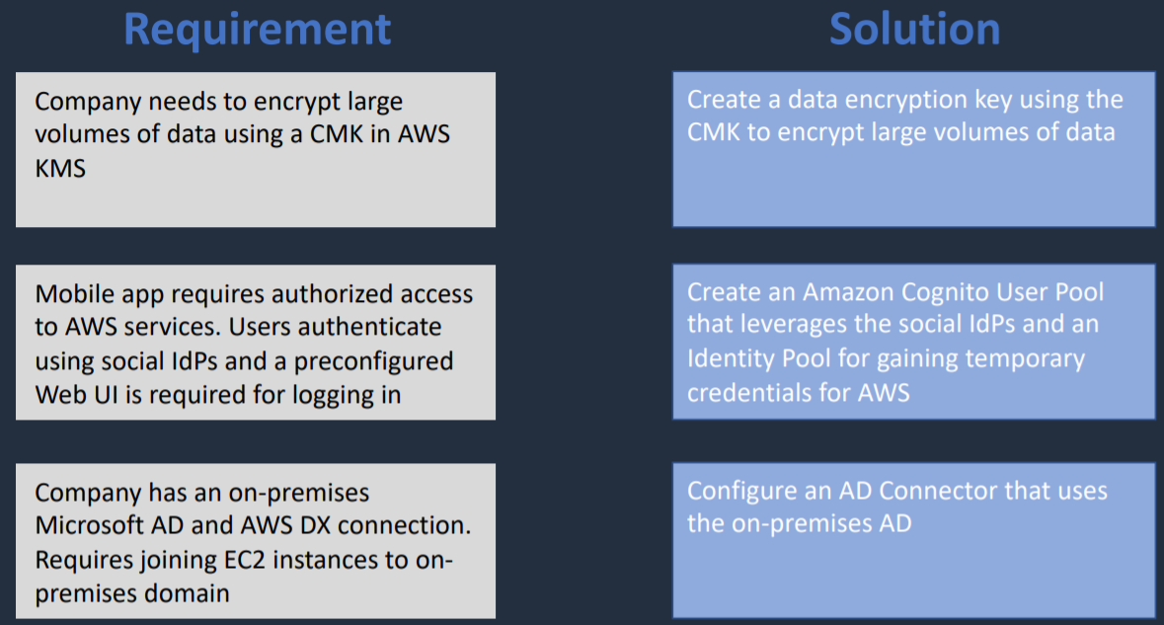

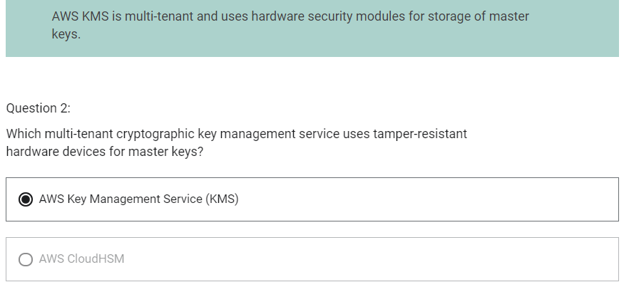

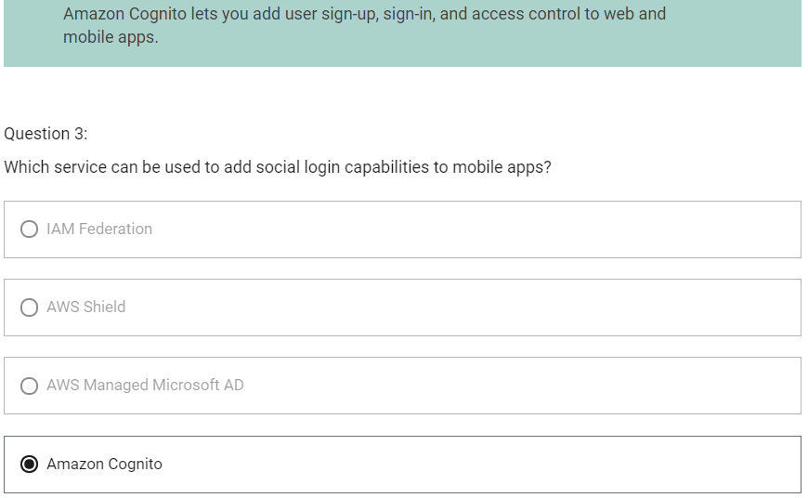

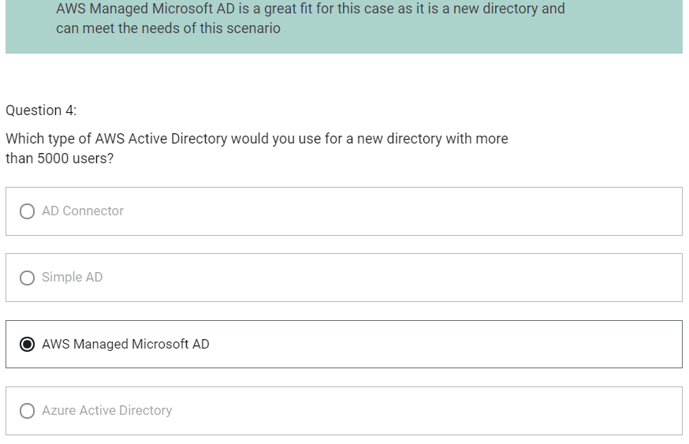

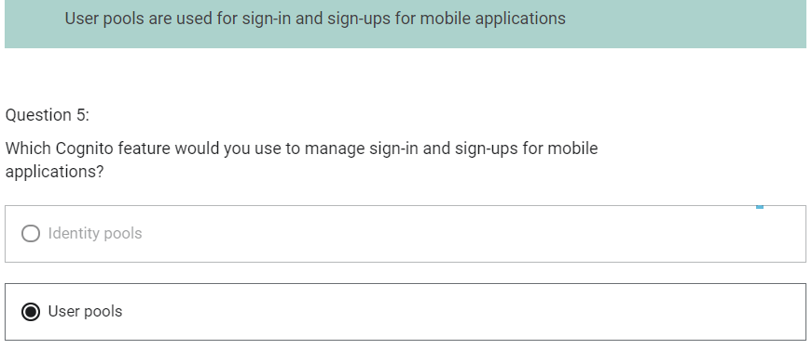

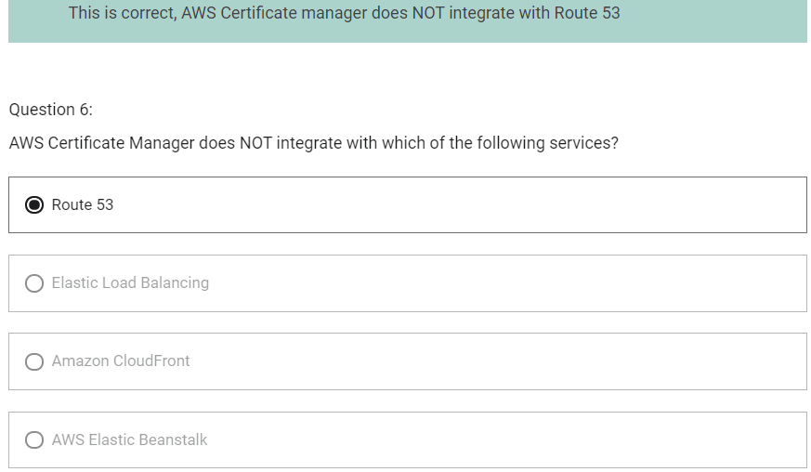

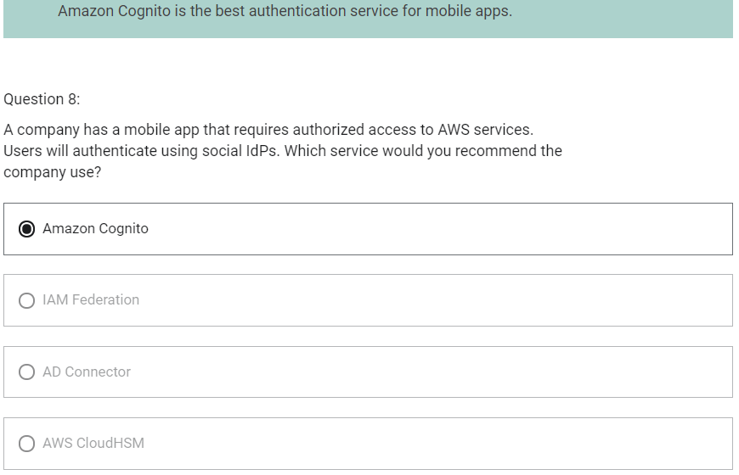

Migration and Transfer

AWS Application Discovery Service

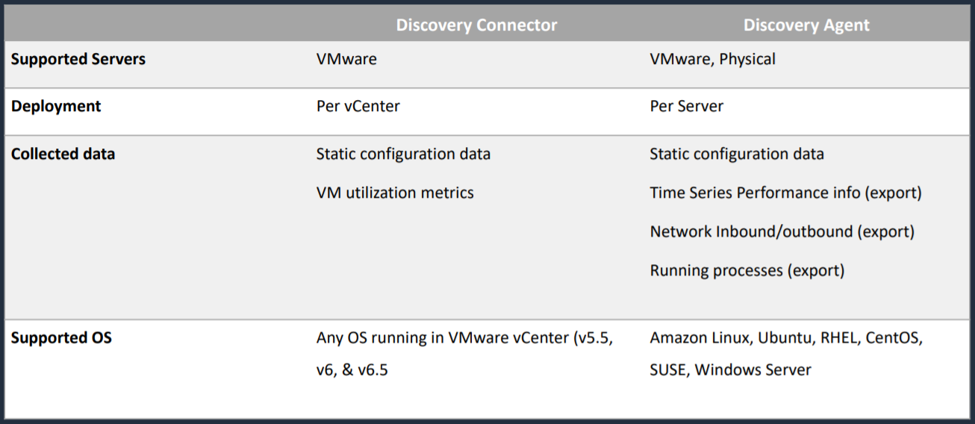

1. Collects data abut servers in the on-premises data centers

Data Migration Service

Use Cases

1. Cloud to Cloud
2. On-premises to Cloud
3. Homogenous migrations
4. Heterogenous migrations

AWS Server Migration Server

1. Can be automated, incremental and scheduled migrations

DataSync

1. Service we can use to migrate data from our file systems into AWS
2. Destinations can be
   1. Amazon Simple Storage Service (S3)
   2. Amazon FSx for Windows File Server
   3. Amazon Elastic File System
3. Data is encrypted in transit with TLS
4. The actual migration of data is scheduled and automated
5. Pay per GB transferred
6. Can improve performance for data transfers up to 10x faster than traditional tooling

AWS Snowball Family

1. AWS Snowball and Snowmobile are used for migrating large volumes of data to AWS
2. Snowball Edge Compute Optimized
   1. Provides block and object storage and optional GPU
   2. Use for data collection, machine learning and processing, and storage in environments with intermittent connectivity
3. Snowball Edge Storage Optimized
   1. Provides block storage and Amazon S3 compatible object storage
   2. Use for local storage and large-scale data transfer
4. Snowcone
   1. Small device used for edge computing, storage and data transfer
   2. Can transfer data offline or online with AWS DataSync agent
5. Use a secure storage device for physical transportation
6. Snowball (80TB) (50TB) “petabyte scale”
7. Snowball Edge (100TB) “petabyte scale”
8. Snowmobile “exabyte scale” upto 100 PB per Snowmobile
9. Ways to optimize performance of Snowball transfers
   1. Use the latest Mac or Linux Snowball Client
   2. Batch small files together
   3. Perform multiple copy operations at one time
   4. Copy from multiple workstations
   5. Transfer directories, not files

Architectural Patterns – Migration and Transfer

